Solutions

Introduction

These questions are designed to help you to develop your mental models (pictures in your head) of what happens to the particles when a substance dissolves. This will help you to develop your ability to explain your observations.

|  |  |
| --- | --- |
| An icon used to indicate the Macroscopic part of Johnstone's triangle. | **Macroscopic:** what we can see. Think about the properties that we can observe, measure and record. |
| An icon used to indicate the Sub-microscopic part of Johnstone's triangle. | **Sub-microscopic:** smaller than we can see. Think about the particle or atomic level. |
| An icon used to indicate the Symbolic part of Johnstone's triangle. | **Symbolic:** representations. Think about how we represent chemical ideas including symbols and diagrams. |

Questions

1. A student adds substances to test tubes of water to find out if they dissolve.
2. First they test everyday cooking ingredients. State whether the substances are soluble or insoluble.
3. salt __________
4. flour __________
5. sugar ___________

Next, the student tests substances from the lab and describes their observations in a table.

1. Give the meaning of the word colourless.

_________________________________________________________________________________

__________________________________________________________________________________

1. Give the meaning of the word clear.

_________________________________________________________________________________

__________________________________________________________________________________

1. Complete the table to show whether each unknown substance is soluble or insoluble.

|  |  |  |
| --- | --- | --- |
| **Unknown substance** | **Observation after adding to water** | **Soluble or insoluble?** |
| W | white lump and  clear and colourless liquid |  |
| X | cloudy and white |  |
| Y | clear and colourless |  |
| Z | clear and blue |  |

1. Select the observation that tells you that the substance has dissolved and a solution has formed. Circle your answer.

|  |  |
| --- | --- |
| **A** | colourless |
| **B** | cloudy |
| **C** | clear |



1. A teacher measures the combined mass of a beaker of water and a smaller beaker containing 4 g of sugar.

The teacher adds the sugar to the beaker of water and replaces the smaller beaker on the balance.

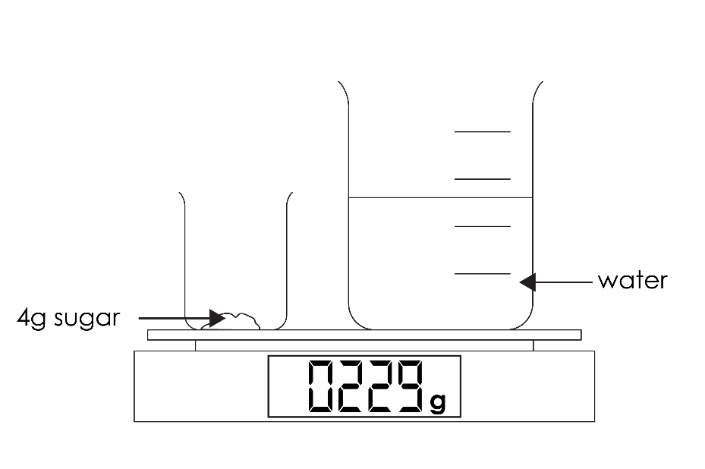

1. Predict the mass reading on the balance when the sugar is added to the water.

_________ g

1. The particle diagrams for water and sugar are shown below.

|  |  |
| --- | --- |
| A square box containing 16 grey circles, regularly arranged in a 4x4 grid where each circle is just touching its neighbours to the left, right and above and below it. These represent sugar particles. | A square box filled with approximately 40 white circles that are all the same size. The circles are close together, touching and overlapping in an irregular arrangement. These represent water particles. |
| **sugar particles** | **water particles** |

Draw a new particle diagram to show sugar dissolved in water.

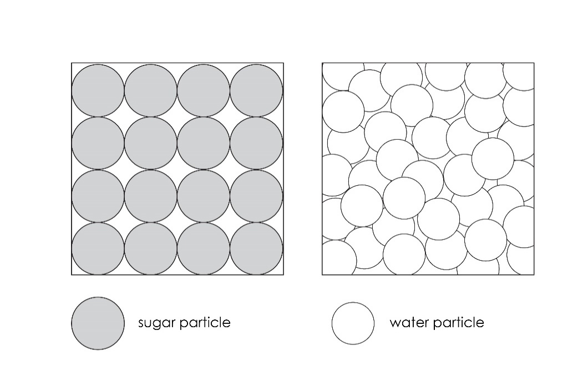

1. Use your diagram to explain your answer to part (a).

__________________________________________________________________________________

__________________________________________________________________________________

__________________________________________________________________________________



1. A student adds chalk powder to water. Chalk is insoluble in water. When chalk powder is added to water it forms a mixture called a suspension. The suspension mixture looks cloudy and white.
2. Explain why the suspension looks cloudy.

__________________________________________________________________________________

__________________________________________________________________________________

__________________________________________________________________________________

1. The student draws a diagram to explain what happens to the particles.

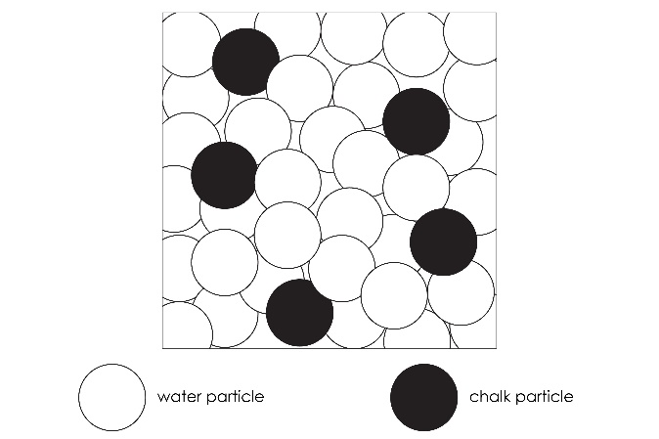

Explain why this particle diagram does **not** represent a suspension.

__________________________________________________________________________________

__________________________________________________________________________________

__________________________________________________________________________________

1. Draw an improved diagram to represent a suspension.



1. After leaving the mixture the student notices that the liquid no longer looks cloudy. There is a layer of white at the bottom of the test tube.

Explain the change that has occurred.

__________________________________________________________________________________

__________________________________________________________________________________

__________________________________________________________________________________