Melting and freezing stearic acid

This investigation is part of the Nuffield practical collection, developed by the Nuffield Foundation and the Royal Society of Chemistry. Delve into a wide range of chemical concepts and processes with this collection of over 200 step-by-step practicals: [rsc.li/43bjGql](https://rsc.li/43bjGql)

Learning objectives

1. Determine the melting and freezing point of a sample of stearic acid by setting up and carrying out an experiment.
2. Carefully make temperature readings and record them in a table.
3. Plot and interpret a heating and/or cooling curve.
4. Use particle theory to explain what happens during melting and freezing.

Learners will successfully set up and carry out the experiment (LO1); produce a results table (LO2) and draw a graph (LO3). LO3 and LO4 will be met by answering questions on the student sheet.

Introduction

In this experiment, a solid turns into a liquid and then the liquid turns into a solid. The energy changes are examined.

Learners will take the temperature of stearic acid at regular intervals as they heat and cool it. They will observe the melting and freezing point of the acid and plot a graph. This experiment can also be done using data-logging equipment.

This practical takes quite a long time to carry out. Learners can begin by simply recording their data but, once they get the hang of what they are doing, most should be able to plot the graph at the same time as taking readings. If data-loggers are used, learners will need another activity to do alongside the experiment.

Scaffolding

There are two versions of the student sheet. The support sheet (✪) offers more scaffolding, including a ready-drawn table and a graph with axes and scales, whereas on the standard sheet (✪✪) learners are expected to make their own decisions when drawing the table and graph. Teachers will need to provide graph paper for learners using the standard sheet.

For those learners unable to successfully complete their own experiment (LO1), a set of sample results for the heating and cooling curve are included at the end of these teacher notes, so that they can successfully complete LO3 and LO4.

Integrated instructions are available in the PowerPoint presentation as an alternative to the written method on the student sheet.

Technician notes

Read our standard health and safety guidance ([rsc.li/3zyJLkx](https://rsc.li/3zyJLkx)) and carry out a risk assessment before running any live practical.

Equipment

Apparatus

* Safety glasses
* Beaker (250 cm3)
* Boiling tube
* Thermometer (0–100°C)
* Stop clock
* Clamp, stand and boss
* Bunsen burner
* Tripod
* Gauze
* Heat resistant mat

Chemicals

* Stearic acid (octadecanoic acid, less than 5 g is needed).

Preparation

|  |  |
| --- | --- |
| **Chemicals supplied for the practical and hazards** | **Preparation** |
| Stearic acid solid (octadecanoic acid), (s).  Currently not classified as hazardous. See CLEAPSS Hazcard [HC038b](https://science.cleapss.org.uk/Resource/HC038b-Higher-monobasic-aliphatic-acids.pdf). | Stearic acid can be pre-measured in the boiling tubes. Label the boiling tube with the name of the chemical using a permanent pen. |

Safety and hazards

Make sure that learners can use a Bunsen burner with confidence and remind them how to handle hot liquids in beakers, as in CLEAPSS student safety sheets [SSS092](https://science.cleapss.org.uk/Resource/SSS092-Using-a-Bunsen-burner.pdf) and [SSS095](https://science.cleapss.org.uk/Resource/SSS095-Handling-hot-liquids-in-beakers.pdf).

Allow enough time for the equipment to cool down before asking learners to put away their equipment. In case of burns, follow the instructions on the CLEAPSS emergency cards [E2a](https://science.cleapss.org.uk/Resource/Emergency-Cards-E-Cards.pdf) and cool the burn by immediately irrigating with gently running water for at least 20 minutes and until pain is relieved and heat is no longer felt.

Recycle the stearic acid and dispose of any small amounts of solid stearic acid in the general waste bin, if not reusable. Keep the stearic acid in boiling tubes that are used for this practical only. Check that the boiling tubes are not damaged before giving them out to the next class.

Teaching notes

Remind learners not to attempt to move the thermometer in the solid stearic acid, as it will break.

Energy must be supplied to melt a solid; this same energy is released when the liquid re-solidifies.

This experiment presents a good opportunity to demonstrate how to maintain a steady temperature using a Bunsen burner. Slide the Bunsen burner aside as the boiling becomes too vigorous; slide it back as the water stops boiling. It is not essential that the water bath is boiling. Provide learners with another thermometer and ask them to maintain a lower temperature, say 80°C.

A variation to this experiment is to plot only the cooling curve. Place all the boiling tubes with stearic acid into a large beaker. Place some hot water in the beaker and continue to heat with a Bunsen burner. Remove from the heat when all the stearic acid has melted. Get learners to place a thermometer into the stearic acid and place the boiling tube into a test tube rack or beaker. Ask them to take the temperature every 30 seconds or every minute and plot a graph. Many learners will anticipate that the stearic acid will continue to cool to zero – it is useful to discuss why the stearic acid stops cooling when it reaches room temperature.

In either version of the experiment, it is good practice for learners to draw a graph of their results. There should be a clear horizontal line in the graph which corresponds to the changes of state; however many school samples of stearic acids are not very pure, so the line is often not perfectly horizontal. The exact melting and freezing points of the stearic acid may not be exactly the same and will depend on the purity of the product and where it was purchased from, but are usually about 55–70°C.

Answers

1. 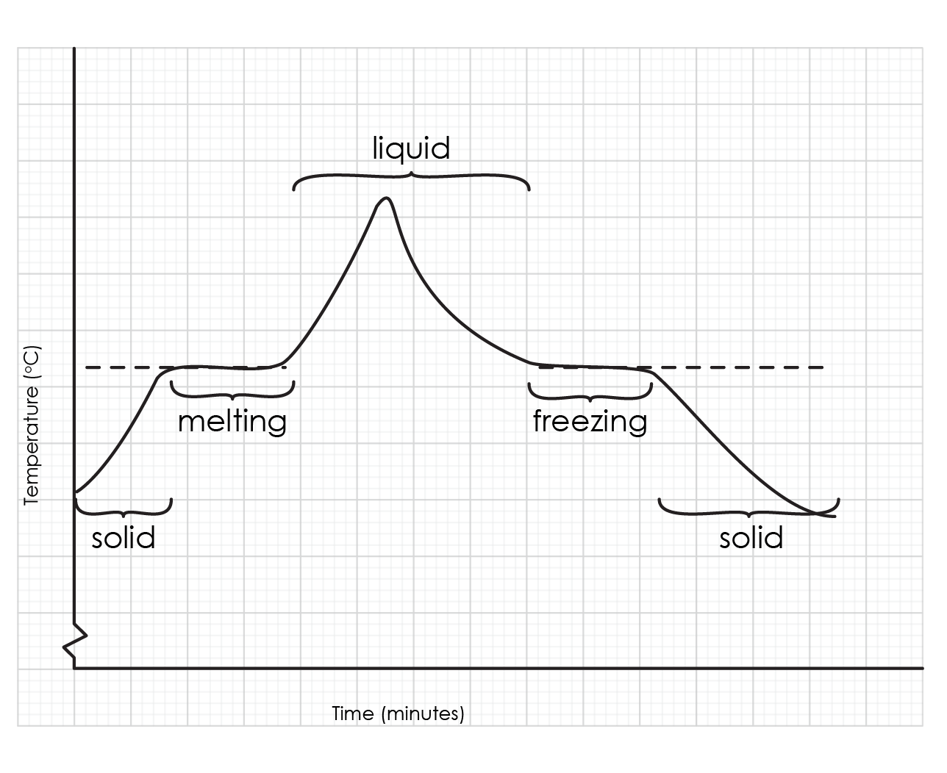*Support and challenge*

The graph should look similar to this sketch graph.

There should be a suitable scale and the points should be plotted correctly.

1. *Support and challenge*

At the start the temperature increases, until it reaches a plateau for a few minutes. Then it continues to increase until it reaches a maximum point. Next, the temperature starts to decrease until it reaches a plateau again, at the same temperature as before. Finally, it starts to decrease again.

1. *Support and challenge*

See the sketch graph in the answer to question 1.

1. *Support and challenge*

The melting and freezing point line will be from 55–70°C (where the graph plateaus). They should both be the same.

1. *Support*

|  |  |  |
| --- | --- | --- |
| Twenty five grey circles arranged in a regular structure of five columns and five rows with all the circles touching their neighbours to either side and above and below. A line is drawn from this diagram to the label 'Solid stearic acid'. |  |  |
|  |  | **Liquid stearic acid** |
| Six grey circles which are not touching each other and are spread out in an irregular arrangement. No line is drawn from this diagram. |  |  |
|  |  | **Solid stearic acid** |
| Twenty grey circles filling the bottom 2/3rds of the outline of a beaker. They are not in a regular arrangement but most are touching and slightly overlapping each other. A line is drawn from this diagram to the label 'Liquid stearic acid'. |  |  |

*Challenge*

|  |  |
| --- | --- |
| (a) | (b) |
| Twenty five grey circles arranged in a regular structure of five columns and five rows with all the circles touching their neighbours to either side and above and below. | Twenty grey circles filling the bottom 2/3rds of the outline of a beaker. They are not in a regular arrangement but most are touching and slightly overlapping each other. |

1. *Support*In solid stearic acid, the particles are very close together in a **regular** pattern. The particles **vibrate** around a fixed position. Solids have a fixed **shape**. As the temperature increases, the kinetic energy of the particles in the solid **increases** and so the particles vibrate faster.

During **melting**, the forces of attraction between the particles are **overcome** by the kinetic energy of the particles. The particles are now free to move. They are in the **liquid** state.  
  
As the temperature increases, the kinetic energy of the particles in the liquid increases and so the particles move more **quickly**.

*Challenge*

During melting, the kinetic energy of the particles in the solid increases so the particles vibrate faster. The forces of attraction between the particles are overcome by the kinetic energy and the particles are now free to move in the liquid state.

During freezing, the kinetic energy of the particles in the liquid decreases, they start to slow down. The forces of attraction between the particles cannot now be overcome by their kinetic energy and they take on the regular arrangement of the solid. The particles now have less kinetic energy and can only vibrate around a fixed position.

Sample data

For a heating curve

|  |  |
| --- | --- |
| **Time (minutes)** | **Temperature (°C)** |
| 0 | 34 |
| 1 | 37 |
| 2 | 41 |
| 3 | 44 |
| 4 | 47 |
| 5 | 50 |
| 6 | 53 |
| 7 | 56 |
| 8 | 58 |
| 9 | 58 |
| 10 | 58 |
| 11 | 58 |
| 12 | 60 |
| 13 | 65 |
| 14 | 72 |
| 15 | 80 |

|  |  |
| --- | --- |
| **Time (minutes)** | **Temperature (°C)** |
| 0 | 80 |
| 1 | 73 |
| 2 | 67 |
| 3 | 62 |
| 4 | 59 |
| 5 | 58 |
| 6 | 58 |
| 7 | 58 |
| 8 | 58 |
| 9 | 58 |
| 10 | 58 |
| 11 | 58 |
| 12 | 58 |
| 13 | 57 |
| 14 | 56 |
| 15 | 55 |
| 16 | 54 |
| 17 | 53 |
| 18 | 52 |
| 19 | 50 |
| 20 | 48 |
| 21 | 46 |
| 22 | 44 |
| 23 | 41 |
| 24 | 37 |
| 25 | 34 |

For a cooling curve