Atomic structure

Introduction

These questions are designed to help you to develop your mental models (pictures in your mind) of atoms. This will help you to use different models to create explanations. Use the icon in the margin to find out which level of understanding the question is developing.

|  |  |
| --- | --- |
| An icon used to indicate the Macroscopic part of Johnstone's triangle. | **Macroscopic:** what we can see. Think about the properties that we can observe, measure and record. |
| An icon used to indicate the Sub-microscopic part of Johnstone's triangle. | **Sub-microscopic:** smaller than we can see. Think about the particle or atomic level. |
| An icon used to indicate the Symbolic part of Johnstone's triangle. | **Symbolic:** representations. Think about how we represent chemical ideas including symbols and diagrams. |

Questions



1. An atom is made up of three different types of sub-atomic particle. Every element has an atomic number and a mass number. These can help to work out the number of each sub-atomic particle in an atom.
2. Complete the sentences below with the correct sub-atomic particles (protons, neutrons or electrons).

The atomic number gives the number of positive __________________ and the number of negative __________________. The mass number minus the atomic number gives the number of __________________.

1. The atomic number of lithium is 3 and the mass number is 7. State the number of each sub-atomic particle in an atom of lithium.

|  |  |
| --- | --- |
|  | protons |
|  | electrons |
|  | neutrons |

1. The atomic model is a way of representing different parts on an atom. Add the following labels to the diagram to show the different parts of a lithium atom:

* proton
* neutron
* electron
* nucleus
* energy level (or electron shell)

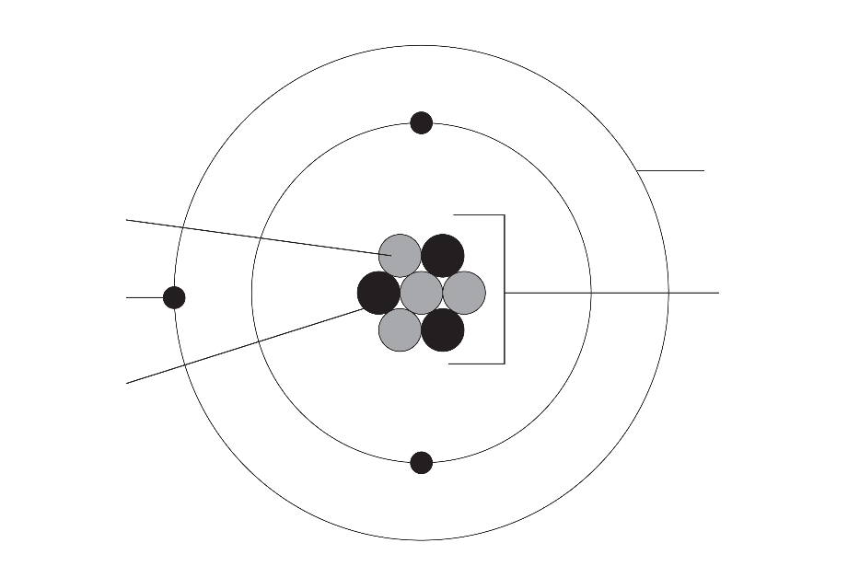



1. Different sub-atomic particles have different charges.
2. State the name of the sub-atomic particle with the following charges.

|  |  |
| --- | --- |
| **Charge** | **Sub-atomic particle** |
| positive |  |
| negative |  |
| no charge |  |

1. Explain why the nucleus of an atom has a positive charge overall.

__________________________________________________________________________________

__________________________________________________________________________________

1. Explain why an atom has no charge overall.

__________________________________________________________________________________

__________________________________________________________________________________

1. Name the force between the nucleus and the electrons that holds an atom together.

__________________________________________________________________________________



1. In the two diagrams below, a helium atom is represented in two different ways.

Diagram A shows a **particle model** of helium. There are weak forces of attraction between the helium atoms. Diagram B shows the **atomic model** of helium. It shows the different parts that make up a helium atom.

|  |  |
| --- | --- |
| Five identical white circles, spaced far apart in an irregular arrangement. One of the circles is labelled 'helium atom'. | An atomic model of helium. In the centre of the diagram are two grey and two black circles, all the same size. The circles are close together and touching. Surrounding these four circles is one large circle. On the large circle are two much smaller black circles - one at the top and one at the bottom. |
| A | B |

1. Use the particle model to explain why helium fills the shape of a container.

__________________________________________________________________________________

__________________________________________________________________________________

1. Use the atomic model to explain why an atom of helium has no overall charge.

__________________________________________________________________________________

__________________________________________________________________________________

1. Use the most suitable model to explain why helium has a low boiling point.

__________________________________________________________________________________

__________________________________________________________________________________

__________________________________________________________________________________

1. Suggest why there is **not** one correct model of helium.

__________________________________________________________________________________

__________________________________________________________________________________