Structure and bonding of carbon

Scientists experimented for many years to remove a single layer of carbon atoms from graphite. They predicted that it would have very useful properties. After many expensive experiments, they eventually succeeded using common sticky tape to remove a layer of carbon atoms from a lump of graphite. This single layer was named graphene.

This is an electron microscope image of graphene.

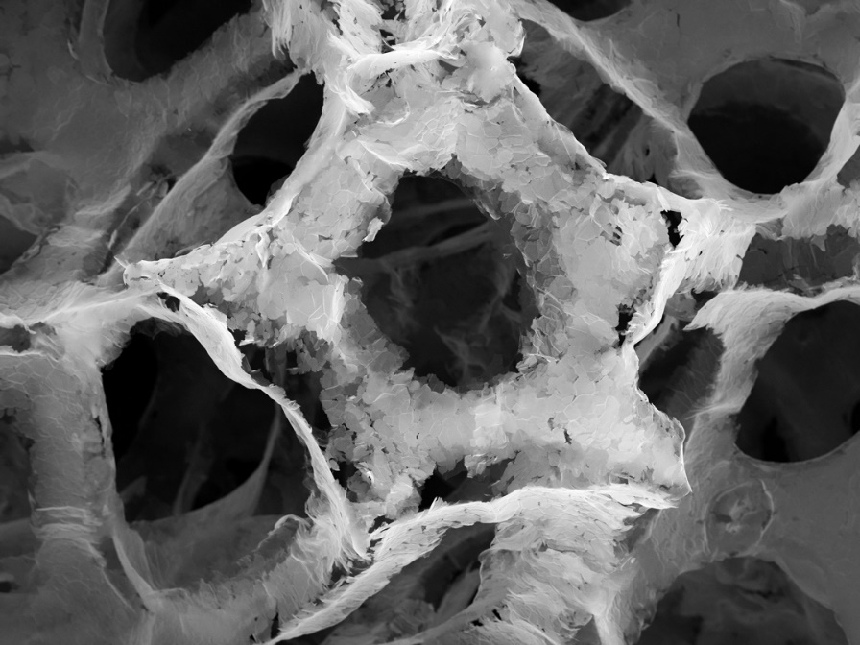

Source: © Shutterstock

1. (a) What are the lighter-coloured hexagon shapes?

Circle the correct answer.

1. empty spaces
2. intermolecular forces
3. rings of five carbon atoms
4. rings of six carbon atoms

(b) What are the darker spaces in the image?

Circle the correct answer.

1. empty spaces
2. intermolecular forces
3. rings of five carbon atoms
4. rings of six carbon atoms
5. A sheet of graphene is one atom thick, or 0.345 nm thick. What is the correct thickness of graphene in metres?

Circle the correct answer.

Hint: remember,

2. The diagram shows the structure of graphite:

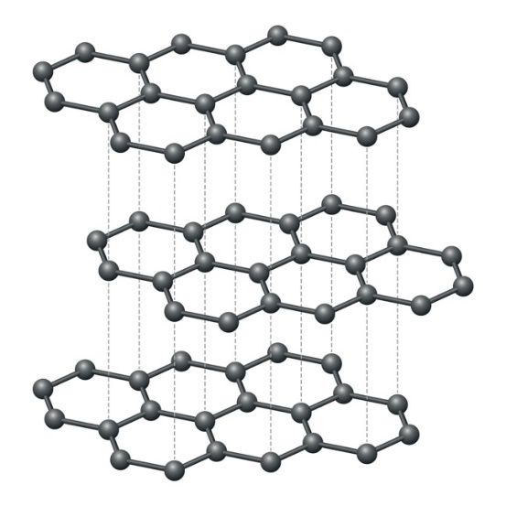

Source: © Shutterstock

* 1. Name the forces that hold the layers together.

____________________________________________________________________________

* 1. Suggest why a layer of carbon atoms was easy to remove with sticky tape. Circle one or more answers.

1. the intermolecular forces are easily overcome
2. the intermolecular forces are weak
3. the intermolecular forces do not need much energy to break
   1. Each layer of carbon atoms in this diagram has 21 carbon atoms. How many delocalised electrons does each carbon atom produce?

____________________________________________________________________________

* 1. The diagram shows three layers of carbon atoms.

The thickness of each layer of carbon atoms is 0.345 nm.

The distance between the layers of carbon atoms in the diagram of graphite is 0.340 nm.

Calculate the thickness of the sample of graphite in the diagram.

Give your answer in nanometres (nm).

____________________________________________________________________________

____________________________________________________________________________

____________________________________________________________________________

1. In the 1980s scientists were investigating carbon atoms in deep space. What they found was so surprising, they thought they had made a mistake. They had discovered Buckminsterfullerene.
   1. Choose words from those provided to complete the sentences. You do not have to use all the words.

simple molecular giant covalent giant ionic C60 60C

Until the 1980s, diamond and graphite were the only known forms of carbon. Both have a __________________ __________________ structure. The formula of the Buckminsterfullerene is __________________ .

Buckminsterfullerene has a __________________ __________________ structure.

This image shows a model of the structure of Buckminsterfullerene.

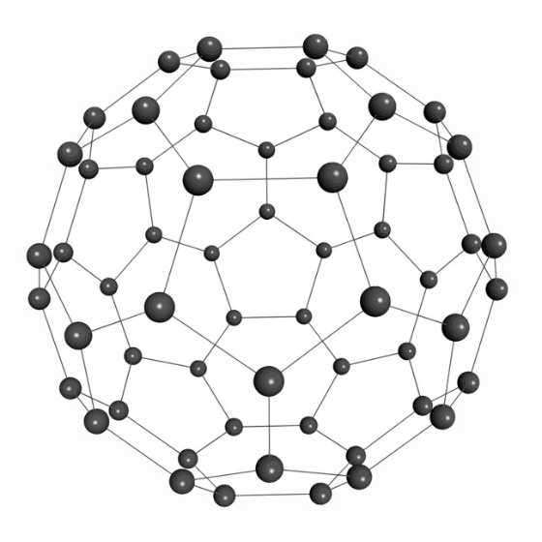

Source: © Shutterstock

* 1. Describe how the carbon atoms are arranged in Buckminsterfullerene.

Refer to the shapes formed by the carbon atoms.

____________________________________________________________________________

____________________________________________________________________________

____________________________________________________________________________

* 1. Calculate the relative formula mass of C60.

*A*r carbon 12

____________________________________________________________________________

____________________________________________________________________________

1. Scientists think the first diamonds were discovered in caves in India nearly   
   4000 years ago. They were valued for their hardness, strength and brilliance. This is a representation of the structure of diamond.

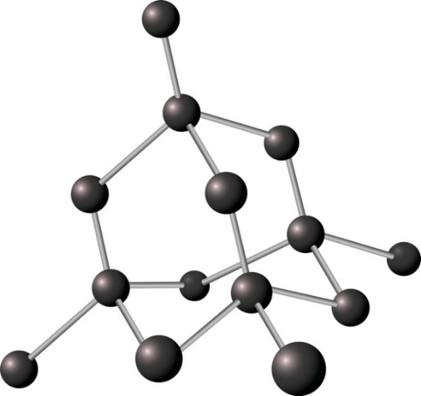

Source: © Shutterstock

* 1. Explain why diamonds are hard. Refer to bonding and structure.

____________________________________________________________________________

____________________________________________________________________________

* 1. Jewellers weigh diamonds in carats. One carat 0.200 g.

Calculate the mass, in grams, of a 2.5-carat diamond.

____________________________________________________________________________

____________________________________________________________________________

* 1. The density of diamond = 3.51 g/cm3.

Calculate the volume of a 2.5-carat diamond.

Give your answer to three significant figures.

The equation for density is:

Use the equation and your answer from **question 4(b).**

____________________________________________________________________________

____________________________________________________________________________

____________________________________________________________________________

Which question(s) did you get wrong? Why?

What will you do next time you’re asked a similar question?