**Changing the state of water scarcity**

This resource forms part of the **atomic model** topic package where you will find more resources to embed literacy skills development into your teaching. You can edit all the linked files in this resource to best suit the needs of your learners.

Learning objectives

1. Use active reading strategies to help you understand a science news story.
2. Use the glossary to support your understanding of unfamiliar words.
3. Know what key information to look for when reading a science news story.
4. Understand how people write about science differently depending on their audiences.
5. For extension – confidently talk about the science news story, with consideration for your audience.

Questions 1–3 in the student sheet support learning objectives 1 and 2. Question 6 supports learning objective 3. Questions 7–9 support learning objective 4 and the ‘Present the news’ extension task supports learning objective 5.

Introduction

Reading about science is pivotal for understanding the world around us and the events and discoveries that effect our lives. In this reading comprehension, learners will actively engage with a simple text about a research article.

*Education in Chemistry* has collated and distilled a wealth of science research news stories (see [rsc.li/4jvfRU0](https://rsc.li/4jvfRU0)). This reading comprehension resource is based on one of these stories relevant to the **atomic model** topic. This resource includes:

|  |  |  |
| --- | --- | --- |
|  | **Extension task** | |
| **Reading comprehension worksheet**  A simplified summary of a research article with comprehension questions and a glossary. | **Present the news slides**  Instructions for extension task, plus hints and reflection questions. | **Present the news script**  A script template for learners to write into in groups, and a table for reflecting on class presentations. |

Reading comprehension activity

The story text has line numbers so you can easily direct learners to particular parts of the text. These can be disabled, more information [bit.ly/4cHKkeW](https://bit.ly/4cHKkeW)

Model active reading

Read the story aloud with your learners and prompt them throughout to actively engage with the text. You can ask:

* ‘What do you think will happen next?’
* ‘How would you rephrase what’s just been said?’
* ‘What is this news story about?’

More info: [rsc.li/4jqaF3A](https://rsc.li/4jqaF3A)

Consider using playback or recording software, so that learners can listen to the text on a device as they read along.

Question 6 asks learners to write a summary of the news story for their classmates. You can work through this question as a class first, before tasking learners to draw out the required information from the text independently. You can get learners to peer mark the summaries.

Glossary of relevant terms

The glossary is pre-populated with vocabulary from the story that learners may need support with. The Education Endowment Foundation recommends prioritising teaching tier 2 and tier 3 terms, which learners are less likely to hear or read outside of their science lessons. More information: [bit.ly/4imgii2](https://bit.ly/4imgii2)

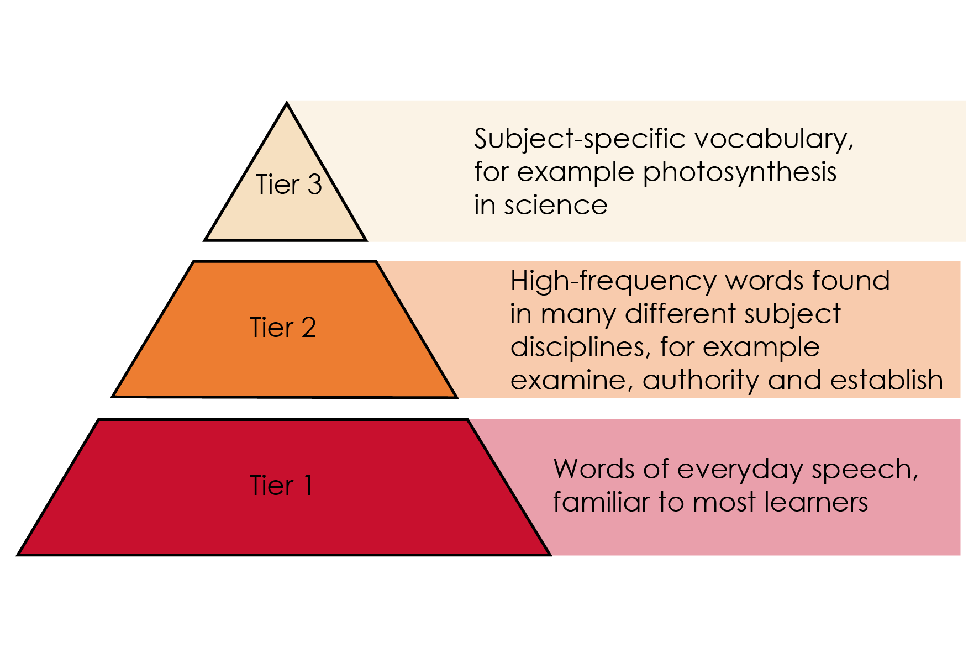

Reproduced with permission from Guilford Press, copyright 2013

The words listed in bold in the glossary are key terms and link with our key terms support resources ([rsc.li/3XTkheu](https://rsc.li/3XTkheu)). For more challenge, remove or edit entries and task learners with researching and then populating the glossary.

Accompanying resources

To answer questions 7 and 8, learners will need access to a longer and more complex version of the reading comprehension text. This is available to download and print or can be viewed online. Learners will need a printed version to annotate in question 7. See: Helping drought-hit areas ([rsc.li/3MSjNk0](https://rsc.li/3MSjNk0)).

Extension task: present the news

Instruct learners to present the science news story they have read as an item in a news programme.

Split learners into groups of three or four and assign each of them one of three roles – news anchor, reporter, or scientist. If there are more than three per group, assign multiple scientists. It’s important that everyone says something during the presentation.

* Project the ‘Present the news’ slides on the board. Explain the task (slide 2) and provide learners with printouts of what each role needs to do (slides 3–5).
* Talk through the slide called ‘What does a good news presentation look like?’ (slide 6) before inviting the groups to present (allow five minutes per group).
* Give learners the script template and direct them to prepare, as a group, what they want to say in the presentation. This will firstly involve reading the introduction on the script template, which you can do as a class if necessary. As a rough guide, allow about 45 minutes for learners to prepare.
* Direct learners to fill in the feedback sheet on the script template while their classmates are presenting. After all groups have presented, invite reflections and make notes of any learnings for the next speaking and listening activity.

Oracy Cambridge’s Oracy skills framework provides more information about speaking and listening skills. For more information, see: [bit.ly/4jBaTEG](https://bit.ly/4jBaTEG)

Metacognition

This resource supports learners to develop their metacognitive skills in three key areas.

|  |  |
| --- | --- |
| **Aspect** | **Ideas for prompts** |
| Plan | * Question 6 provides learners with a series of prompts to scaffold their summary of the science news story. * The ‘present the news’ script introduction contains questions for learners to ask themselves when planning the presentation, for example about keeping to time. |
| Monitor | * Ask learners questions when reading the text aloud (see section called ‘model active reading’) to prompt them to monitor their understanding throughout the task. * The comprehension questions prompt learners to assess how much the active reading strategies help them to understand the text, and what other strategies they can employ to aid their understanding. |
| Evaluate | * Invite feedback on answers to the metacognitive questions (in the red boxes) and collate a reading strategies ‘cheat sheet’ as a class. Revisit this cheat sheet the next time you do a reading comprehension activity. * Use the populated feedback table to reflect as a class on the strengths of the presentations and identify things to work on next time you do a class speaking and listening activity. |

Example answers and guidance

1. The particles in a gas are spread out and moving quickly. As the gas condenses the particles slow down and move closer together, arranging themselves so that they are all touching each other, but can still move over one another.
2. Larger crystals could be used to collect water from the air. As the water condenses in channels it could be collected in a container for drinking or used to water crops.
3. Condensing – when a gas is cooled, energy is transferred from the gas to the gas’ surroundings and the gas turns into a liquid.
4. Sublimes – when a solid is heated, gains energy and turns into a gas, without turning into a liquid first.
5. Scarcity – a situation in which something is not easy to find or get.

Learners rate how much the glossary is helping them. Do a rough show of hands to gauge confidence and note learners’ responses.

1. Scientific words: crystals, condensing, subliming, organic, sublimes, gas, particles.

The point of this exercise is to prompt learners to consider which potentially unfamiliar words are specific to science or chemistry, compared to e.g. connecting words. The list above is an example and there may be variation in answers.

1. Look for a good understanding of the key message in the story. Example answer – water, condensing, crystals, harvest, scarcity.

Learners rate how much circling words is helping them. Do a rough show of hands to gauge confidence and note learners’ responses.

Learners rate their confidence explaining the story. Do a rough show of hands to gauge confidence and note learners’ responses. Ask learners to share their strategies for the benefit of the class.

How learners rate the techniques in questions 3 and 4, and their confidence to explain the story, can inform your approach to future reading comprehension activities.

1. Ask learners to share what they have learned from reading the news article.
2. Indicative answers for summary of story.

* *What have the scientists discovered? (Findings)*

That water can condense from the air onto crystals.

* *What was the problem they were trying to solve? (Context)*

Combating a lack of water in desert areas or areas where normal water supply has been disrupted or contaminated.

* *Why does their discovery matter? (Relevance/application)*

It could provide water to people living in hot regions for drinking or to use for watering crops.

Climate change means that more areas are becoming hot and more people are suffering from drought.

It could also be used in areas after a natural disaster when there is no running water available.

* *Think about who it matters to, and what impact it could have for them. (Impact)*

People and animals living in areas where there isn’t a reliable supply of clean drinking water.

1. Learners should highlight the full article in different colours using the prompts. See the highlighted text below as an example.

* What have the scientists discovered? (Findings)
* What was the problem they were trying to solve? (Context)
* Why does their discovery matter? (Relevance/application)
* Think about who it matters to, and what impact it could have for them. (Impact)

**Science turns the taps on in drought-hit areas**

Original article by Rebecca Trager. Adapted by Nina Notman.

**Harvesting water directly from air offers a potential method that could fight water scarcity caused by climate change**

Scientists have observed water spontaneously condensing and moving across the surface of an organic crystal that is slowly subliming. This finding could pave the way for a new approach to collecting drinking water from the air in arid regions.

Nearly two-thirds of the global population currently live in regions with severe fresh water shortages for at least one month each year. Climate change will see even more people affected by drought in the future. Technical solutions are increasingly being sought to supply water to those in need.

**Sublime secrets**

Researchers are particularly keen to develop tools to tap into water supplies in the air. This is a vast resource, with many times more water existing as vapour in the atmosphere than liquid water in our rivers at any given moment. Researchers at New York University Abu Dhabi in the United Arab Emirates hope their observations will lead to a novel way to harvest water vapour.

The scientists made their findings when studying the surface of crystals of hexachlorobenzene, a fungicide banned worldwide. They noticed that water droplets were condensing on the surface of the crystals. They also observed that the water droplets were triggering the solid hexachlorobenzene to be slowly converted into vapour – a process called sublimation. The team saw that the sublimation caused tiny channels to form on the crystal surface, and that the water droplets were being funnelled along these channels in a single direction.

‘This [directional movement] was found to be caused by changes in the width of small channels over time,’ the research team noted in their paper.

The research team suggest that this previously unseen phenomenon could inspire new technologies for the collection of water vapour from the air that do not require electricity. Situations in which passive water harvesting could be helpful include disaster relief, where normal drinking water supplies are disrupted or contaminated, and military operations in remote locations.

* The article is longer.
* It contains more details about the crystals.
* It contains quotes from scientists.
* It gives examples of why the research was being done and where it could be useful
* It has subheadings.

1. Look out for an awareness of different writing formats and an appreciation that different audiences have different needs or interests, for example:
2. shorter version, links to other interesting articles, key message up front, relevant pictures or video clips;
3. longer version, lots of detail, including information on who did the research and maybe their contact information;
4. simplifying complicated language, pictures to aid understanding.

Example script for Present the news

|  |  |  |
| --- | --- | --- |
| **Role** | **What to communicate** | **Example script** |
| News anchor | Introduce the issue in one sentence. | A lack of water is a problem in many parts of the world. |
| News anchor | Introduce the resolution. So, briefly say that scientists may have solved the problem. | Scientists have discovered a way of collecting water from the air using crystals. |
| News anchor | Introduce your classmate reporter who will provide more information. | Our reporter (name of learner) has been investigating. |
| Reporter | Talk about the problem and its context in more detail. | Two thirds of the global population live in areas with severe freshwater shortages for at least one month of each year. This could increase as climate change continues to cause global temperature increases. |
| Reporter | In one sentence, introduce the scientist(/s) and say what they have done to solve the problem. | Here is (learner name) to tell us about their work obtaining water from the air. |
| Reporter | Ask the scientist your first question to explain what they’ve discovered. | Tell us what did you and your team discover? |
| Scientist | Answer the first question. | We noticed that water droplets were condensing on the surface of some crystals we were studying, and then causing the crystals to sublime which created channels for the water to collect in. |
| Reporter | Ask the scientist why the discovery is important. | Why is this discovery so important? |
| Scientist | Explain what a difference this research could make to people and where it might be used. | It could allow us to collect water from the air without using electricity. This is especially important in areas that may have been hit by natural disasters, or where there are long term problems accessing fresh water. |
| Reporter | Ask the scientist what they need to do or find out next, to move the research forward towards having a real impact on people. | What are the next steps in your research? |
| Scientist | Tell the reporter what else needs to be done or found out in order to move closer to this discovery having a real impact on people. | We need to see if this can be scaled up to produced large amounts of water from the air and if this can be collected easily to allow people to drink it.  We would also like to know if this works with other crystals too.  And further down the line, we’d need to test any water captured by this method to make sure it would be safe to drink or use. |
| Reporter | Thank the scientist. | Thank you so much for your time today. |
| Scientist | Acknowledge the thanks. | No problem, thank you for having me. |
| News anchor | Say something in response to what the scientist and the reporter have said, which reflects what your audience might be thinking. Thank the reporter. This will end the presentation. | Thank you to our reporter (learner name) for that report. A really exciting new technique which could save lives in areas facing long term droughts or emergency situations. |

Acknowledgements

Vocabulary tier diagram: Beck, Isabel L., Margaret G. McKeown, and Linda Kucan. *Bringing Words to Life: Robust Vocabulary Instruction*. New York: Guilford Press, 2013.