Structure and bonding of carbon

Scientists experimented for many years to remove a single layer of carbon atoms from graphite. They predicted that it would have very useful properties. After many expensive experiments, they eventually succeeded using common sticky tape to remove a layer of carbon atoms from a lump of graphite. This single layer was named graphene.

1. This is an electron microscope image of graphene.

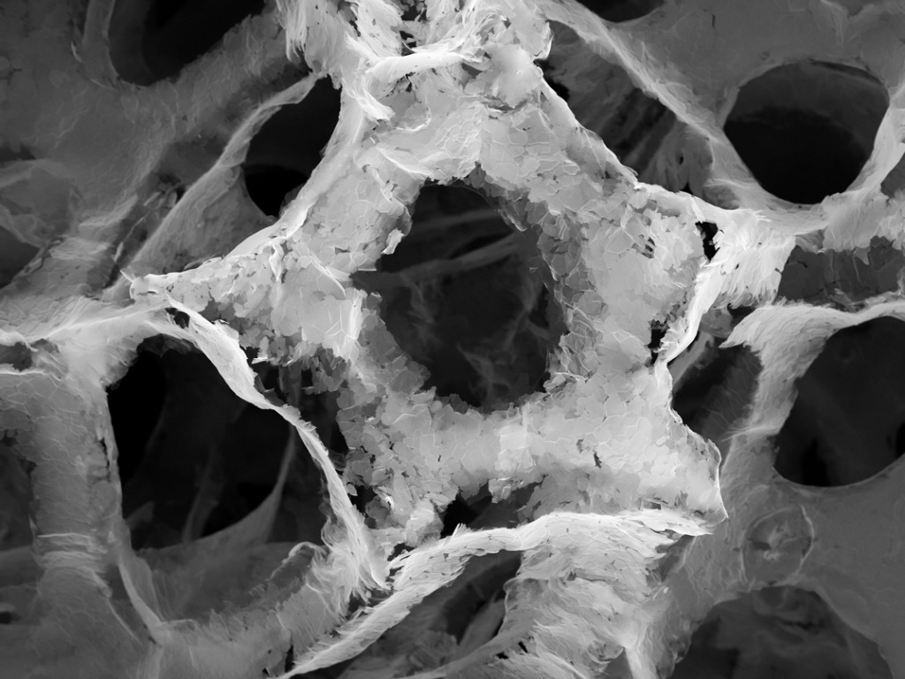

Source: © Shutterstock

* 1. What do each of the following represent in the image?

1. The lighter hexagonal shapes

____________________________________________________________________

1. The darker spaces

____________________________________________________________________

* 1. Explain why it was easy to remove a layer of carbon atoms from graphite.

____________________________________________________________________________

____________________________________________________________________________

____________________________________________________________________________

Diagram A shows the structure of graphene and diagram B shows the structure of graphite.

|  |  |
| --- | --- |
| Diagram A  A two-dimensional diagram showing many hexagons all joined together and made up of six spheres joined by grey lines.  Source: © Shutterstock | Diagram B  Three separate layers of six hexagons all joined together and made up of six spheres joined by grey lines. There are dashed lines drawn between the three layers to represent the forces between them.  Source: © Shutterstock |

* 1. Explain why graphene is usually represented by a 2D diagram, while graphite is represented by a 3D diagram.

____________________________________________________________________________

____________________________________________________________________________

____________________________________________________________________________

____________________________________________________________________________

* 1. Sheets of graphene are 0.345 nm thick.

What is the thickness of a sheet of graphene in metres?

Hint: remember,

____________________________________________________________________________

____________________________________________________________________________

* 1. A sample of graphite is three layers thick. The distance between the layers is 3.40 nm. Calculate the thickness of the sample of graphite. Give your answer in nanometres (nm).

____________________________________________________________________________

____________________________________________________________________________

1. In the 1980s scientists were investigating carbon atoms in deep space. What they found was so surprising, they thought they had made a mistake. They had discovered Buckminsterfullerene, C60.
   1. Name the type of structure in:
2. diamond
3. graphite
4. Buckminsterfullerene
   1. The molecular formula of Buckminsterfullerene is C60. Calculate its relative formula mass.

*A*r carbon 12

____________________________________________________________________________

____________________________________________________________________________

* 1. What is the mass of one mole of C60 molecules?

____________________________________________________________________________

* 1. How many molecules are present in one mole of C60 molecules?

____________________________________________________________________________

* 1. The diameter of a C60 molecule is 1.1 nm. The diameter of a Premier League football is 0.22 m. How many times larger is the diameter of the football than a C60 molecule?

________________________________________________________________________________________________________________________________________________________

____________________________________________________________________________

1. Scientists think the first diamonds were discovered in caves in India nearly 4000 years ago. They were valued for their hardness, strength and brilliance.

This is a representation of the structure of diamond.

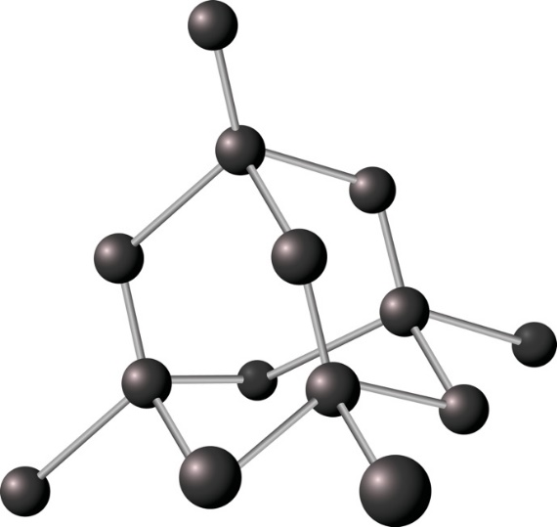

Source: © Shutterstock

* 1. Explain why diamonds are hard. Refer to bonding and structure.

____________________________________________________________________________

____________________________________________________________________________

____________________________________________________________________________

* 1. Jewellers weigh diamonds in carats. One carat 0.200 g.

Calculate the mass in grams of a 2.5-carat diamond.

____________________________________________________________________________

____________________________________________________________________________

* 1. Calculate the number of moles of carbon atoms in a 2.5 carat diamond.

*A*r carbon 12

____________________________________________________________________________

____________________________________________________________________________

* 1. Calculate the number of carbon atoms in a 2.5 carat diamond.

Hint: Avogadro constant

____________________________________________________________________________

____________________________________________________________________________

Which question(s) did you get wrong? Why?

What will you do next time you’re asked a similar question?