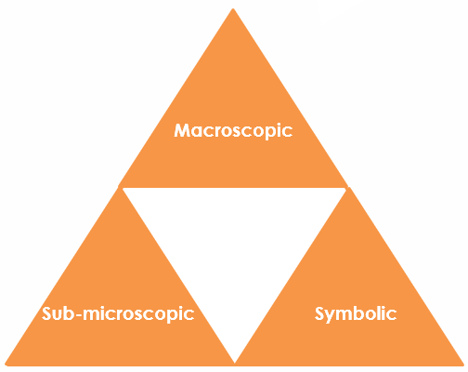Carbon allotropes: Johnstone’s triangle

Learning objectives

1. Describe two different carbon allotropes based on observations.
2. Use symbolic models to represent carbon allotropes.
3. Explain how the different bonding in carbon allotropes relates to their properties.

Introduction

Carbon forms giant covalent compounds that have very different properties according to the arrangement of the atoms.

Johnstone’s triangle

In chemistry we make sense of the things that we can see by representing what we can’t see using formulas, equations, diagrams and models.

Johnstone’s triangle is a way of thinking about these different concepts as different corners of a triangle:

* Macroscopic – what we can see. Think about the properties we can observe, measure and record.
* Sub-microscopic – smaller than we can see. Think about the particle or atomic level.
* Symbolic – representations. Think about how we represent chemical ideas including symbols and diagrams.

Being able to connect and move between these three different levels is important for scientific understanding.

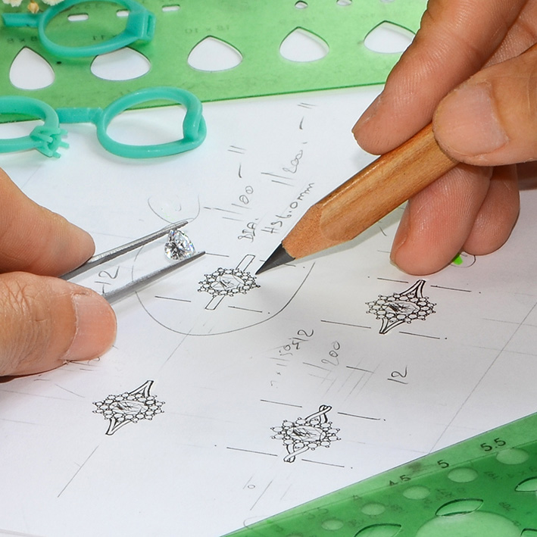

Macroscopic – what we can see

Describe the following allotropes, their properties and uses:

* Diamond

* Graphite pencil

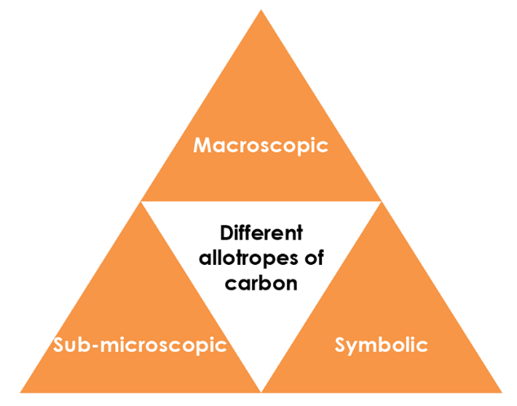

Symbolic – representations

Label the following on the diagrams below:

* Carbon atom
* Covalent bond
* Intermolecular force

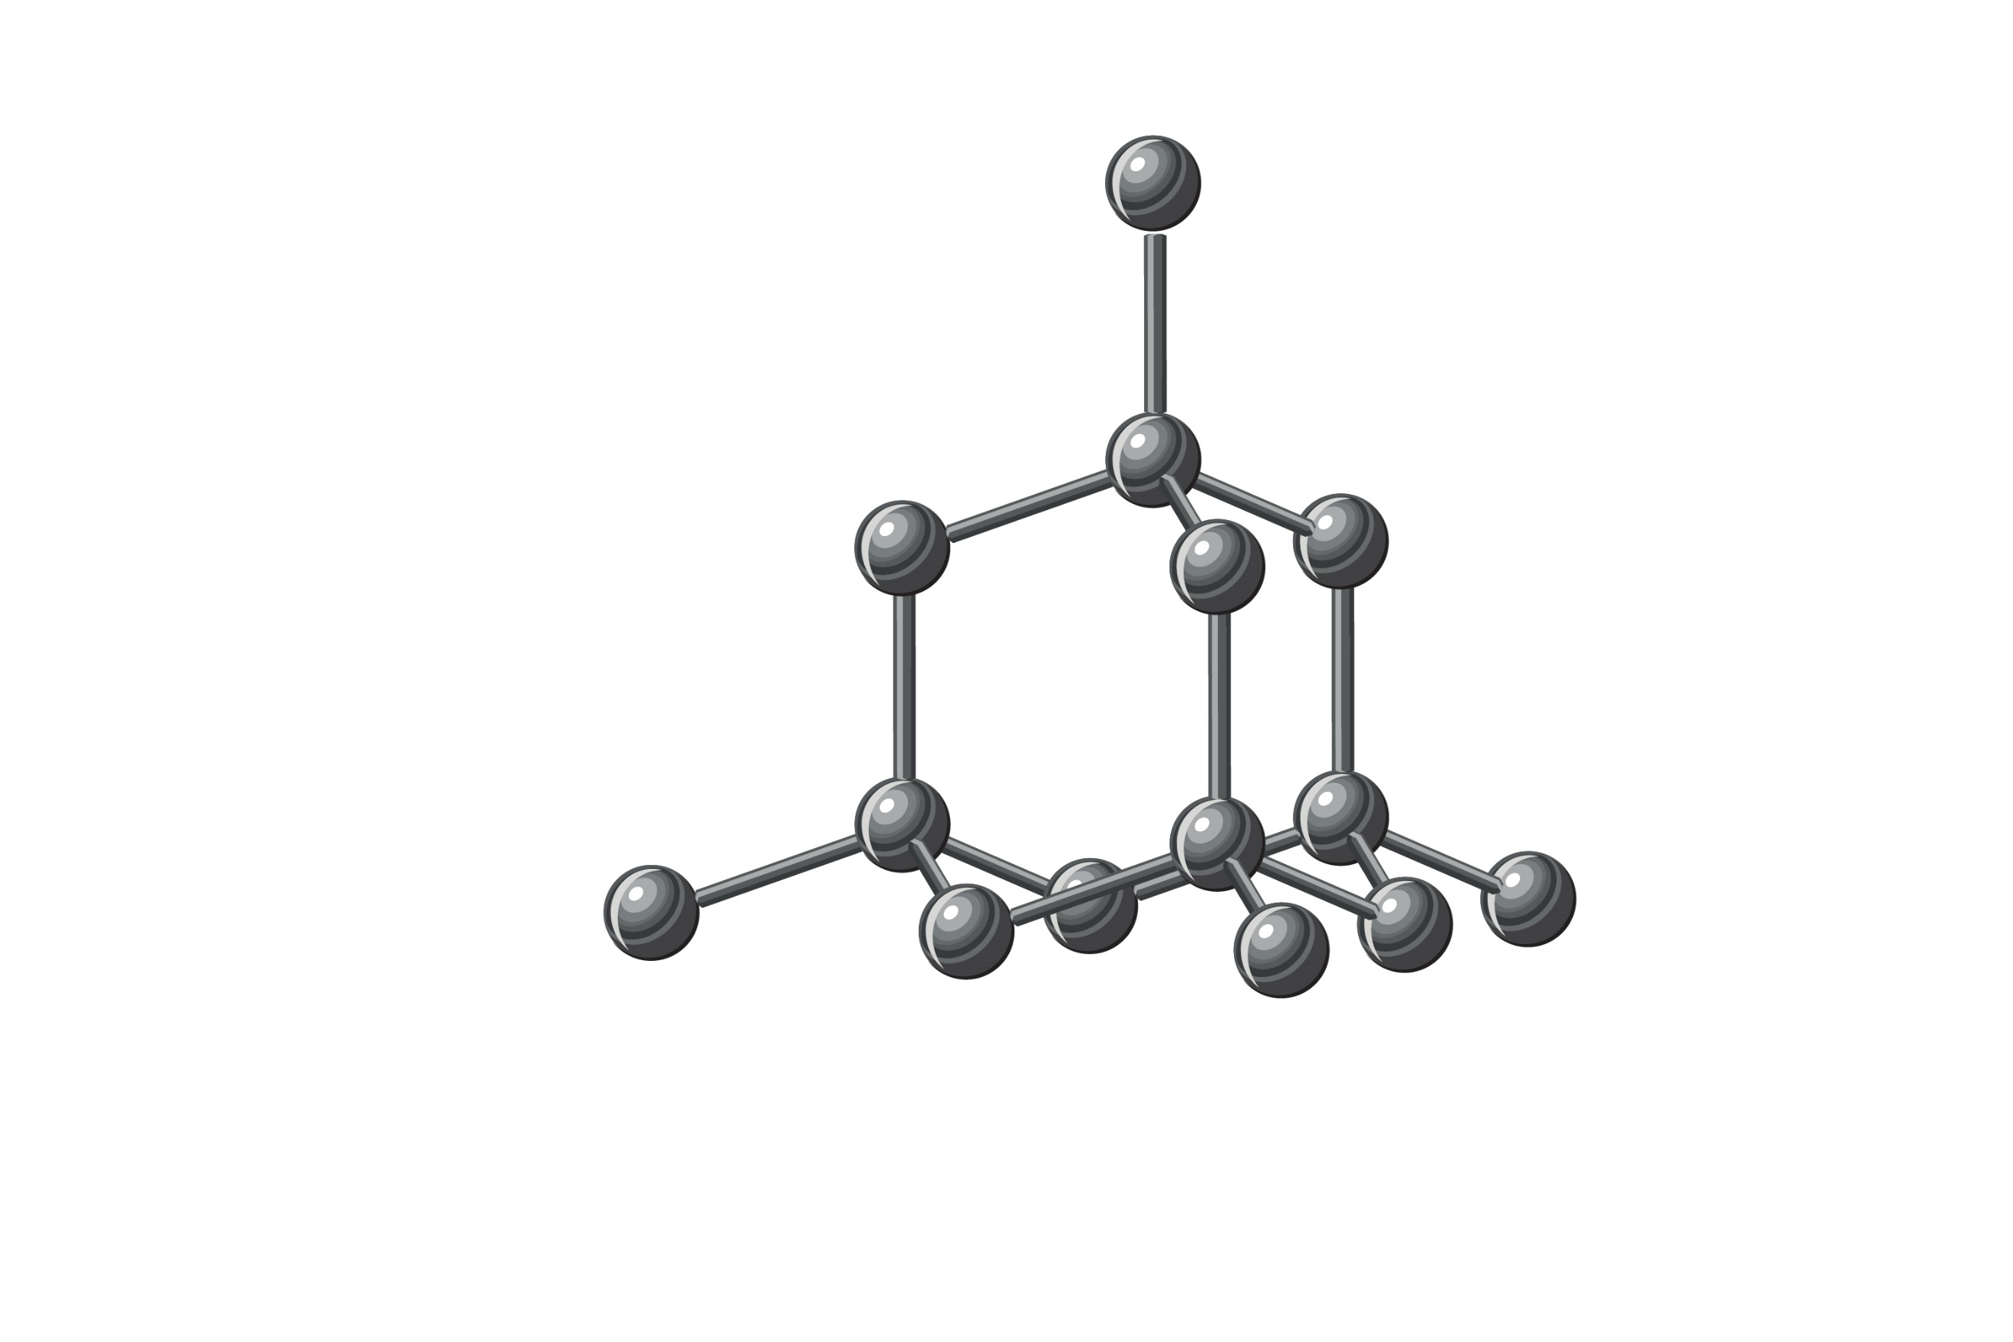

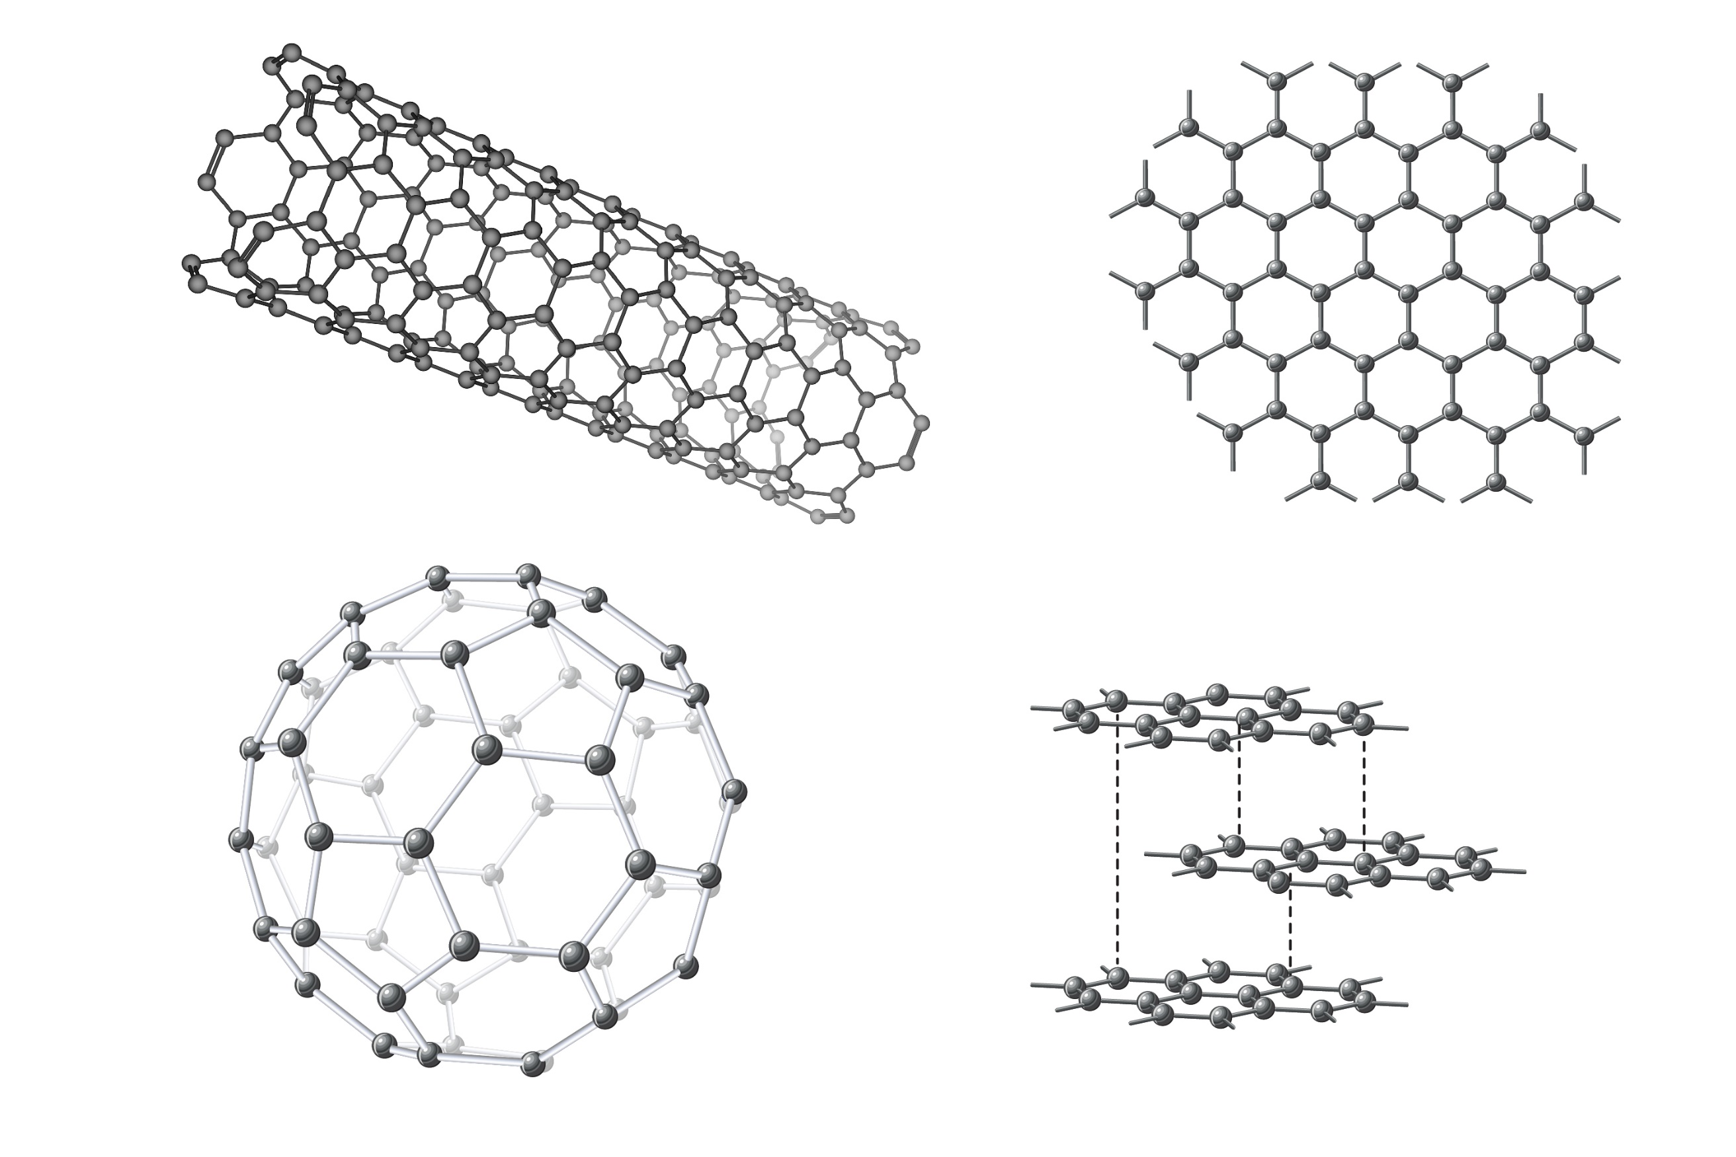

Sub-microscopic – smaller than we can see

Complete the table below by writing ‘diamond’, ‘graphite’, or ‘both’ in the final column:

|  |  |
| --- | --- |
| Made of only one type of atom. |  |
| Has a giant covalent structure. |  |
| Contains delocalised electrons. |  |
| Each carbon atom is bonded to three other carbon atoms. |  |
| Each carbon atom is bonded to four other carbon atoms. |  |
| Formed of flat sheets of linking hexagons. |  |
| Formed of a 3D lattice of repeating tetrahedrons. |  |