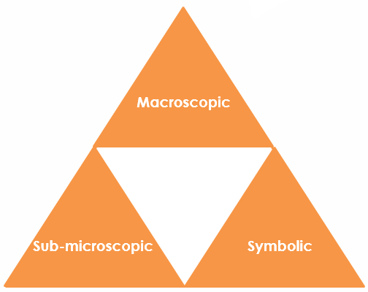Isotopes of hydrogen: Johnstone’s triangle

Learning objectives

1 Determine the number of protons, neutrons and electrons in an atom from the atomic symbol.

2 Recognise similarities and differences in the number of protons, neutrons and electrons between atoms and their different isotopes.

Introduction

Many elements have different isotopes. These are forms of the same element that have different numbers of neutrons, leading to the differing masses of the isotopes.

Johnstone’s triangle

In chemistry we make sense of the things that we can see by representing what we can’t see using formulas, equations, diagrams and models.

Johnstone’s triangle is a way of thinking about these different concepts as different corners of a triangle:

* Macroscopic – what we can see. Think about the properties we can observe, measure and record.
* Sub-microscopic – smaller than we can see. Think about the particle or atomic level.
* Symbolic – representations. Think about how we represent chemical ideas, including symbols and diagrams.

Being able to connect and move between these three different levels is important for scientific understanding.

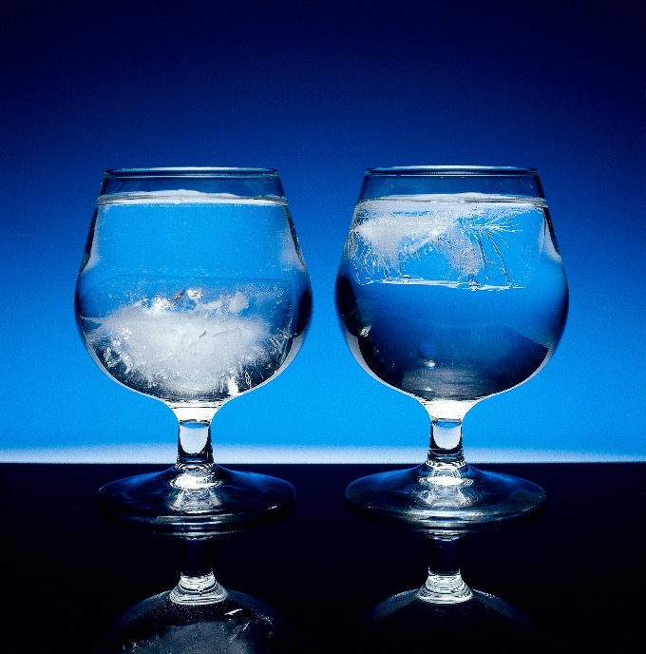

Macroscopic – what we can see

Look at the image. It shows an ice cube made of ‘heavy water’ () in a glass of water. has the same structure as water, but with the hydrogen atom () replaced by deuterium ().   
What do you notice about the position of the ice cube?   
  
  
Is this what you would expect?

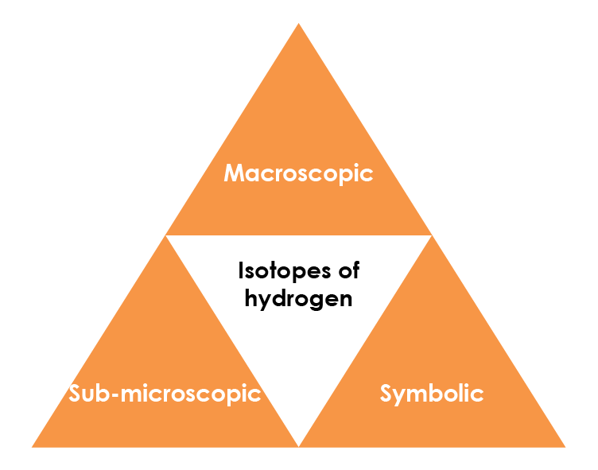

© Charles D. Winters/Science Photo Library

Symbolic – representations

We show the number of subatomic particles using atomic symbols. Hydrogen exists as two different naturally occurring isotopes, , and .

Complete the table to show the number of each subatomic particle in these isotopes:

|  |  |  |  |
| --- | --- | --- | --- |
|  | **Protons** | **Neutrons** | **Electrons** |
|  |  |  |  |
|  |  |  |  |
|  |  |  |  |

Sub-microscopic – smaller than we can see

Complete the following sentences about atoms and isotopes.

Isotopes of the same element have the same number of ___________________ and ____________________ but different numbers of ____________________.

This means the __________________________ of different isotopes is the same but the __________________________ differs.

If the proton number is different it is a different ____________________.