Particle diagrams

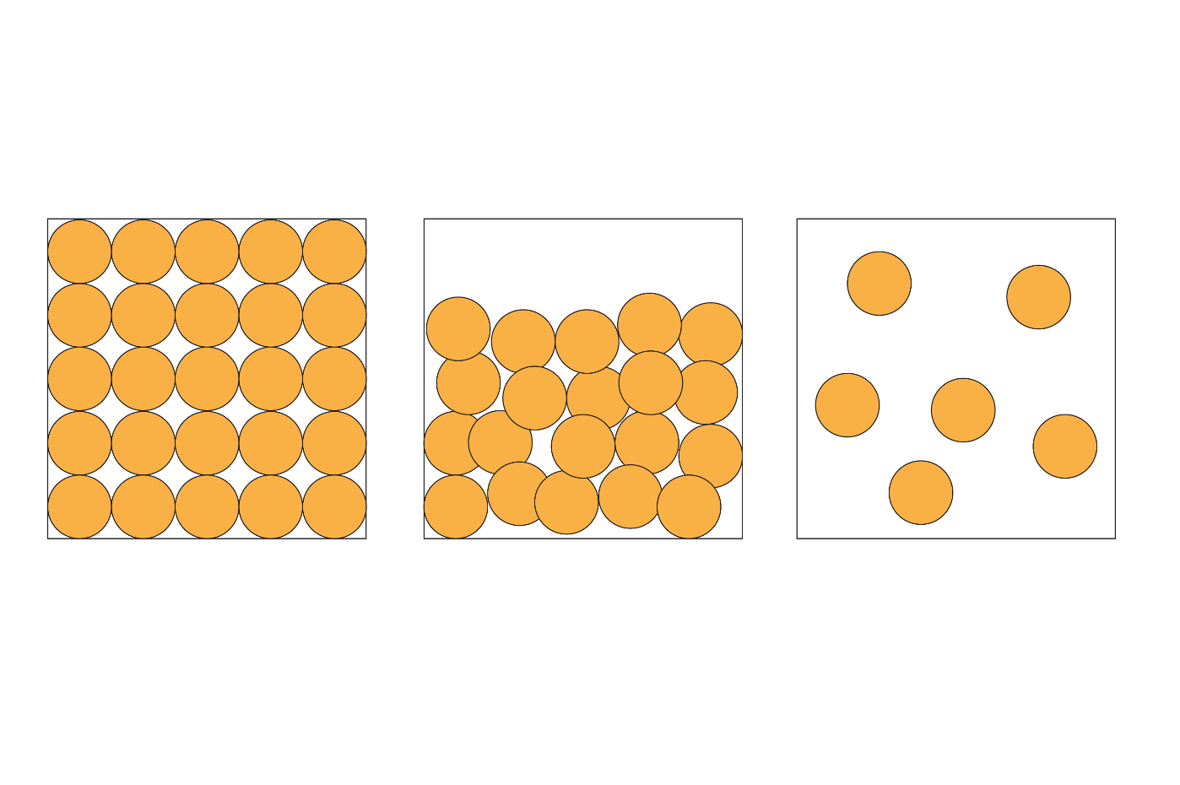These 2D diagrams represent particles in a solid, a liquid and a gas.

**solid liquid gas**

1. The circles in the diagrams can represent different types of particles.
   1. Name **two** different particles the circles could represent.

____________________________________________________________________________

_____________________________________________________________________________

(2 marks)

(b) Explain why the following features of the particle diagrams are limitations of the particle model:

1. The particles are represented as spheres.

_____________________________________________________________________________________________

_____________________________________________________________________________________ **(1 mark)**

1. The particles are solid.

_____________________________________________________________________________________________

_____________________________________________________________________________________ **(1 mark)**

1. The particles are all the same size.

_____________________________________________________________________________________________

_____________________________________________________________________________________ **(1 mark)**

1. The diagrams can be used to explain some properties of solids, liquids and gases.
   1. Which diagram(s) suggest each of the following properties?
2. Particles can flow.

_____________________________________________________________________________________ **(1 mark)**

1. Particles vibrate in a fixed position.

_____________________________________________________________________________________ **(1 mark)**

1. Particles can be easily compressed.

_____________________________________________________________________________________ **(1 mark)**

1. Substance has a low boiling point.

_____________________________________________________________________________________ **(1 mark)**

* 1. Which diagram represents the substance with the strongest forces between the particles?

_____________________________________________________________________________________ **(1 mark)**

1. The diameter of a helium atom is 0.064 nm. The average distance between helium atoms at standard temperature and pressure (stp) is about 3.0 nm.
   1. Calculate the ratio of the diameter of a helium atom to the distance between helium atoms at stp. Give your answer to three significant figures.

____________________________________________________________________________________**(2 marks)**

* 1. Suggest another limitation of the particle diagrams shown by your answers to **question** **3(a)**.

_____________________________________________________________________________________**(1 mark)**

1. Particle diagrams can be used to show changes of state.
   1. State why changes of state are physical changes and not chemical changes.

_____________________________________________________________________________________**(1 mark)**

* 1. Complete the table showing changes of state.

|  |  |
| --- | --- |
| **Change of state** | **Term describing change of state** |
| solid to liquid |  |
|  | boiling |
| gas to liquid |  |
|  | freezing |
| solid to gas |  |

(5 marks)

* 1. Describe how each of the following factors change when a substance changes from a solid, to a liquid and then to a gas:

1. the energy of the particles

_____________________________________________________________________________________**(1 mark)**

1. the movement of the particles.

________________________________________________________________________________________________________________________________________________________________**(2 marks)**

1. The particle model assumes that all particles are independent of each other. In fact, there are forces between the particles.
   1. Name the forces between the particles in:
2. solid copper metal

_____________________________________________________________________________________ **(1 mark)**

1. liquid water

_____________________________________________________________________________________ **(1 mark)**

1. oxygen gas

_____________________________________________________________________________________ **(1 mark)**

* 1. State how the strength of the forces between particles affects the following:

1. melting and boiling points

____________________________________________________________________________

_____________________________________________________________________________________ **(1 mark)**

1. the movement of the particles

____________________________________________________________________________

_____________________________________________________________________________________ **(1 mark)**

[Total: 27 marks]

Which question(s) did you get wrong? Why?

What will you do next time you’re asked a similar question?