Carbon allotropes: Johnstone’s triangle

This resource is from the **Johnstone’s triangle series** which can be viewed at: [rsc.li/3WUOFVK](https://rsc.li/3WUOFVK). It will help learners understand the different ways you need to think in chemistry, building their mental models and understanding.

Learning objectives

1. Describe two different carbon allotropes based on observations.
2. Use symbolic models to represent carbon allotropes.
3. Explain how the different bonding in carbon allotropes relates to their properties.

How to use Johnstone’s triangle

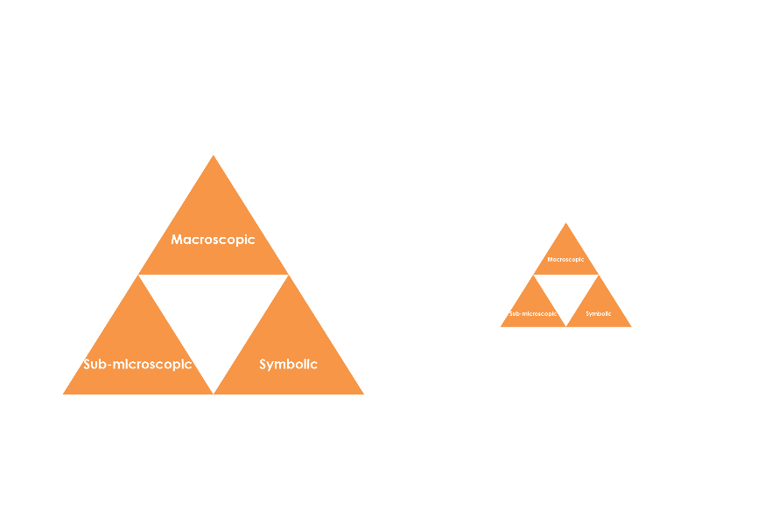Use Johnstone’s triangle to develop learners’ thinking about scientific concepts at three different conceptual levels:

* Macroscopic – what we can see. Think about the properties we can observe, measure and record.
* Symbolic – representations. Think about how we represent chemical ideas including symbols and diagrams.
* Sub-microscopic – smaller than we can see. Think about the particle or atomic level.

For learners to gain a deeper awareness of a topic, they need to understand it at all three levels.

When introducing a topic, do not try to introduce all of the levels of thinking at once. This will overload working memory. Instead complete the triangle over a series of lessons, beginning with the macroscopic level and introducing other levels, in turn, once secure.

All of the levels are interrelated, for example, learners need visual representation of the sub-microscopic in order to develop mental models of the particle or atomic level.

Find further reading about Johnstone’s triangle and how to use it in your teaching at [rsc.li/3X08N96](https://rsc.li/3l0g6sR).

Scaffolding

It is important to share the structure of the triangle with learners prior to use. Tell them why you want them to use the triangle and how it will help them to develop their understanding. Use an ‘I try, we try, you try’ approach when you are introducing Johnstone’s triangle for the first time.

More resources

To further develop learner’s thinking in all areas of Johnstone’s triangle, try our **Developing understanding** worksheets ([rsc.li/3YaxFKB](https://rsc.li/3YaxFKB)). These include icons in the margin referring to the conceptual level of thinking needed to answer the question.

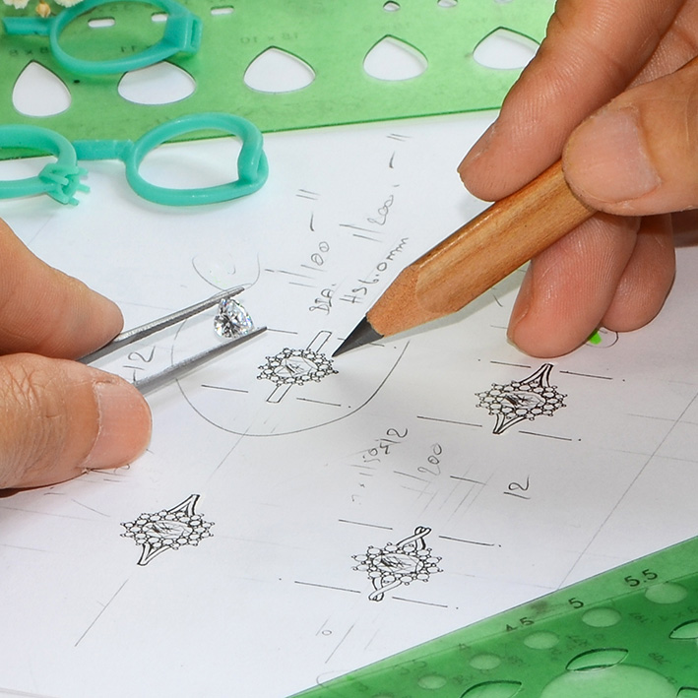

Macroscopic – what we can see

Describe the following allotropes, their properties and uses:

* Diamond **Transparent crystal, highly reflective, very hard,   
  electrical insulator. Used for decoration and industrial cutting.**
* Graphite **Black/grey solid with a metallic lustre. Soft, conducts   
  electricity. Used for pencils, lubricants and electrodes.**

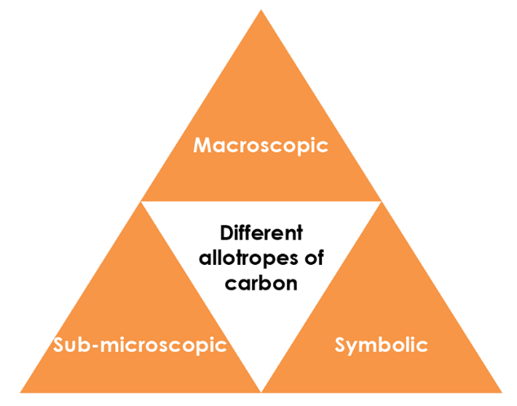

Symbolic – representations

Label the following on the diagrams below:

* Carbon atom
* Covalent bond
* Intermolecular force

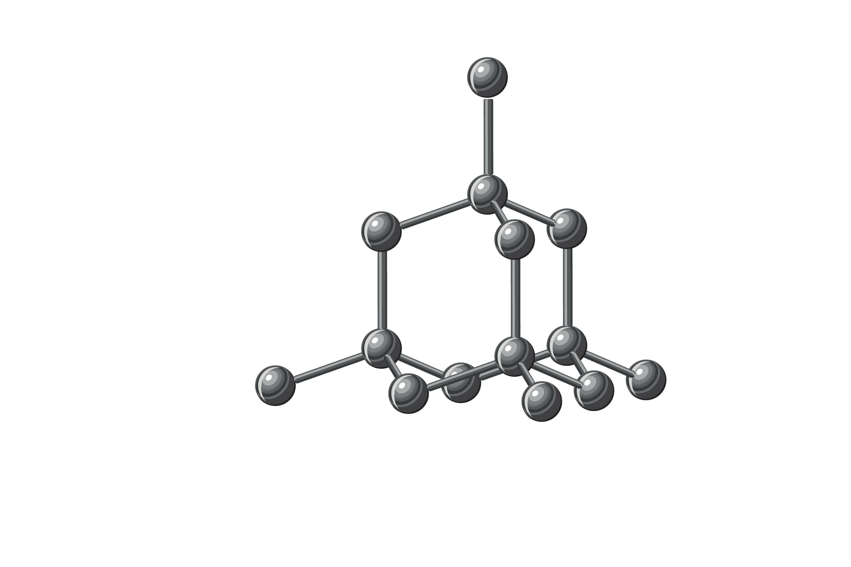

A ball-and-stick diagram showing three flat sheets of atoms bonded together in a pattern of hexagons with hanging bonds at the outer edges. Between the sheets, which are arranged horizontally, there are vertical dotted lines.
One of the spheres is labelled 'Carbon atom', one of the solid horizontal lines  between is labelled 'Covalent bond' and one of the vertical dotted lines is labelled 'Intermolecular force'

Sub-microscopic – smaller than we can see

Complete the table below by writing ‘diamond’, ‘graphite’, or ‘both’ in the final column:

|  |  |
| --- | --- |
| Made of only one type of atom. | **Both** |
| Has a giant covalent structure. | **Both** |
| Contains delocalised electrons. | **Graphite** |
| Each carbon atom is bonded to three other carbon atoms. | **Graphite** |
| Each carbon atom is bonded to four other carbon atoms. | **Diamond** |
| Formed of flat sheets of linking hexagons. | **Graphite** |
| Formed of a 3D lattice of repeating tetrahedrons. | **Diamond** |

**Intermolecular force**

**Covalent bond**

**Carbon atom**

**Carbon atom**

**Covalent bond**