Microscale electrolysis

These technician notes are part of a collection of microscale chemistry resources at: [**rsc.li/4iiIjbl**](https://rsc.li/4iiIjbl)**.** Integrated instructions for this experiment are available from **rsc.li/3CLTZDk.**

Introduction

This experiment is ideally suited to lessons on electrolysis and displacement of halogens for learners aged 11–16.

Equipment (per group)

* Copper chloride (0.5 mol dm-3), approx. 1 ml
* Potassium iodide (0.1 mol dm-3), few drops
* Potassium bromide (0.1 mol dm-3), few drops
* Blue litmus paper (damp)
* Petri dish, with two holes in the sides for electrodes to pass through
* 2 x carbon fibre electrodes, 1 mm diameter (kite rods work well)
* 2 x crocodile clips or connector blocks (cut to size)
* 2 x electrical leads
* 9 V battery or 9 V DC power supply
* 4 x pipettes (or dropper bottles for solutions)
* Print out of integrated instructions

Safety equipment

* Eye protection: safety glasses to EN166 F

Equipment set-up

To carry out this experiment, each group will require a Petri dish with two holes drilled through. If access to a drill is problematic, you can make the holes using a hot needle heated in a Bunsen burner flame. By conducting this experiment on a microscale in a Petri dish, you will significantly reduce the risks associated with the production of chlorine gas.

You can use a holder made from Corriflute or Perspex. The holders are optional, but they do provide stability and help to hold the electrodes in the correct position. If not, use a small piece of adhesive putty (such as Blu Tack) to keep the electrodes in place.

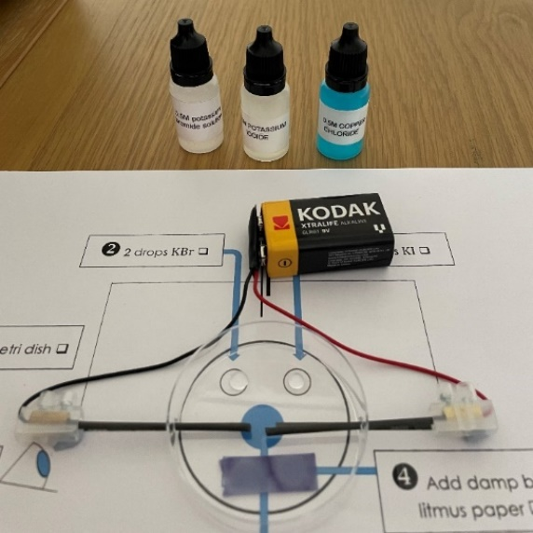

Method

1. Arrange the electrodes so that they are in the centre of the Petri dish about 1 cm apart. Place the Petri dish on top of a labelled diagram to make it easier to record your observations. **Note**: do not connect to the power supply until you are ready to start the experiment as chlorine gas could be released into the room.
2. Add two drops of potassium bromide solution to one side of the Petri dish.
3. Add two drops of potassium iodide solution to the Petri dish. This should be on the same side as the potassium bromide but not close enough for the chemicals to mix.
4. Dampen a piece of blue litmus paper and place on the other side of the Petri dish.
5. Add 3–4 drops of copper chloride solution to the reaction vessel so that it covers both the electrodes.
6. Place the lid on the Petri dish.
7. Finally, connect the wires to the power supply. Clip the crocodile clips onto the electrodes (or use connector blocks) and observe.

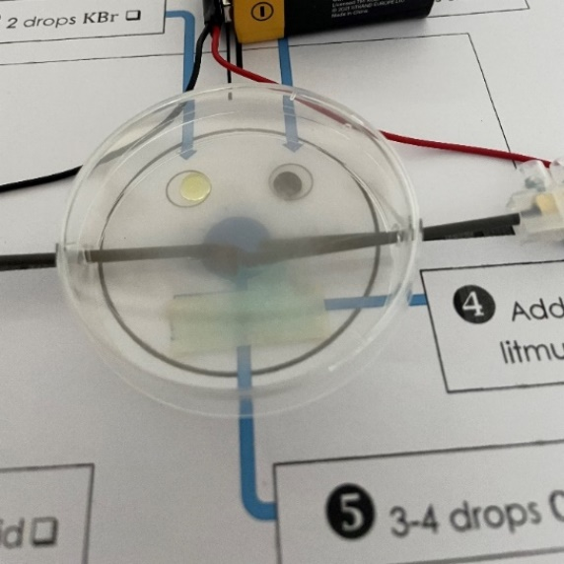

Expected results

The image below shows the expected results at the end of the experiment.

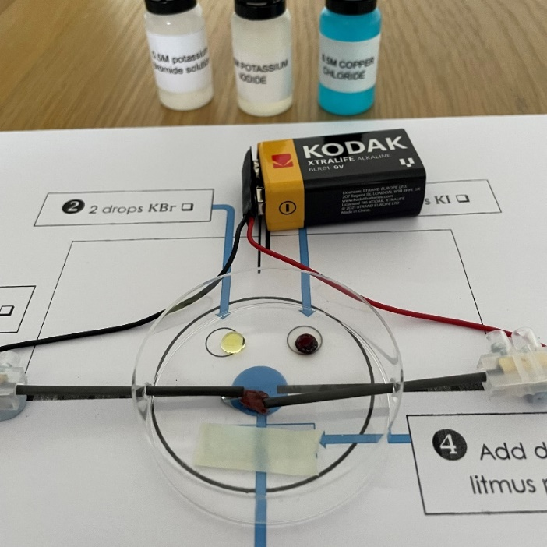

* An orange/brown solid can be observed forming at the negative electrode, in this experiment the solid produced is copper.
* Bubbles can be observed at the positive electrode indicating the formation of a gas, in this example the gas is chlorine.
* The drop of potassium bromide acts as an indicator, changing from colourless to orange as chlorine displaces the bromide ions and produces bromine.
* The drop of potassium iodide also acts as an indicator, changing from colourless to brown as chlorine displaces the iodide ions and produces iodine.
* The damp blue litmus paper is bleached, indicating the presence of chlorine.

Safety

* Read our standard health and safety guidance ([rsc.li/3zyJLkx](https://royalsocietychemistry.sharepoint.com/sites/TeamRSCEducation/Shared%20Documents/Education%20coordinators/ITE%20-%20Initial%20teacher%20education/ITE%20Microscale%20focus%20(presentation)/Microscale%20updates/Electrolysis/rsc.li/3zyJLkx)) and carry out a risk assessment before running any live practical.
* Please note that although working on a microscale reduces the amount of chlorine gas produced, some will still be present in the environment. To mitigate this risk, make sure you are working in a well-ventilated area. Chlorine gas is oxidising, toxic and dangerous to the environment, see CLEAPSS Hazcard HC022.

Oxidising (Symbol: flame over circle)Acute toxicity (Symbol: skull and crossbones)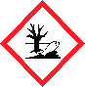

|  |  |
| --- | --- |
| **Chemical supplied for the practical** | **Preparation** |
| Copper chloride, 0.5 mol dm-3  CuCl2.2H2O(aq)  Not currently classified as hazardous.  CLEAPSS Hazcard 027A. | Copper chloride, solid or hydrated copper chloride  CuCl2.2H2O(s)  MW = 170.48 g mol-1  Health hazard (Symbol: exclamation mark)Hazardous to the Environment - CLP Hazard Pictogram  WARNING  Harmful if swallowed. Causes skin irritation. Causes serious eye irritation. May cause respiratory irritation. Very toxic to aquatic life. Long-lasting damage to fish.  To prepare 100 cm3 of 0.5 mol dm-3 copper chloride solution: wear eye protection. Weigh out 8.52 g of copper(II) chloride. Add the solid to about 75 cm3 of water in a beaker or laboratory jug. Stir to dissolve (warm gently if necessary – use a glass beaker). If you have used a beaker, pour the solution into an appropriately sized measuring cylinder or laboratory jug and add water to 100 cm3. Mix well. Pour the solution into a labelled bottle.  CLEAPSS recipe sheet RB031. |
| Potassium iodide 0.1 mol dm-3  KI(aq)  Not currently classified as hazardous but can be irritating to eyes.  CLEAPSS Hazcard 047b.  Technician tip: store in dark bottles or add a couple of sodium thiosulfate crystals to a solution that has become slightly yellow – although the colour will not affect the outcome of the practical. | Potassium iodide  KI(s)  MW = 166.00 g mol-1  To prepare 100 cm3 of 0.1 mol dm-3 solution of potassium iodide: wear goggles. Weigh out 1.66 g of potassium iodide and add to 75 cm3 of distilled water with stirring. Once dissolved make up to 100 cm3.  CLEAPSS recipe sheet 072. |
| Potassium bromide 0.1 mol dm-3  KBr(aq)  Not currently classified as hazardous but can be irritating to eyes.  CLEAPSS Hazcard 047b. | Potassium bromide  KBr(s)  MW = 119.00 g mol-1  To prepare 100 cm3 of 0.1 mol dm-3 of potassium bromide,first make 100 cm3 of 1 M stock.  Wear eye protection. Weigh out  11.9 g of potassium bromide. Add the solid to about 75 cm3 of water in a beaker or laboratory jug. Stir to dissolve (warm gently if necessary – use a glass beaker). If you have used a beaker, pour the solution into an appropriately-sized measuring cylinder or laboratory jug and add water up to 100 cm3. Mix well. Pour the solution into a labelled bottle.  CLEAPSS recipe sheet 068. |

Disposal

At the end of the experiment:

* Clean the negative electrode with either sandpaper or wire wool, if necessary, to remove the copper deposits.
* Place the Petri dish in a bucket of water. Dispose of the water down a foul water drain.

Acknowledgements

This resource is based on a method developed by CLEAPSS, PP059 Micro-electrolysis of copper(II) chloride solution, available at [science.cleapss.org.uk](https://science.cleapss.org.uk/).

Images © Royal Society of Chemistry.