Atomic structure

1. The diagram represents an atom of beryllium.

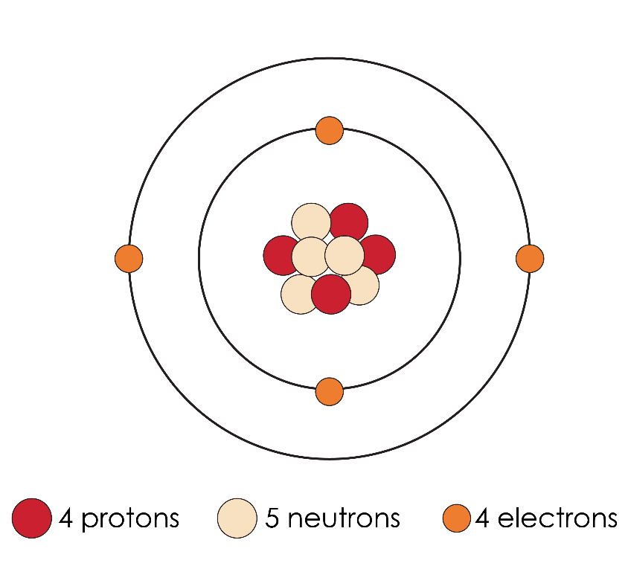

* 1. State the atomic number of beryllium.

_____________________________________________________________________________________ (1 mark)

* 1. State the mass number of beryllium.

_____________________________________________________________________________________ (1 mark)

* 1. Where is most of the mass of a beryllium atom found?

_____________________________________________________________________________________ (1 mark)

* 1. How many sub-atomic particles in one atom of beryllium have:

i. a positive charge _______________________________________ **(1 mark)**

ii. a negative charge ______________________________________ **(1 mark)**

iii. are neutral ______________________________________________ **(1 mark)**

* 1. An atom of sodium can be represented as:

Write a similar symbol for an atom of beryllium.

_____________________________________________________________________________________ (1 mark)

* 1. Which is most likely to be the radius of a beryllium atom? Circle the correct answer. [Hint: 1 nm = 1 m]

(1 mark)

1. 11.2 nm
2. 1.12 nm
3. 0.112 nm
4. 0.0112 nm
5. (a) Complete the equation to calculate the number of neutrons in an atom using atomic number and mass number.

number of neutrons _______________________________________ **(1 mark)**

(b) Complete the table to show the numbers of sub-atomic particles.

|  |  |  |  |
| --- | --- | --- | --- |
| **Atom or ion** | **Number of protons** | **Number of neutrons** | **Number of electrons** |
|  |  |  |  |
|  |  |  |  |
| + |  |  |  |
| 3– |  |  |  |

(4 marks)

1. The image shows three isotopes of carbon.

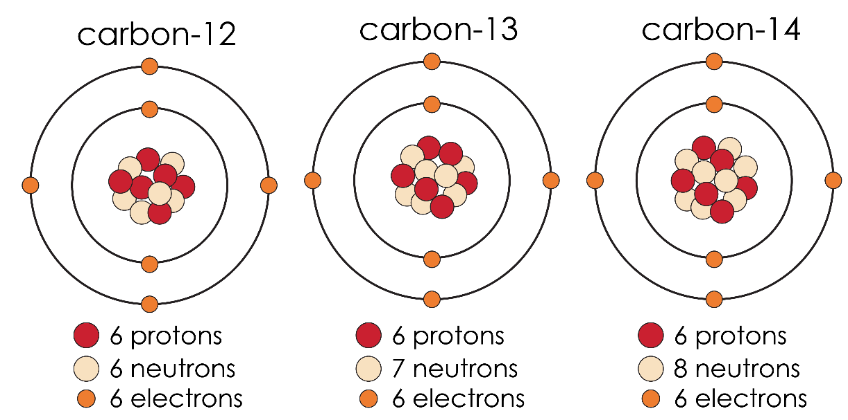

Source: Adapted from © Shutterstock

* 1. Define the term isotope.

__________________________________________________________________________________

__________________________________________________________________________________

(2 marks)

* 1. Write the symbol for each isotope.

i carbon-12: ________________________________________________ **(1 mark)**

ii carbon-13: _______________________________________________ **(1 mark)**

iii carbon-14: ________________________________________________ **(1 mark)**

* 1. Explain why atoms of the three isotopes do not have an overall electrical charge.

(2 marks)

* 1. The atomic mass of carbon is 12 but the relative atomic mass of carbon, calculated to three decimal places, is 12.001. Explain the difference in these numbers.

(2 marks)

* 1. Chlorine has two isotopes and .

The relative atomic mass of chlorine is 35.5. Which of the two chlorine isotopes is more commonly found?

(1 mark)

1. Theories about atomic structure have changed over time. The diagram shows how the theory about atomic structure has changed over time.

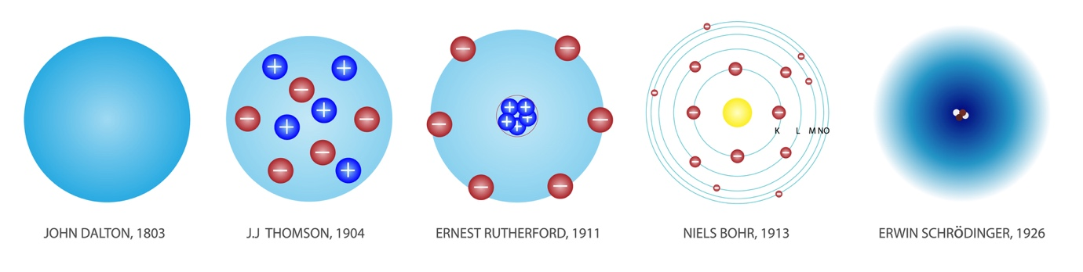

Source: © Shutterstock

* 1. Why did these models change over time?

____________________________________________________________________________________________________

____________________________________________________________________________________________________

(2 marks)

* 1. Complete the table with the missing information that connects the scientist and their discovery about the structure of the atom.

|  |  |
| --- | --- |
| **Scientist** | **Contribution to atomic structure model** |
| John Dalton |  |
|  | discovered the negatively charged electrons and reasoned that they were in a positive field. |
| Ernest Rutherford |  |
|  | discovered that electrons orbit the central nucleus in shells/energy levels. |

(4 marks)

[Total: 28 marks]

Which question(s) did you get wrong? Why?

What will you do next time you’re asked a similar question?