Becoming Mendeleev

This resource accompanies the infographic poster **Group 1, 7 and 0 and their trends** in *Education in Chemistry* which can be viewed at: [rsc.li/3ZyJ33p](https://rsc.li/3ZyJ33p)

Learning objectives

1. Explore key periodic trends of group 1, group 7 and group 0.
2. Describe how Mendeleev used trends in chemical and physical properties to arrange elements in groups.
3. Predict properties of elements based on trends in groups.
4. Use graphs and numerical data to make predictions.

By using this resource, learners will become more confident in using data from observations, tables and graphs to make predictions based on numerical information. Task 1 uses experimental observations, while tasks 2 and 3 use tables and graphs.

Task 1 focuses on the reactivity of group 1, whilst tasks 2 and 3 focus on physical properties such as melting points and density.

Scaffolding

Axes are provided for graphical tasks, but to stretch and challenge learners ask them to scale their own axes. Additionally, ask learners to plot the graph for task 3 question 2. This graph produces a curved line of best fit. There is also an anomaly present (for helium) which learners can research further.

If necessary, support learners with drawing their lines of best fit and prompt them to draw straight lines or curves based on the data and how far along in the course you are (and how much graphical work learners have encountered).

By working through each of the three tasks, learners will gradually build skills. Ensure learners have received feedback on the previous task before setting subsequent ones, so they can build upon their prediction skills.

Making the models at home for task 2 provides learners with a key opportunity to visualise intermolecular forces and to link this to their role in melting and boiling points. It also serves as a revision technique.

Answers

Task 1: the alkali metals (group 1)

1. All alkali metals have one valence electron.
2. , as francium would have 1 valence electron, which it loses during reactions.
3. The reactivity increases down the group.
4. Explosive / more reactive than caesium.
5. Francium hydroxide.
7. ­
8. The resultant solutions would get more alkaline down the group.
10. Giant ionic lattice.

Task 2: the halogens (group 7)

1. Simple molecular structure with covalent bonding.
2. 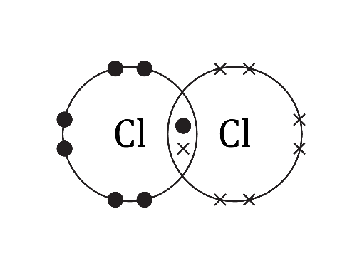
3. Astatine will likely be simple molecular structure with covalent bonding.
4. and .
5. The number of occupied shells increases as you go down the group.
6. As the size of the molecules increases, the strength of the intermolecular forces increases. This means that it requires more energy to overcome the forces and melt the substance, increasing the melting point.
7. Tennessine molecules will be larger, with stronger intermolecular forces. This means it will require a large amount of energy to overcome the forces. Tennessine is therefore likely to be a solid at room temperature.
8. Colour intensity of the vapours increases down the group; from pale (yellow), pale (green), dark (red), to deep (purple).
9. Astatine is likely to be dark in colour.
10. (a)

|  |  |  |  |  |
| --- | --- | --- | --- | --- |
| **Element** | **Molecular formula** | ***M*r** | **Melting point (°C)** | **Boiling point (°C)** |
| **Fluorine** |  | 38 | -220 | -188 |
| Chlorine |  | 71 | -102 | -34 |
| **Bromine** |  | **160** | -7 | 59 |
| Iodine |  | 254 | 114 | 184 |
| Astatine |  | **420** | 300 | 350 |
| Tennessine |  | 588 | ? | ? |

(b),(c),(d),(e),(f)  
A completed annotated graph of the data from question 2.10. The x-axis is labelled "Mr of molecule" and extends from 0 to 600 with numbers at intervals of 50. The y-axis is labelled "Temperature (degrees C)" and extends from -250 to 550 with numbers at intervals of 50 degrees C. 

A smooth curve is drawn through the data points. The curve for boiling point is orange, the curve for melting point is dark blue. The curves are both extended as straight dotted lines beyond the final plot point (astatine).  

A horizontal green line is labelled 'Room temperature' at 22 degrees C. A vertical dashed turquoise line is labelled Tennessine at an Mr of 588. The dashed turquoise line crosses the dotted dark blue line at 500 degrees C. The dashed crosses the orange dotted line at 550 degrees C. 

The graph is annotated with Bp = approximately 550 degrees C in orange and Mp = approximately 500 degrees C in dark blue.

Task 3: the noble gases (group 0)

1. (a)

|  |  |  |  |
| --- | --- | --- | --- |
| **Element** | **Atomic number** | **Density (kg/m3)** | **Atomic radius (pm)** |
| Helium | **2** | 0.18 | 31 |
| Neon | **10** | 0.90 | 38 |
| Argon | **18** | 1.78 | 71 |
| Krypton | **36** | 3.71 | 88 |
| Xenon | **54** | 5.85 | 108 |
| Radon | **86** | 9.97 | 120 |
| Oganesson | **118** | Unknown | 152 |

1. A completed graph of the data from Question 3.1 (a). 

   The x-axis is labelled "Atomic number" and extends from 0 to 120 with numbers at intervals of 10. The y-axis is labelled "Density (kg per metres cubed)" and extends from 0 to 15.0 with numbers at intervals of 1.0 kg per metres cubed. 

   The straight line of best fit is drawn through the data points. A vertical red line is drawn at atomic number 118. The vertical line stops where it meets the line of best fit. A horizontal red line is drawn from where these two lines intercept to the y-axis where it meets the y-axis at 13.2 kg per metre cubed.
2. The density increases as you go down group 0.
3. Density estimate is approximately 13.2 kg/m3.
5. Moles = = 9.96 x 10-24 mol
6. Answer to (d) i. x 24 = Volume in dm3 (Approx. 2.4 x 10-22 m3)
8. The atomic radius increases down group 0.
9. As the size of the atoms increases, we would expect the strength of the forces between atoms to increase and hence the melting and boiling points would increase.