**Carboxylic acids: knowledge check**

1. The image shows a molecular model of a carboxylic acid molecule.

Draw a circle around the carboxylic acid functional group and add labels to identify each part of the molecule indicated on the image.

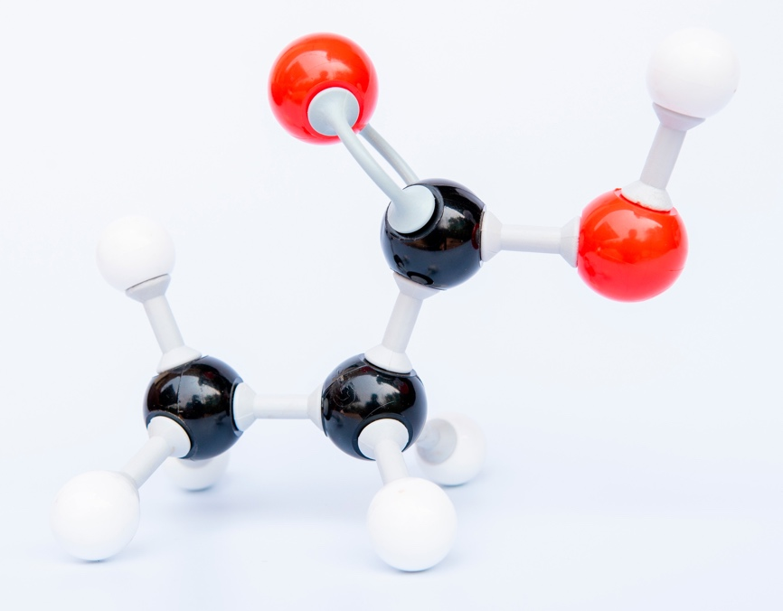

1. The table includes images of molecular models of the first four carboxylic acids. Complete the table by adding the names and molecular formulas for each of the four carboxylic acids.

|  |  |  |
| --- | --- | --- |
| **Molecular model** | **Name** | **Molecular formula** |
| There is an image of a molecular model. The model has one black sphere in the middle. This is connected to one white sphere by a single bond and a single bond to a red sphere which is also connected to one white sphere by a single bond. The black sphere is also connected to a red sphere with a double bond. |  |  |
| There is a photograph of a molecular model. The model has two black spheres in the middle. The first black sphere has three white spheres connected to it by single bond and has a single bond to the second black sphere. The second black sphere is connected to two red spheres. One red sphere is connected by a double bond. The other red sphere is connected to the second black sphere by a single bond and also to a white sphere by a single bond. |  |  |
| There is a photograph of a molecular model. The model has three black spheres in the middle. The first black sphere has three white spheres connected to it by single bonds and has a single bond to the second black sphere. The second black sphere is connected to two white spheres by single bonds and to the third black sphere by a single bond. The third black sphere is connected to two red spheres. One red sphere is connected by a double bond. The other red sphere is connected to the third black sphere by a single bond and also to a white sphere by a single bond. |  |  |
| There is a photograph of a molecular model. The model has four black spheres in the middle. The first black sphere has three white spheres connected to it by single bonds and has a single bond to the second black sphere. The second black sphere is connected to two white spheres by single bonds and to the third black sphere by a single bond. The third black sphere is connected to two white spheres by single bonds and to the third black sphere by a single bond. The fourth black sphere is connected to two red spheres. One red sphere is connected by a double bond. The other red sphere is connected to the third black sphere by a single bond and also to a white sphere by a single bond. |  |  |

1. Decide whether each of the following statements is true or false and tick the box.
   1. Carboxylic acid molecules fully ionise in water. **True False**
   2. Carboxylic acids are weak acids. **True False**
   3. Solutions of carboxylic acids in water have a pH above 7. **True False**
   4. The functional group of carboxylic acids is . **True False**
   5. The general formula for carboxylic acids is . **True False**
   6. The molecular formula for pentanoic acid is . **True False**
   7. Ethanoic acid is a stronger acid than hydrochloric acid. **True False**

Use the space below to write out the correct version of any statements you think are false.

1. Carboxylic acids have typical acid properties.

Complete the sentences describing the typical chemical reactions of carboxylic acids.

Hydrochloric acid is a strong acid and __________________ ionises in water.

Ethanoic acid is a weak acid and __________________ ionises in water.

A solution of ethanoic acid has a __________________ pH than a solution of hydrochloric acid with the same concentration.

Carboxylic acids react with:

* metals to form _________________________ and _________________________ gas
* bases to form ___________________________ and ___________________________
* carbonates to form ____________________________, ____________________________ and ____________________________ gas.

**Acids and bases: test myself**

1. Which **two** formulas represent carboxylic acids?

1. Draw the displayed formula for ethanoic acid.
2. What type of ions are produced by all carboxylic acids when they ionise?
3. Complete the word equations representing the reactions of ethanoic acid.
   1. ethanoic acid + __________________ → magnesium ethanoate + __________________
   2. ethanoic acid + magnesium oxide → __________________ + __________________
   3. ethanoic acid + magnesium __________________ → __________________

+ __________________

+ carbon dioxide gas

1. Write a word equation to represent the general reaction between a carboxylic acid and an alcohol.

__________________ + __________________ → __________________ + __________________

1. Esters are a homologous series. What is their functional group?
2. The image shows the reaction between ethanoic acid and ethanol to form an ester:

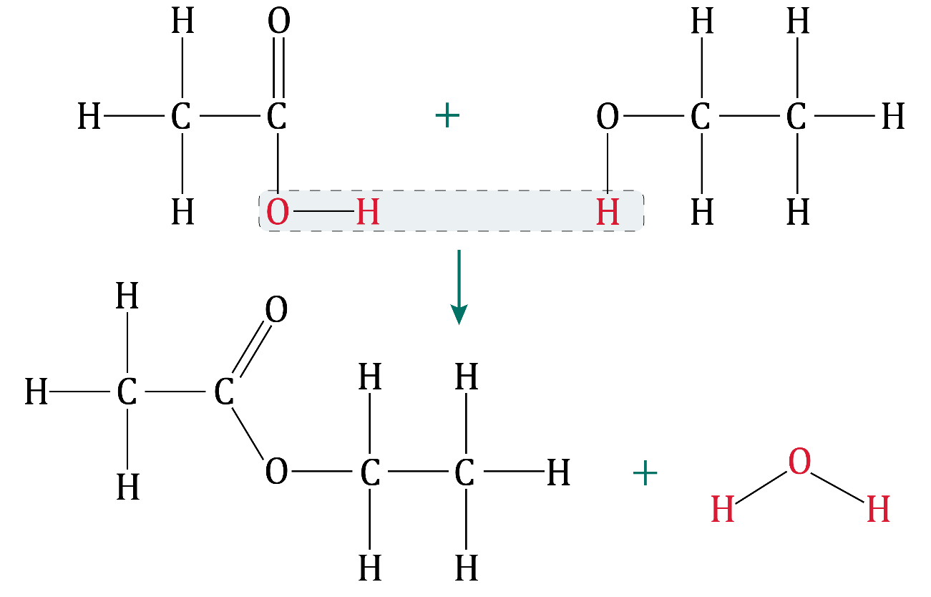

Name the ester formed.

1. Ethanol, , reacts with an oxidising agent to produce ethanoic acid and a second product.

Complete the balanced symbol equation representing this reaction.

__________________ + 2[O] → __________________ + __________________

**Carboxylic acids: feeling confident?**

1. Diagrams **A** and **B** represent two different acids.

The formula HA is used to represent the acid molecule in diagram **A**.

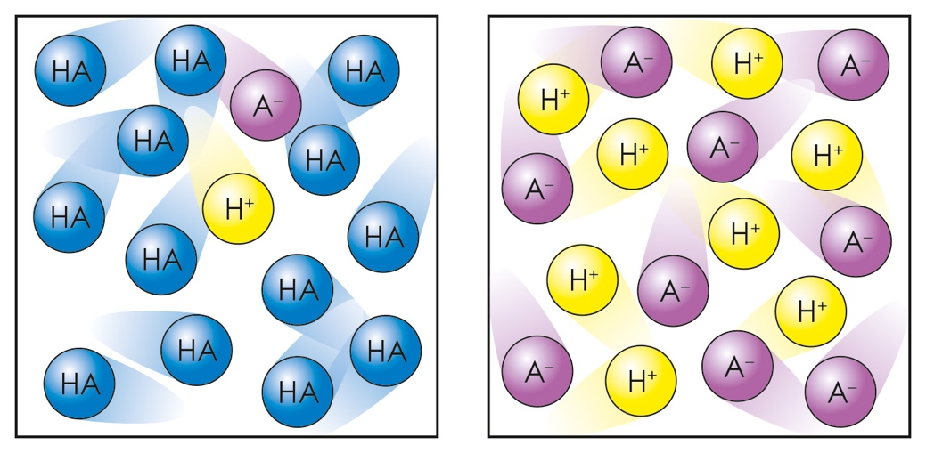

**A B**

* 1. What does the in each diagram represent?
  2. Which diagram represents the acid that would react the fastest with magnesium ribbon?
  3. Which diagram represents ethanoic acid and which represents hydrochloric acid? Explain how you made your conclusion.

1. The diagram shows the displayed formula of an ester.

Use this image to answer the questions.

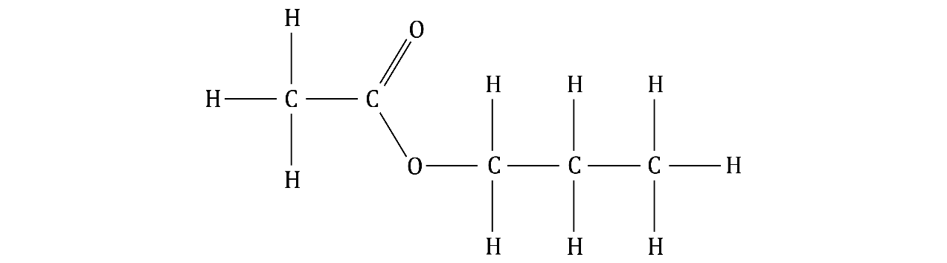

* 1. Name the carboxylic acid used to make this ester.
  2. Name the alcohol used to form this ester.
  3. Name the ester shown.

**Carboxylic acids: what do I understand?**

Think about your answers and confidence level for each mini-topic. Decide whether you understand it well, are unsure or need more help. Tick the appropriate column.

|  |  |  |  |
| --- | --- | --- | --- |
| **Mini-topic** | **I understand  this well** | **I think I understand this** | **I need more  help** |
| I can identify the functional group and general formula of carboxylic acids. |  |  |  |
| I can write the molecular formulae and draw the displayed formulas of the first four carboxylic acids. |  |  |  |
| I know that carboxylic acids are weak acids. |  |  |  |
| I can describe the reactions of carboxylic acids with metals, bases and carbonates. |  |  |  |
| I can describe the reactions of carboxylic acids with alcohols to produce esters and identify the functional group of an ester. |  |  |  |
| I can name an ester and identify the displayed formula of ethyl ethanoate. |  |  |  |
| I can write an equation for the reaction between ethanol and an oxidising agent. |  |  |  |
| **Feeling confident? topics** | **I understand  this well** | **I think I understand this** | **I need more  help** |
| I can describe the difference between strong and weak acids. |  |  |  |
| I can name esters. |  |  |  |