Allotropes of carbon: flashcards
Education in Chemistry
January 2021
rsc.li/37VMEhr
Use these flashcards to explore the different properties and uses of four allotropes of carbon – diamond, graphite, graphene and buckminsterfullerene.
These differentiated flashcards are designed to be used alongside the allotropes of carbon infographic poster. Learners extract information from the infographic to complete the cards. Additional prompts are included on some of the flashcards to encourage independent research beyond the infographic.
Flashcards are a great way to organise information for revision. They could also be used for small group work, a market-stall style activity or a homework research task.
The infographic is designed to be displayed as a poster in the classroom. However, this activity could also be carried out with the infographic displayed on a projector or as printed handouts shared amongst small groups. Download the pdf with the link above.

Differentiation
The cards have been differentiated to offer stretch or support as required.
Stretch (blue edge) | Support (yellow edge)
Most answers are free text allowing learners to articulate understanding in their own words. | Answers are in a variety of formats including one word, multiple choice and free text answers.
Questions are at a higher level on Bloom’s taxonomy (describe/explain). | Questions are more structured (state/why?).
Each card has space to add uses beyond those included in the infographic, based on independent research. | All uses can be found on the infographic with the exception of one use of buckminsterfullerene. This could be used as an extension or homework activity.
Learners need to find three uses for each allotrope. | Learners need to find two uses for each allotrope.

Allotrope: |  | Diamond
 | 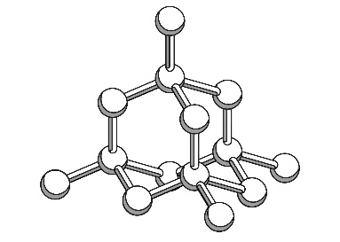 |  |  | Description of structure and bonding:
 | Ancient or modern discovery? |  |  |  |  | No. of bonds on each carbon atom:
 | Use |  |  | Explanation for use

Allotrope:
 | 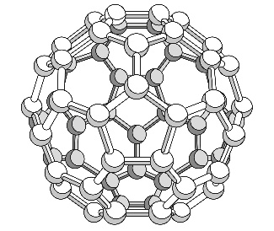 |  |  | Description of structure and bonding:
 | Ancient or modern discovery? |  |  |  |  | No. of bonds on each carbon atom:
 | Use |  |  | Explanation for use
Allotrope:
 | 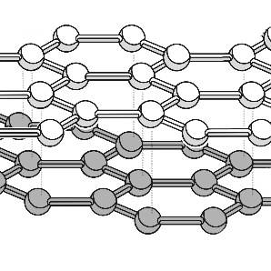 |  |  | Description of structure and bonding:
 | Ancient or modern discovery? |  |  |  |  | No. of bonds on each carbon atom:
 | Use |  |  | Explanation for use

Allotrope:
 | 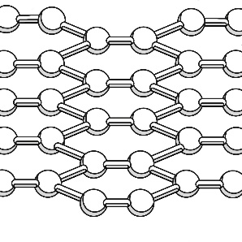 |  |  | Description of structure and bonding:
 | Ancient or modern discovery? |  |  |  |  | No. of bonds on each carbon atom:
 | Use |  |  | Explanation for use

Allotrope:
 |  |  |  | Shape:
 |  |  |  | Type of bonds (tick one): | - Giant ionic  - Giant covalent  - Simple covalent
 | Historic or modern discovery? |  |  |  |  | No. of bonds on each carbon atom:
 | Use |  |  | Why is it a good material for this purpose?
 | Drill bits
 | Jewellery

Allotrope:
 |  |  |  | Shape:
 |  |  |  | Type of bonds (tick one): | - Giant ionic  - Giant covalent  - Simple covalent
 | Historic or modern discovery? |  |  |  |  | No. of bonds on each carbon atom:
 | Use |  |  | Why is it a good material for this purpose?
 | Drug delivery

Allotrope:
 |  |  |  | Shape:
 |  |  |  | Type of bonds (tick one): | - Giant ionic  - Giant covalent  - Simple covalent
 | Historic or modern discovery? |  |  |  |  | No. of bonds on each carbon atom:
 | Use |  |  | Why is it a good material for this purpose?
 | Pencil leads
 | Nuclear reactor cores

Allotrope:
 |  |  |  | Shape:
 |  |  |  | Type of bonds (tick one): | - Giant ionic  - Giant covalent  - Simple covalent
 | Historic or modern discovery? |  |  |  |  | No. of bonds on each carbon atom:
 | Use |  |  | Why is it a good material for this purpose?
 | Solar cells
 | Electronic displays

