**Collision theory and Maxwell–Boltzmann distribution curves**

This resource accompanies the article **How to teach Maxwell–Boltzmann distribution curves** in *Education in Chemistry* where you can find guidance and teaching strategies, including common misconceptions: [**rsc.li/3YAZDiM**](https://rsc.li/3YAZDiM)

**Resource components**

|  |  |
| --- | --- |
|  |  |
| **Presentation**: slides include key points and examples. | **Student sheet**: with questions to consolidate and check understanding. |

**Learning objectives**

1. Understand reaction kinetics in terms of collision theory and energy profile diagrams.
2. Draw and interpret Maxwell–Boltzmann distribution curves.
3. Use Maxwell–Boltzmann distribution to explain how a change in temperature affects the rate of reaction.
4. Use Maxwell–Boltzmann distribution to help explain the action of a catalyst on reaction rate.

Use as a revision resource or to bridge the gap between learning at 14–16 and post-16 courses, or to complement practical activities on these topics.

The first half of the presentation (slides 3–7) recaps the basics of collision theory and stimulate a class discussion about previous learning on rates of reaction. Slides 8–12 introduce Maxwell–Boltzmann (MB) distribution curves and show how the curves link to collision theory.

**Scaffolding**

Get learners to work through the questions on the student sheet independently or as a small group to offer peer support to each other.

**Teaching sequence**

1. Use slides 3–5 to recap key points about collision theory and reaction kinetics.

Initially, show learners the diagrams on slides 4 and 5 and ask them to describe what is shown in each diagram using appropriate terminology. Encourage ideas such as diatomic molecules, bonds breaking, atoms rearranging and formation of an intermediate.

1. Discuss the energy profile diagrams on slide 6. Ensure learners understand what each diagram represents:

* Start by drawing learners’ attention to axes labels.
* In the left-hand diagram, the reactants collide in the correct orientation with sufficient energy to react, so the activation energy is achieved, successful collisions occur and products are formed.
* In the right hand diagram, the reactants do not have sufficient energy to react, so the activation energy is not achieved, successful collisions do not occur and no products are formed.

1. Share the graph on slide 7, showing typical data from an investigation into the reaction of magnesium and acid. Use this slide to stimulate discussion about why the rate of reaction changes throughout the reaction. Within this discussion, remind learners about factors that can change the rate of reaction, including temperature, concentration, surface area, pressure and the addition of a catalyst.

To increase the level of challenge, ask learners to calculate and compare the rate of reaction at given points on the graph.

1. Use the simulation linked from slide 8 to introduce Maxwell–Boltzmann curves.

* Start with a low simulation speed – link this back to a low temperature.
* Observe the histogram and discuss the colour coding of the particles.
* Then increase the simulation speed – link to a higher temperature.
* Observe how the shape and colours of the histogram have changed.
* Emphasise that the number of particles are the same.
* Stress that we are looking at an energy distribution and not a process graph.

1. Highlight the key features of the Maxwell–Boltzmann distribution illustrated on slide 9.

* The area under the curve represents the total number of particles and so remains constant.

Going from lower energies to higher energies:

* Zero particles have zero energy.
* The most probable energy of a particle is shown by the maximum height on the curve.
* The mean energy of the particles present is different from the most probable energy. It is higher.
* The position of the activation energy is key. Only particles with kinetic energy equal to, or greater than, the activation energy have enough energy to react (indicated by the area shaded orange on the graph). All the remaining particles (indicated by the area shaded green on the graph) do not have enough kinetic energy to react.

1. Illustrate what happens to the Maxwell–Boltzmann distribution curve when temperature increases (slide 10).
2. Finally, show the effect of a catalyst on activation energy by showing the energy profile diagram on slide 11 and how that impacts the Maxwell–Boltzmann distribution curve on slide 12.

**Answers**

1. (a) The particles collided in the wrong orientation, so the collision was unsuccessful and no reaction took place.

(b) Accept any diagram that shows particles meeting in the correct orientation for a successful collision and new products to form.

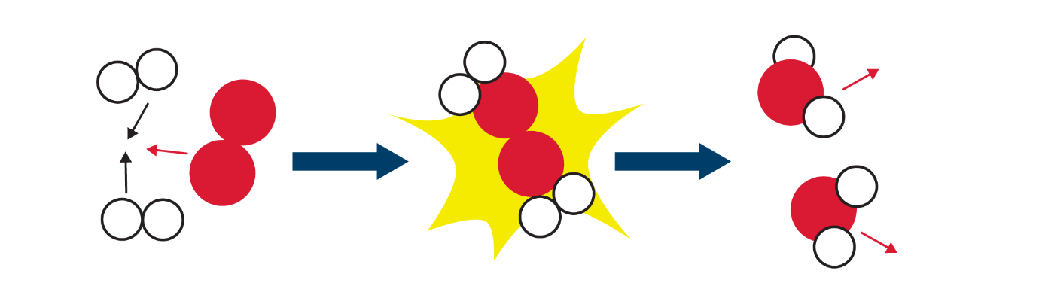

(c) The activation energy is the minimum amount of energy required for particles to react.

(d) For a reaction to take place, the reactant particles must collide with kinetic energy equal to, or greater than, the activation energy and with the correct orientation. In reality, in a sample of gas, the kinetic energy of most particles is less than the activation energy and therefore most collisions will not result in a chemical reaction.

1. (a)

* The most probable energy – 2
* The activation energy – 5
* The mean energy – 3
* Total number of particles present – 4
* Particles with low energy – 1
* Particles that will have enough energy to react - 6

(b) Collisions cause particles to slow down.

(c)

1. False – the peak of the curve represents the probable energy. The mean energy is found to the right of the peak.
2. True – zero particles have zero energy.
3. False – there is no maximum energy for the particles.
4. False – it is the frequency of successful collisions that increases.
5. False – it always stays the same as it represents the total number of particles present.
6. Many more particles have kinetic energy that is equal to, or greater than, the activation energy and so the frequency of successful collisions will increase.

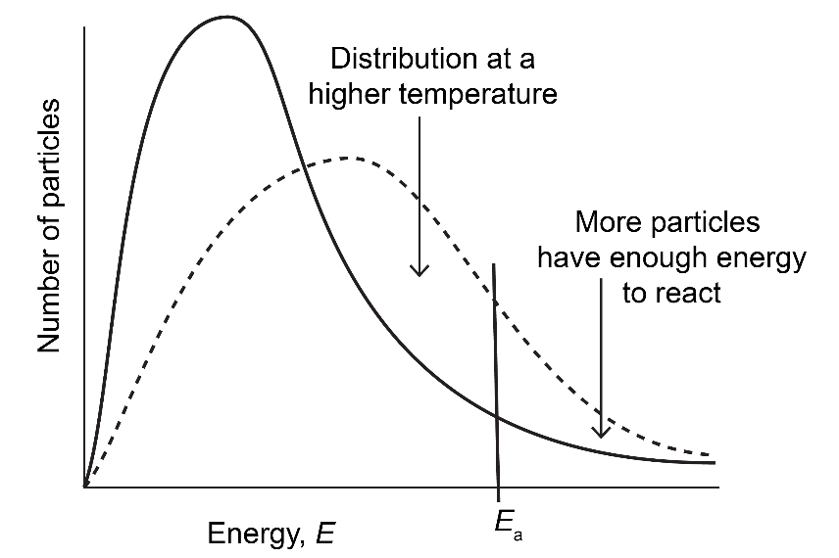

1. (a) A catalyst is a chemical that increases the rate of reaction without taking part/reacting in the reaction.

(b) A catalyst works by providing a reaction pathway with an alternative lower activation energy.

(c) The shape the curve remains the same, a new *E*a should be shown at a lower energy level

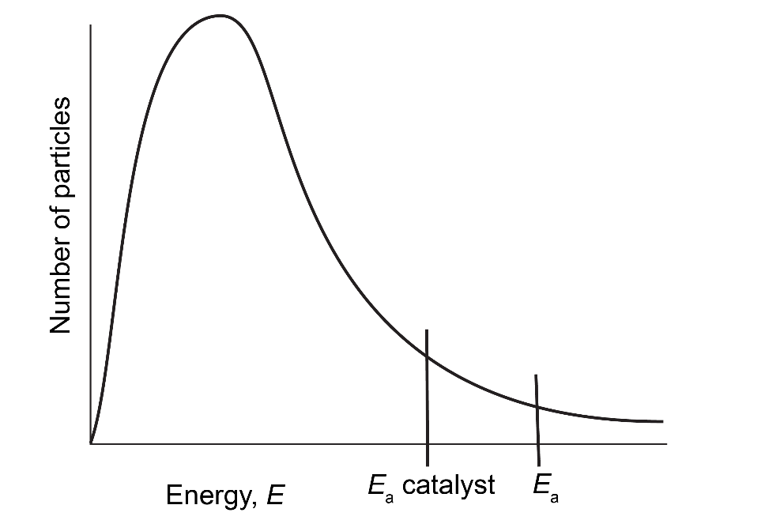

(d) When a catalyst is added, the number of particles with energy greater than, or equal to, the activation energy increases. Therefore there will be a greater chance of colliding particles resulting in successful collision. As the frequency of successful collisions increases, so does the rate of reaction.

1. (a) Number of particles or number of molecules.

(b)

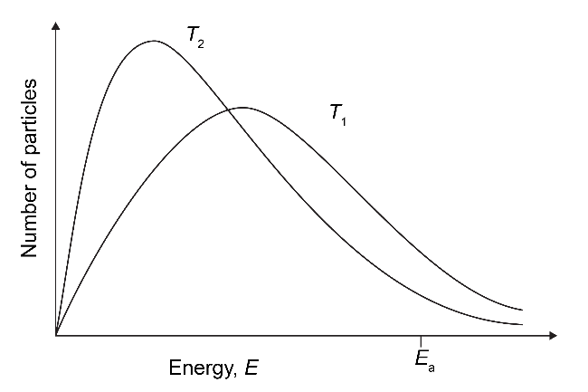

(c) At lower temperatures the particles/molecules have a lower kinetic energy. Fewer collisions will have energy greater than, or equal to, the activation energy so more collisions will be unsuccessful. Therefore, the frequency of successful collisions will decrease and so will the rate of reaction.

(d) A catalyst provides an alternative reaction pathway with a lower activation energy. This means that the number of particles with energy greater than, or equal to, the activation energy increases. Therefore, there will be a greater chance of colliding particles resulting in successful collisions. As the frequency of successful collisions increases, the rate of reaction increases.