Solutions

This resource is from the **Johnstone’s triangle** series which can be viewed at: [rsc.li/4mIS9pd](https://rsc.li/4mIS9pd). In this series you will also find our **Solutions: Johnstone’s triangle** worksheet which introduces the triangle in the context of rock salt and can be viewed at: [rsc.li/422BP92](https://rsc.li/422BP92).

Learning objectives

|  |  |  |
| --- | --- | --- |
| **LO** | **Objective** | **Where assessed** |
| **1** | Identify a solution from an observation. | Q1 |
| **2** | Use particles to explain why mass is conserved when a substance dissolves. | Q2 |
| **3** | Explain a suspension in terms of being a mixture of water and small pieces of an insoluble solution. | Q3(a) and (d) |
| **4** | Explain a suspension using particle diagrams. | Q3(b) and (c) |

How to use this resource

This resource aims to develop learners’ understanding of solutions and dissolving. The questions encourage learners to interpret a range of observations of soluble and insoluble substances being mixed with water and then to think about how these different observations may be represented using particle diagrams. As a result, learners should develop more secure mental models to support their thinking about this topic.

|  |  |  |  |  |
| --- | --- | --- | --- | --- |
| **When to use?** | Enter with solid fill Introduce | Watering pot with solid fill **Develop** | Arrow circle with solid fill **Revise** | Clipboard Mixed with solid fill Assess |
| Use after initial teaching or discussion of this topic to develop ideas further. You can also use as a revision activity. | | | |
| **Group size?** | Head with gears with solid fill **Independent** | Group brainstorm with solid fill **Small group** | Classroom with solid fill **Whole class** | Work from home house with solid fill **Homework** |
| Suitable for independent work either in class or at home. Or use the questions for group or class discussions. | | | |
| **How long?** | Stopwatch 25% with solid fillArrow Right outlineStopwatch 50% with solid fill | | 15–30 mins | |

Johnstone’s triangle

Johnstone’s triangle is a model of the three different conceptual levels in chemistry: macroscopic, sub-microscopic and symbolic. You can use Johnstone’s triangle to build a secure understanding of chemical ideas for your learners.

Find further reading about Johnstone’s triangle and how to use it in your teaching at [rsc.li/4klHYVL](https://rsc.li/4klHYVL)

Johnstone’s triangle and this resource

The icons in the margin indicate which level of understanding each question is developing to help prompt learners in their thinking.

|  |  |
| --- | --- |
| An icon used to indicate the Macroscopic part of Johnstone's triangle. | **Macroscopic:** what we can see. Think about the properties that we can observe, measure and record. |
| An icon used to indicate the Sub-microscopic part of Johnstone's triangle. | **Sub-microscopic:** smaller than we can see. Think about the particle or atomic level. |
| An icon used to indicate the Symbolic part of Johnstone's triangle. | **Symbolic:** representations. Think about how we represent chemical ideas including symbols and diagrams. |

The levels are interrelated, for example, learners need visual representation of the sub-microscopic to develop mental models of the particle or atomic level. Our approach has been to apply icons to questions based on what the learners should be thinking about.

Questions may be marked with two or all three icons, indicating that learners will be thinking at more than one level. However, individual parts of the question may require learners to think about only one or two specific levels at a time.

Support

This worksheet is ramped so that the earlier questions are more accessible. The activity becomes more challenging in the later questions. You can give extra explanations for the more challenging questions. If completing as an in-class activity it is best to pause and check understanding at intervals, as often one question builds on the previous one.

It is useful for learners to observe macroscopic properties first-hand. You could circulate examples of substances in the classroom, run a class practical of a chemical reaction or show a teacher demonstration of properties. Question 1(a) requires learners to know about the solubility of the common kitchen ingredients flour, salt and sugar. A demonstration of these ingredients mixed with water would be beneficial, particularly for learners with little experience of cooking.

Additional support may be needed for any learners still lacking in confidence in the required symbolic representation, for example by sharing and explaining a diagram or a simulation that can show movement of the particles.

Answers

1. *Guidance note:* This question develops learners’ understanding of observations made when soluble and insoluble substances are mixed with water (macroscopic understanding). In part (d), two examples are used for both soluble and insoluble substances to show that different observations can be made for each. A soluble substance may produce a clear and colourless or a clear and coloured solution. An insoluble substance may remain as a solid lump in clear and colourless water or (if a powder) it may mix with the water to form a cloudy mixture.
2. soluble
3. insoluble
4. soluble
5. Colourless means to have no colour.
6. Clear means transparent (see through).

|  |  |  |
| --- | --- | --- |
| **Unknown substance** | **Observation after adding to water** | **Soluble or insoluble?** |
| W | white lump and  clear and colourless liquid | **insoluble** |
| X | cloudy and white | **insoluble** |
| Y | clear and colourless | **soluble** |
| Z | clear and blue | **soluble** |

1. **C** clear



1. *Guidance note:* This question develops learners’ understanding of how the conservation of measured mass (macroscopic understanding) can be explained in terms of the conservation of the particles (sub-microscopic understanding).
2. 229 g

A diagram similar to that shown with the smaller number of particles labelled as sugar particles and the larger number of particles labelled as water particles.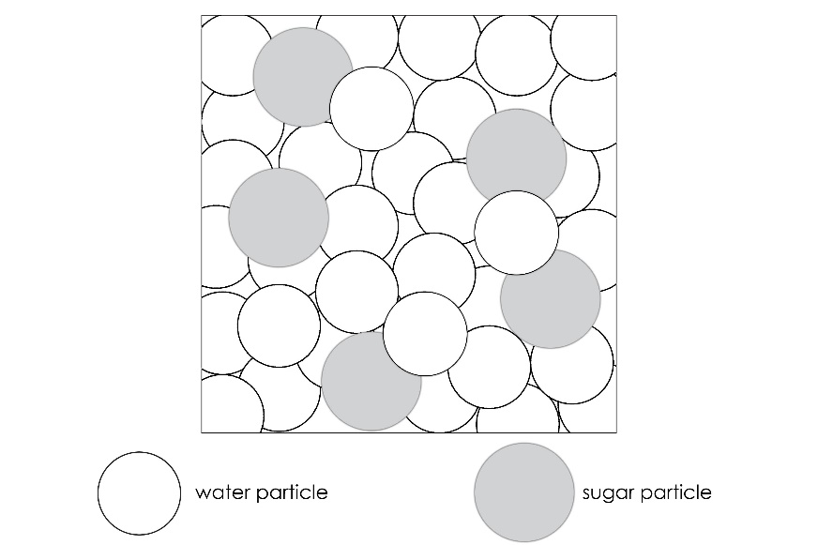

1. When sugar dissolves, it breaks down into individual particles that are too small to see. But because the particles are still there the overall mass does not change.



1. *Guidance note:* This question developers learners’ understanding of how a suspension of an insoluble powder is different to a solution of a soluble substance in terms of the arrangement of particles (sub-microscopic understanding). In a solution the solute particles mix with the water at the individual particle level. With an insoluble powder the visible specks of powder are made up of many particles. It may help learners to recognise that compared to their diagram there would be many more particles making up each speck of powder.

The question also supports learners to understand why a cloudy solution can change to a clear liquid with a layer at the bottom, when the powder settles (macroscopic understanding).

1. The suspension looks cloudy because tiny pieces of chalk are mixed throughout the water. The pieces of chalk are white and not clear.
2. The particle diagram shows individual particles of chalk. These particles would be too small to see.
3. A diagram showing clumps of chalk particles (arranged as in the solid state) mixed with water particles (arranged as in the liquid state). For example:

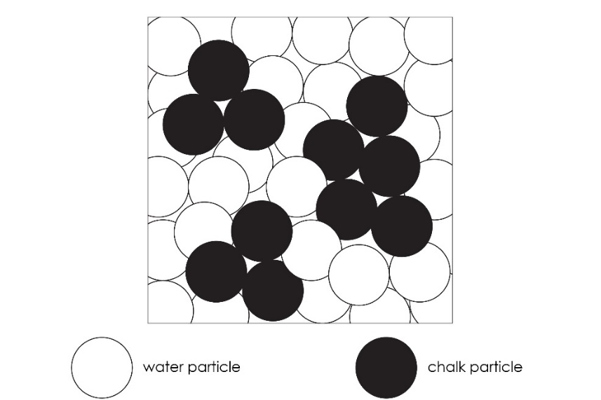

1. The tiny particles of chalk have settled (fallen) to the bottom of the test tube. This has created a layer of chalk and above it a layer of water.