Sustainable foam can remove 99.9% of microplastics

*Original article by Julia Robinson. Adapted by Nina Notman.*

Scientists address the urgent challenge of microplastic pollution

A foam made of the polymers cellulose and chitin removes up to 99.9% of microplastics from water and maintains its effectiveness after repeated use.

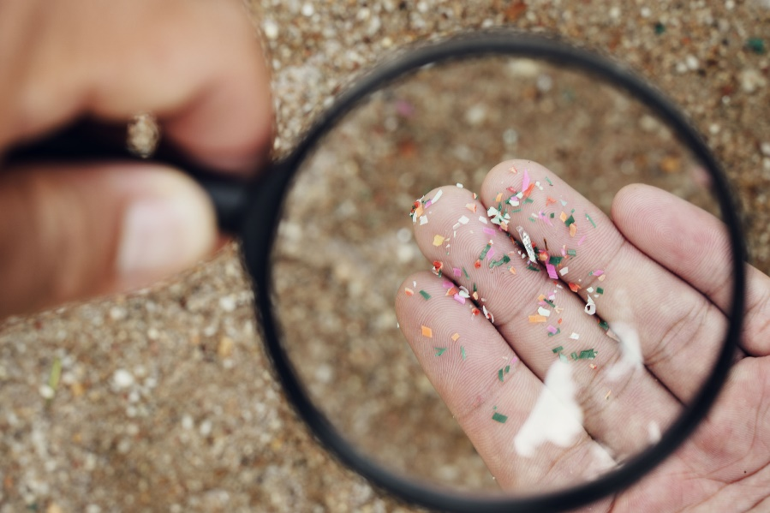

*Source: © Sansoen Saengsakaorat/Shutterstock*

*Could a foam made from cotton and squid help solve the microplastic crisis?*

Microplastic pollution is increasing in terrestrial and aquatic environments at an alarming rate, making the need for practical approaches to remediate this urgent. The China-based research team set out to design a sustainable material that absorbs microplastics from water.

**Plentiful polymers**

The starting materials include two of the most abundant polysaccharides in nature: chitin, from the internal shell of squids, and cellulose from cotton. The team showed that these polysaccharides self-assemble into a foam with a highly porous, interconnected structure.

During initial testing, the researchers demonstrated the foam’s ability to adsorb tiny particles of the common plastics poly(phenylethene), poly(methyl 2-methylpropenoate, poly(propene) and poly(ethylene terephthalate).

Next, the team investigated how the foam performed with real-world water samples. It used irrigation, lake and coastal water – each containing a variety of plastics, toxic metals, chemical dyes and other pollutants. In the first cycle, the scientists found that the foam adsorbed microplastics from the water with 98%–99.9% efficiency, and after five cycles, it adsorbed microplastics with 95%–98% efficiency.

Although the experiments involved just 10 minutes of cooking, pollutants levels remained substantially elevated in the research kitchen for over an hour afterwards. Oil quantity and hob temperature also influenced pollution levels, the team found.

‘Improving the ventilation in kitchens, by opening windows or using extractor fans, will help to disperse polluting particles and reduce personal exposure,’ says Christian.

This is adapted from the article **Cellulose and chitin foam can remove nearly all microplastics from water** in *Chemistry* *World.* Read the full article at [bit.ly/416iSU0](https://bit.ly/416iSU0).