Curiosity rover finds missing carbon on Mars

*Original article by James Urquhart. Adapted by Nina Notman.*

**Nasa rover uncovers evidence of carbonate rocks that could answer long-held questions about the planet’s past**

Nasa’s Curiosity rover has discovered carbonate rocks on Mars, helping to solve the conundrum of how the planet was once warm enough to have flowing rivers. These rocks also provide the first evidence of an ancient [carbon cycle](https://edu.rsc.org/cpd/how-to-teach-the-carbon-cycle-at-11-14/4013418.article) similar to the one that makes Earth habitable.

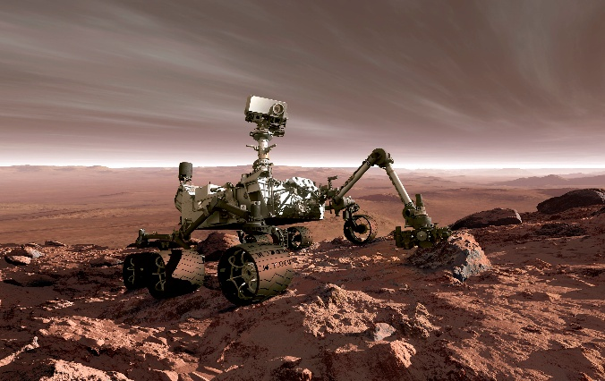

*© Detlev van Ravenswaay/Science Photo Library*

*Data collected by Nasa’s Curiosity rover is instrumental for scientists back on Earth*

This bear jaw reveals lead pollution existed before the industrial revolution and came from the bear’s diet

Scientists have long believed that in the past Mars was warm enough to host liquid water. To do so, it must have had a much thicker atmosphere than it does today, containing large amounts of carbon dioxide that warmed the planet via the [greenhouse effect](https://edu.rsc.org/experiments/modelling-the-greenhouse-effect/1543.article). However, this theory presented a mystery: where did all that carbon dioxide go?

Models had predicted that the gas was probably sequestered in [sedimentary rocks](https://edu.rsc.org/infographics/teaching-the-rock-cycle/4015807.article) in the form of carbonate minerals and that these should be widespread across Mars. However, previous explorations of the planet’s surface by rovers and orbiters, as well investigation of Martian meteorites that have landed on Earth, had revealed only scarce amounts of carbonate minerals.

A mystery solved

The Curiosity rover landed in August 2012 and has now spent more than 12 years on Mars. It carries a suite of analytical instruments for collecting data about the planet that is then beamed back to Earth for analysis. Recently, an international team of scientists found evidence of abundant carbonate rocks just beneath the planet’s surface at the site of a suspected dried-up Martian lake. The data was collected via the rover’s on board CheMin (chemistry and mineral) instrument that uses x-rays to determine the chemical composition of rocks.

‘One of the biggest questions in Mars science is: where are all the carbonates?,’ says team member [Benjamin Tutolo](https://profiles.ucalgary.ca/benjamin-tutolo), from the University of Calgary in Canada. These newly found rocks ‘may hold a substantial portion of the carbon dioxide that was formerly implicated in warming Mars’, he adds.

‘This is an exciting result that has large implications for the nature of the early atmosphere on Mars and a Martian carbon cycle,’ comments [Wendy Calvin](https://www.unr.edu/geology/people/wendy-calvin), a Mars scientist at the University of Nevada, USA, who was not involved in this work.

This is adapted from the article **Carbonates identified by the Curiosity rover indicate a carbon cycle operated on ancient Mars** in *Science.* Read the full article: bit.ly/4kmut85