F1 Developing a model of the atom

Scale

|  |  |  |  |
| --- | --- | --- | --- |
| **Subatomic** | **Atom** | **Molecule** | **Giant structure** |
|  |  |  |  |

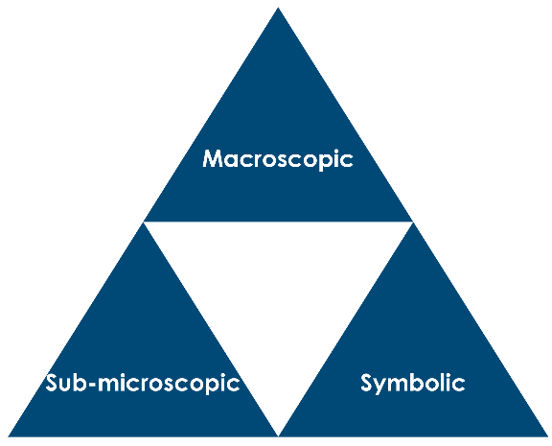

Earliest models of atoms

Ancient Greek ideas – Democritus Approximate dates:

1. Briefly describe Democritus’ suggestions:

John Dalton’s atomic theory Approximate date:

1. State the key points of John Dalton’s theory:

Discovery of subatomic particles

Joseph Thomson Approximate date:

1. The instrument described by Thomson is shown below:

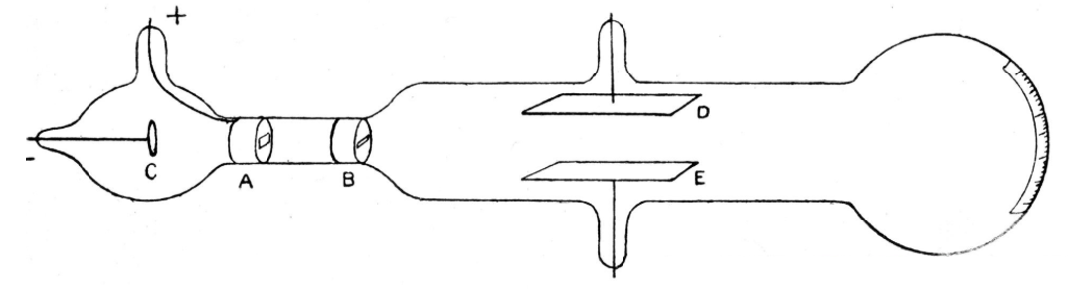

Source: Science and Society Picture Library

1. Assume that plate D on the diagram is positively charged and plate E is negatively charged. Sketch an approximate path of a cathode ray through the apparatus, starting at the cathode C.
2. What could Thomson conclude from:
3. the direction of the cathode ray path?
4. the amount of deviation from a straight line?

c) What did Thomson conclude about electrons?

d) Describe the ‘plum pudding model’ and sketch a labelled diagram.

Rutherford, Geiger, Marsden experiment Approximate date:

1. Complete the table with the combined class results for the lab experiment:

|  |  |
| --- | --- |
| **Total number of balls thrown** |  |
| **Total number passing through frame** |  |
| **Total number not passing through frame** |  |

1. Show a calculation to determine the total fraction of balls that were deflected back.
2. Briefly explain (include a calculation) how the lab experiment allowed us to estimate the diameter of a ping-pong ball.
3. Geiger, Marsden and Rutherford fired alpha particles at gold foil and measured the angle of deflection from the original path (shown as angle ‘A’ on the diagram). Their results are shown in the table, which gives the experimental count *N* of the number of alpha particles detected at each angle *A*.

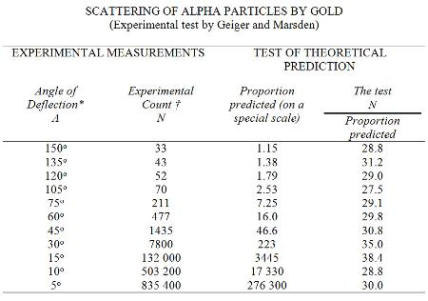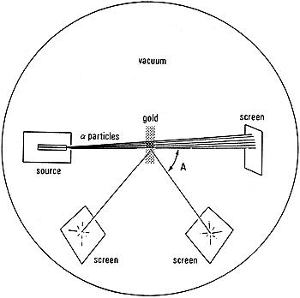

1. What is an -particle?
2. What results were they expecting, assuming a ‘plum pudding model’ for the atom?
3. Calculate the percentage (%) of alpha particles that were deflected at an angle of 5°. Show your working:
4. Mark the diagram to show the position where most alpha particles were counted.
5. Use the data in the table to describe as fully as you can the overall results **observed** in this experiment.
6. Explain (i.e. give a reason for) what happened to the majority of the alpha particles in the experiment – what did this reveal about atomic structure?
7. Explain the difference in count rate *N* between 150° and 5° deflections:
8. Describe the changes that Rutherford and his team made to the model of the atom in light of their results.
9. Suggest how the results of the experiment would have been different if neutrons were used instead of alpha particles (assuming neutrons could be detected by the screen).
10. Suggest how the results of the experiment would have been different if aluminium foil was used instead of gold foil (assuming the foils were of equal thickness).
11. If the gold foil used was 4.0 mm in thickness, how many atoms across is the foil, assuming the radius of a gold atom is 160 pm?

1. Suggest how the results of the experiment would have been different if gold foil with 5.0 mm thickness was used instead; give a reason for your answer.
2. The nucleus of a very large atom like uranium, could have a diameter of around m. If the uranium atom has a diameter of 312 pm, how many times larger than the nucleus is the whole atom?
3. Describe some of the limitations of our ‘ping-pong ball model’ in understanding the alpha particle experiment.

Moseley Approximate date:

1. (a) Which subatomic particle did the experiments by Moseley confirm?

(b) How did the model of the atom change?

The graph shows the results of Moseley’s experiments, with a relationship between the frequency of x-rays emitted from an element target and the charge of the nucleus in that element.

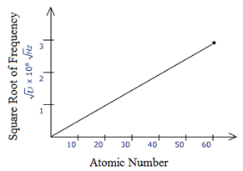

(c) Describe the relationship observed.

(d) Comment on the significance of the result and the link to the periodic table.

1. Moseley’s work showed that, in 1913, only four elements remained to be discovered that had lower atomic numbers than uranium. They had the atomic numbers 43, 61, 72 and 75. Find out what these elements are and when they were eventually discovered.

|  |  |  |
| --- | --- | --- |
| **Atomic number** | **Chemical symbol** | **Name of element** |
| 43 |  |  |
| 61 |  |  |
| 72 |  |  |
| 75 |  |  |

Chadwick Approximate date:

1. The apparatus used by Chadwick is shown below. The neutrons were the ‘radiation’ between the beryllium and paraffin wax.

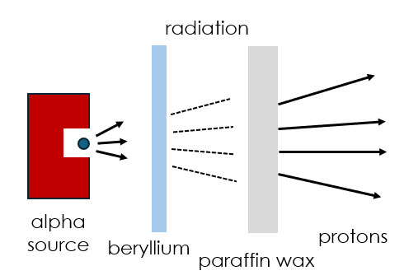

1. How could you demonstrate the particles in the ‘radiation’ were neutral?
2. What was discovered about the mass of the new particle?
3. How was the model of the atom modified in light of these results?
4. Most of the early elements in the periodic table have a roughly 1:1 ratio of protons to neutrons. What does this mean for the mass of an atom of beryllium if the atomic number is 4?
5. A uranium atom has 92 protons and 143 neutrons. What percentage of the mass of the atom is due to the neutrons? Comment on your answer in comparison to the 1:1 ratio for early elements.