Particle diagrams and coffee shops

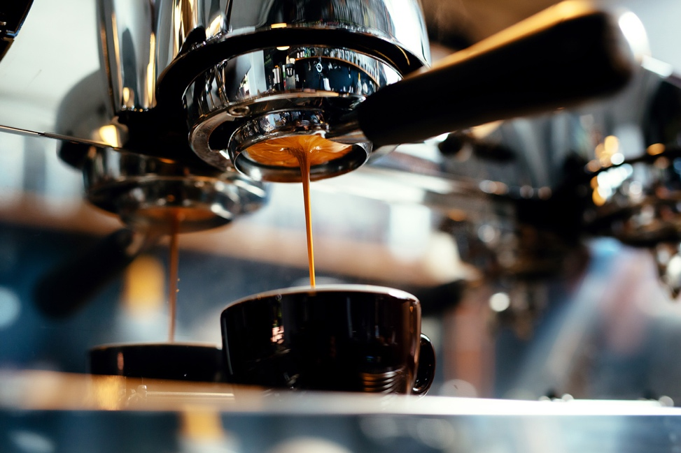There are over 1000 different chemical compounds in coffee. Some of these are responsible for the taste, flavour and smell of coffee.

Source: © Shutterstock

The familiar smell of the coffee shop is inviting to most people. Some of the coffee particles have escaped and are now moving freely in the atmosphere. When they reach your nose, you smell coffee.

1. Barista coffee is made with water at about 95°C. Some of the chemicals in coffee have enough energy to escape the surface and become gaseous.
   1. Describe how each of the following changes when these coffee particles become gaseous:
2. the energy of the particles
3. the distance between particles
4. the speed of the particles.
   1. Draw a diagram of the gaseous particles. Represent the particles using small circles.
5. When baristas make coffee, they filter very hot water through ground-up coffee beans. The coffee grounds must be the right size and packed correctly so that the water flows through at the right speed.
   1. Explain why water can flow in terms of the particles.
   2. Draw a particle diagram to represent the state of the water molecules at 95°C.
   3. The ideal diameter of each coffee ground used to make expresso coffee is 0.3 mm. The diameter of each water molecule is 0.3 nm.
6. What is the ideal diameter of each coffee ground in nm?
7. What is the ratio of the diameter of each water molecule to the ideal diameter of each coffee ground?
   1. The soluble chemicals in the coffee grounds dissolve in the water to make your cup of coffee.

Explain how the following diagram is limited in representing the cup of coffee.

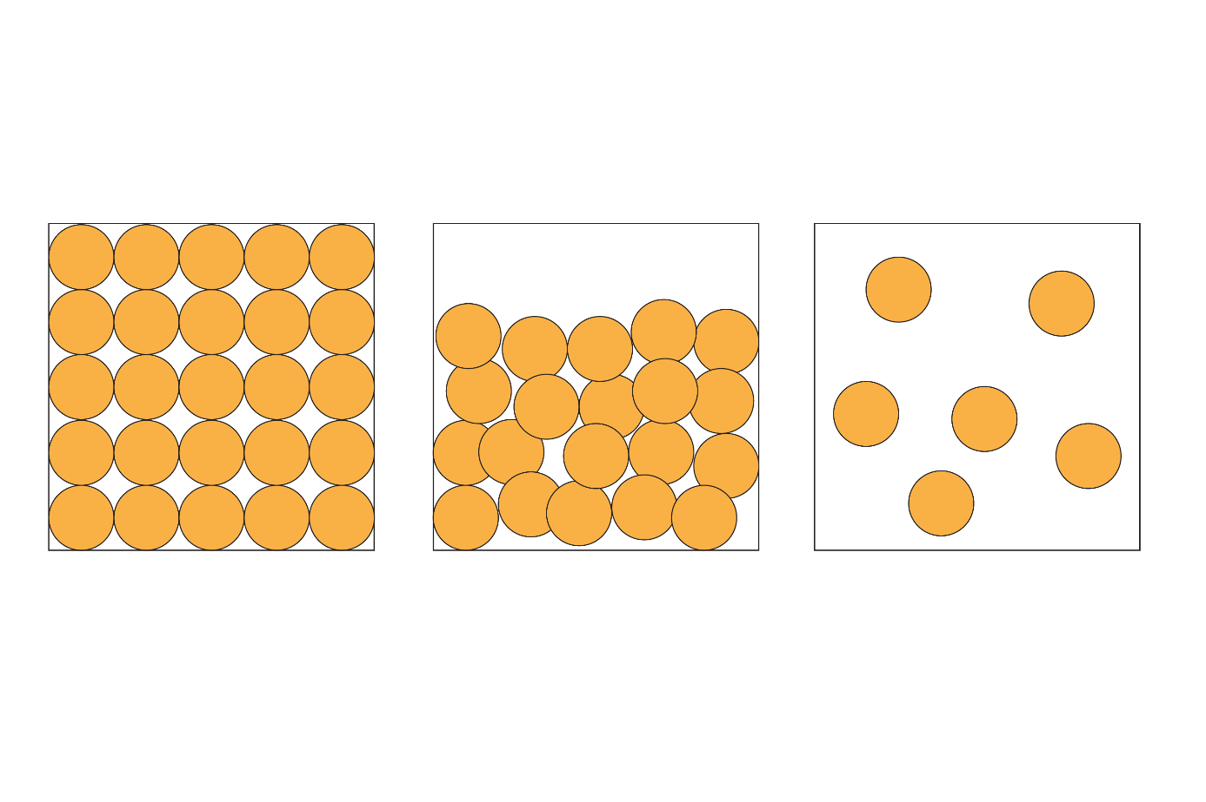

1. Some people add sugar to their coffee. The chemical name for sugar is sucrose. The image shows a model of sucrose:

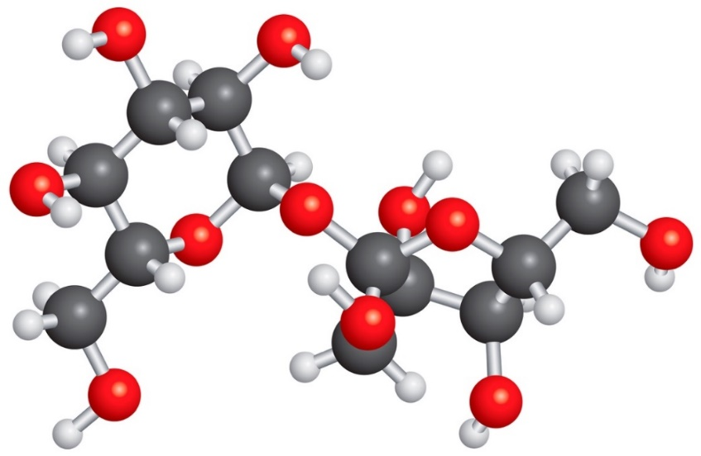

Source: © Shutterstock

Here is a particle diagram representing a solid:



* 1. Explain how the diagram is limited in representing sucrose.
  2. A 200 cm3 cup of coffee contains 10 g of sucrose. Calculate the concentration of sucrose in g/dm3. Give your answer to three significant figures.

Relative molecular mass of sucrose 342

Which question(s) did you get wrong? Why?

What will you do next time you’re asked a similar question?