# Stereoisomerism in alkenes – worksheet

*Education in Chemistry*  
July 2018  
[rsc.li/2JcLfbX](https://rsc.li/2JcLfbX)

**This worksheet accompanies the article ‘Molecular motors power on’. Download the worksheet, answer sheet and full article (MSword or pdf) from** [rsc.li/2JcLfbX](https://rsc.li/2JcLfbX)

Stereoisomers are defined as *molecules with the same structural formula but a different arrangement of the atoms in space*.

Owing to the restricted rotation around a C=C double bond it is possible for alkenes to exist as stereoisomers if there are two different groups attached to each carbon atom in the double bond. This type of stereoisomerism is called **geometric isomerism**.

There are two conventions used to describe the arrangement of groups across a double bond, E/Z isomerism and cis/trans isomerism.

**E/Z isomerism**

The priority of a group is based on atomic number. The atom with the higher atomic number has the highest priority.



**E isomer**

*(entgegen =* opposite)

The highest priority group on each carbon atom is on **opposite** sides

**Z isomer**

*(zusammen =* together)

The highest priority group on each carbon atom is on **the same** side

The priority of a group is based on **atomic number**. The atom attached to the alkene carbon atom with the highest atomic number is given the highest priority.

To clearly show the stereoisomerism across a double bond it is essential to show each alkene carbon atom with a trigonal planar geometry ie

**Cis/trans isomerism**

Cis/trans isomerism is a special case of E/Z isomerism in which two of the substituent groups (one on each carbon atom of the C=C) are the same.



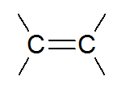

***trans* isomer**

The two C2H5 groups are on opposite sides

***cis* isomer**

The two C2H5 groups are on the same side

**Understanding check**

1. Draw and label the E and Z isomers of each of the following molecules.

a. pent-2-ene

b. 1-chloro prop-1-ene

c. 1-chloro-2-methyl but-1-ene

d. 2-bromo-3-chloro pent-2-ene

e. 2-bromo-1-chloro-1-hydroxy prop-1-ene

2. Each of the following naturally occurring alkenes contains two alkene functional groups, only one of which can exhibit E/Z isomerism.

Identify which alkene functional group can exhibit E/Z isomerism and state whether it is E or Z.



limonene geraniol carvone

3. Identify which of the following alkenes can be labelled using the cis/trans convention as well as the E/Z convention.

For those that can be labelled using the cis/trans convention identify which isomer is drawn.



but-2-ene 1-bromo-1,2-dichloroethene 3-phenyl pent-2-ene

4.

a. In 1999, Ben Feringa and his group created a molecular motor from an overcrowded alkene in which two large groups on either end of the double bond represent propeller blades. Pulses of UV light cause the configuration of the central double bond to switch between cis and trans, and cause the blades to rotate 180 degrees. This is accompanied by a helix inversion in the 3D shape of the molecule, which prevents reverse rotation, keeping the blades spinning in the same direction.

The diagram below shows the four stage rotary cycle of the molecular motor.

i. Identify in which of the steps **A**–**D** the double bond undergoes cis/trans isomerisation.

1. 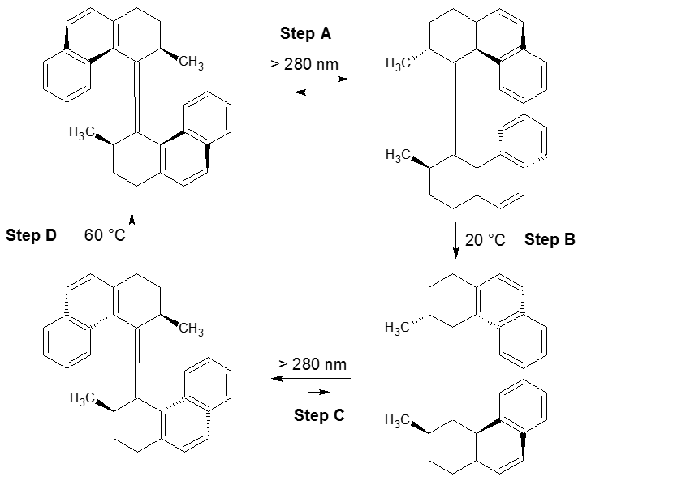Label each structure as having either cis or trans geometry around the double bond.

Redrawn with permission from Springer Nature: *Nature*, [*Light-driven monodirectional molecular rotor*, N Koumura et al., (1999)](https://www.nature.com/articles/43646)

b. Later generations of these molecular motors had a lower ‘stator’ half, which allowed them to be fixed to surfaces.

Look at the diagram below showing a second generation molecular motor. Explain why these do not show geometric isomerism.

