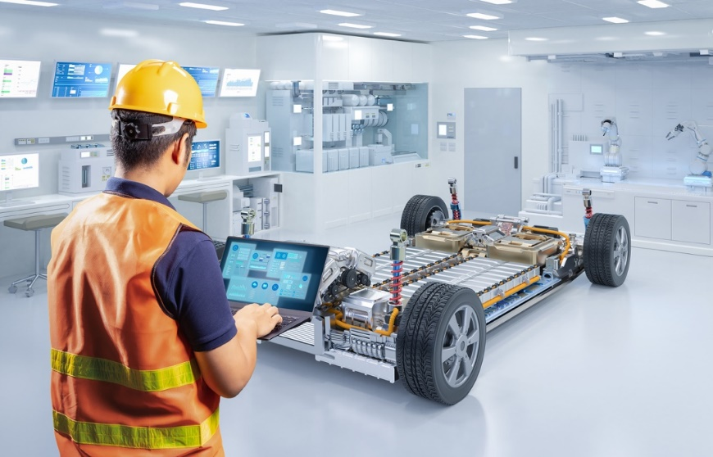Metallic structure and bonding in electric cars

Many different metals are used to manufacture electric cars. Most car bodies are made from iron and aluminium, but different metals are needed to make the batteries and other components.

Source: © Shutterstock

1. Sheets of metal are pressed into shape by robots to make the bodies of cars.
   1. Describe the structure of a metal.
   2. Explain how the structure of a metal allows it to be shaped without breaking.
   3. Metals used by car manufacturers also need to be strong. Most metals are strong because they have strong metallic bonds. Describe a metallic bond.
2. Aluminium magnesium alloys are used in the manufacture of many electric cars. The percentages by mass of metals in a typical alloy and the diameters of their ions are shown in the table.

|  |  |  |
| --- | --- | --- |
| **Metal** | **Percentage () by mass** | **Diameter of an ion/pm** |
| aluminium | 90 | 53 |
| magnesium | 10 | 71 |

* 1. Draw and label a diagram to represent the arrangement of particles in an aluminium magnesium alloy.

Hint: think about the relative sizes of the two types of particles.

* 1. Explain why the aluminium magnesium alloy is less malleable than pure aluminium.

1. The table below gives the amounts of two other metals used to manufacture electric cars. These are average amounts.

|  |  |
| --- | --- |
| **Metal** | **Amount used in average electric car/kg** |
| copper | 53 |
| lithium | 10 |

* 1. Copper is used in the electric circuits because it is an excellent conductor of electricity. Explain why copper can conduct electricity.
  2. Calculate the number of moles of copper used to make an average electric car. Give your answer to one decimal place.

Relative atomic mass (*A*r) copper 63.5

* 1. Copper forms ions with a 2 charge. Calculate the number of moles of delocalised electrons in:

1. one mole of copper atoms.
2. 53 kg of copper.
   1. Lithium is used in electric car batteries. Lithium ions have a 1 charge. Calculate the number of moles of delocalised electrons produced from one mole of lithium atoms.
   2. One mole of a particle contains of that particle. Calculate the number of atoms in:
3. one mole of copper.
4. 53 kg of copper.
   1. The charge on the metal ion and the number of delocalised electrons affect the strength of the metallic bond.
5. Predict which metal (copper or lithium) has the stronger metallic bond.
6. Give a reason for your prediction.

Which question(s) did you get wrong? Why?

What will you do next time you’re asked a similar question?