Metallic structure and bonding: teacher guidance

**These Knowledge check worksheets**provide a series of questions to assess learners’ knowledge and understanding of this topic at the end of a period of teaching or as revision. They are available at Foundation and Higher level and as fully editable versions so you can adapt them to suit learners’ needs. Use for individual student work in class or at home. Find the full set of answers below.

Also available to assess this topic:

* **Review my learning** worksheets: available with three levels of scaffolded support to help build confidence in every learner. Use before, during or after teaching the relevant topic, to understand progress and identify misconceptions, **rsc.li/44igB7V**.
* **In context worksheets** ask learners to apply their knowledge to interesting contexts from everyday life, helping them develop their skills and prepare for examination, including calculation questions to practise mathematical skills within a genuine chemical context**, rsc.li/3RqX1Bb**.

Answers

Please note that particles in metals are referred to as ions. They can also be called particles.

Foundation

1. (a) i. Correctly placed ‘metal ion’ label. [1 mark]

ii. Correctly placed ‘delocalised electron’ label. [1 mark]

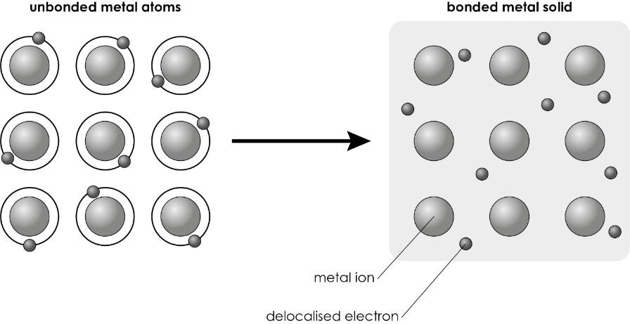

* 1. **B** copper [1 mark]
  2. i. positive charge [1 mark]

ii. negative charge [1 mark]

* 1. electrostatic attraction/force [1 mark]
  2. **A** Delocalised electrons are free to move through the metal structure.

[1 mark]

* 1. **B** giant metallic structure [1 mark]

1. [All correct – 2 marks, two correct – 1 mark]

|  |  |  |
| --- | --- | --- |
| **Physical property** |  | **Explanation** |
|  |  |  |
| High melting point of 1083°C |  | Delocalised electrons move through the metal and carry the electric charge. |
|  |  |  |
| Good electrical conductor |  | Delocalised electrons move through the metal and transfer heat energy. |
|  |  |  |
| Good conductor of heat |  | Layers of metal ions slide over each other. |
|  |  |  |
| Is malleable  (can be hammered into shape without breaking) |  | Large amounts of heat energy are needed to break the strong metallic bonds. |

1. (a) **B** An alloy is a mixture of a metal and one or more other element(s).

[1 mark]

(b) i. The horizontal force on the pure metal will cause the layers of metal ions to move over each other. [1 mark]

ii. The metal ions on the alloy will not move so much with a horizontal force. [1 mark]

(c) Pure metals are too **soft** [1] for many users. Alloys are **harder** [1] than pure metals. The mixture of elements in an alloy has different-sized **particles** [1]. This disrupts the **regular** [1] arrangement of particles in the metal and stops the layers of particles from rolling over each other. [4 marks]

[Total: 17 marks]

Higher

1. (a)

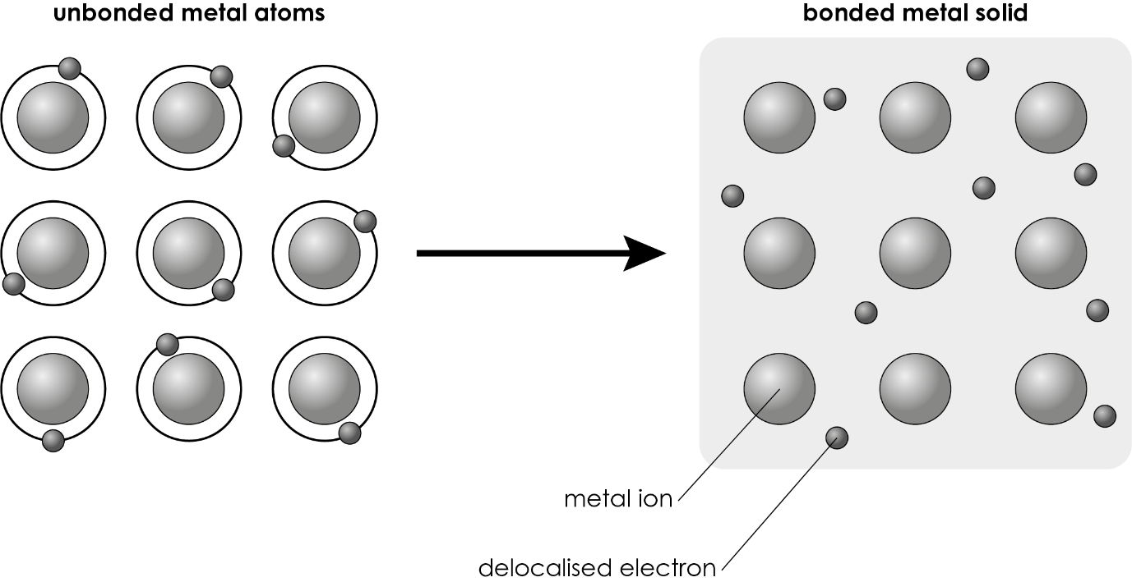

[1 mark for correctly placed ‘metal ion’ label]

[1 mark for correctly placed ‘delocalised electron’ label]

* 1. metallic bonding [1 mark]
  2. group 1 [1 mark]
  3. Examples of suitable answers include (students may have other correct answers):
* Electrons are delocalised in the bonded metal, but not in the unbonded metal.
* There are metal atoms in the unbonded metal and metal ions in the bonded metal.

[2 marks (1 mark for each difference)]

* 1. electrostatic force/attraction [1 mark]
  2. i. The positively charged particles vibrate. [1 mark]

ii. The negatively charged particles are free to move   
through the structure. [1 mark]

* 1. giant metallic structure/lattice [1 mark]
  2. The metal ions would have a 2+ charge. [1 mark]

There would be two delocalised electrons to every magnesium ion.

[1 mark]

* 1. Magnesium is in group 2 [1], so will have two electrons in the outer shell that can be delocalised. [1] [2 marks]

1. (a) Melting point: Strong electrostatic forces between positive ions and delocalised electrons. [1] Take a lot of energy to break. [1] [2 marks]

(b) Boiling point: Strong metallic bonds in copper for the liquid to turn into a gas. [1] Take a lot of energy to break. [1] [2 marks]

(c) Electrical and heat conductivity: Delocalised electrons move through the structure [1] to carry the charge and conduct heat. [1] [2 marks]

(d) Malleability: Layers of regularly arranged metal ions slide over each other. [1] This allows a metal to be hammered or rolled into a new shape and deform without breaking. [1] [2 marks]

1. (a) An alloy is a mixture of a metal and one or more other element. [1 mark]

(b) Layers of regularly arranged metal ions can slide over each other. [1 mark]

(c) i. The metal ions are harder to move. [1 mark]

ii. The different-sized metal ions disrupt the regular arrangement and there is less sliding over of layers. [1 mark]

(d) Alloys are harder and so have potentially more uses than pure metals, which are softer. [1 mark]

[Total: 27 marks]