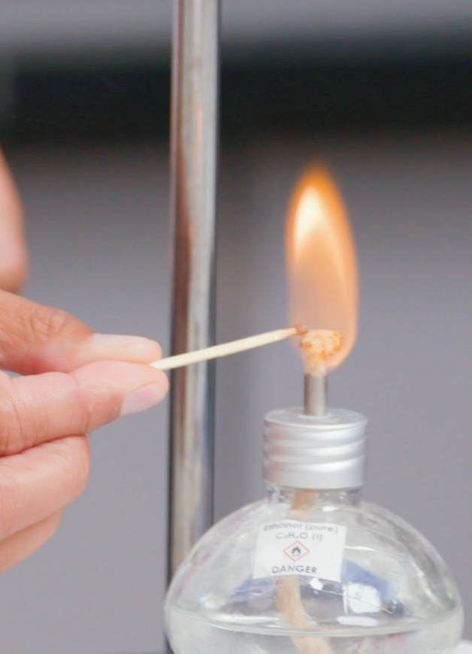

Enthalpy   
change of combustion

Practical video

Supporting resources

Registered charity number: 207890

# Contents

Teacher notes 1

How to use this video 1

Notes on running the practical experiment 1

Key terms 2

Prior knowledge 3

Common misconceptions 3

Real-world contexts 4

Cross-curriculum links and skills 4

How to use the additional resources 4

Intended outcomes 5

Additional resources 6

Pause-and-think questions 6

Follow-up worksheet 10

Support 10

Challenge 12

Follow-up worksheet answers (support and challenge) 15

Structure strip: suggested answer 18

Also available:

* Technician notes
* Integrated instructions
* Frayer models
* Johnstone’s triangle

Download the PDF and editable PowerPoint slides at [rsc.li/4a2Ko7l](http://rsc.li/4a2Ko7l).

# Teacher notes

This resource supports the practical video Enthalpy change of combustion, available here: [rsc.li/4a2Ko7l](http://rsc.li/4a2Ko7l).

The value of experiencing live practical work cannot be overstated. Numerous studies provide evidence of its value in terms of learner engagement, understanding, results and the likelihood of continuing to study chemistry or work in a related field.

Use this video to complement live practical work, or to help learners understand the methods, equipment and skills when they cannot access the lab.

## How to use this video

The video and additional resources are designed for you to use flexibly but read on for suggestions of how to use them with your learners.

### Flipped learning

Show learners the video before the live practical lesson to help it run more smoothly and keep objectives in focus. This will build learners’ confidence and improve their outcomes in the lesson. Use questions from the set provided as part of the preparation task (for more on flipped learning, see [rsc.li/3On7DQF](http://rsc.li/3On7DQF)).

### Consolidation and revision

Show learners the video after the practical – either directly after the lesson or return to it as part of learners’ exam revision.

### Revisiting the practical with a different focus

Practical experiments support many learning outcomes. Focusing on just one or two of those in a lesson will ensure you achieve the lesson’s aims. Use the video to revisit the experiment with a different focus.

### Home learning

Whether it is remote teaching, homework, or individual learner absence, give learners an opportunity to engage with a practical experiment and the associated skills when they are not in the lab.

### Other tips

#### Provide your own commentary

Mute the voice over and provide your own commentary. This will allow you to better engage with learners and adapt the video to the needs and objectives of your lesson.

#### Use questions

A set of pause-and-think questions are provided in two formats, one for teacher-led questions and discussion and a student worksheet to be used independently by learners. Select from these or create your own questions to engage learners and target specific aims.

## Notes on running the practical experiment

The video uses a copper calorimeter but you can use a conical flask instead. The practical shown demonstrates how to measure the enthalpy change of combustion of ethanol. Ensure that the spirit burners have lids as learners will use these to snuff out the flame and stop any hot alcohol from evaporating at the end. It is easy to break the thermometer by knocking it out of the calorimeter. The video shows the thermometer carefully clamped into position and suggests using a glass stirring rod to ensure even heat distribution. By telling everyone to stop when the temperature reaches 70°C with 100 cm3 of water, a class set of results will provide the repeats needed. You can instruct learners to stop at a different final temperature, too.

Learners will collect the following results from this practical:

* The mass of the spirit burner, lid and alcohol at the start of the experiment.
* The initial temperature of the water.
* The mass of the spirit burner, lid and alcohol after heating the water to the desired temperature, 70°C in this case, to work out the mass of alcohol used.

They will calculate the heat energy change in joules using the equation *Eh*, or *Q*, = *mc*Δ*T*. Learners can also determine the heat energy change per gram and per mole of fuel (molar enthalpy) as a challenge.

We only used ethanol (student safety sheet 60 from CLEAPSS: [bit.ly/3T9fcwP](http://bit.ly/3T9fcwP)) as a fuel in the video, but you can use other alcohols and compare their heat energy changes using the same method.

Technician notes, including the equipment list, safety notes and tips are available here: [rsc.li/4a2Ko7l](http://rsc.li/4a2Ko7l). Read our standard health and safety guidance (available from: [rsc.li/3IAmFA0](http://rsc.li/3IAmFA0)) and carry out a risk assessment before running any live practical.

### Procedure for the combustion of ethanol

1. Clamp the calorimeter, or conical flask, using a clamp stand, boss and clamp so that it is approximately 1 cm above the spirit burner when the lid is on.
2. Clamp the thermometer using the same clamp stand and another boss and clamp so that it is in the water but not touching the base of the calorimeter/conical flask. Be careful not to overtighten the clamp as the thermometer might break.
3. Measure 100 cm3 of cold tap water in a measuring cylinder and pour it into the calorimeter or conical flask.
4. Use a thermometer to record the starting temperature of the water.
5. Measure and record the mass of a spirit burner containing ethanol, with the lid on, using a mass balance. Keep the spirit burner the correct way up to avoid spillages.
6. Take the lid off the spirit burner and keep it close.
7. Place the spirit burner on the bottom of the clamp stand and light the wick of the spirit burner. Don’t move the spirit burner when it’s lit.
8. Using tongs, put the lid on the spirit burner to put out the flame when the temperature of the water reaches 70°C or your planned temperature change.
9. Measure the mass of the spirit burner containing ethanol and the lid again and record.
10. Wait until the calorimeter/conical flask is cool before emptying the water and looking at the bottom for soot. Wipe the bottom of the container with some paper towel to remove any soot.

### Integrated instructions

Integrated instructions use clear numbering, arrows and simple pictograms, like an eye to show when to make observations. They were developed using cognitive load theory and remove unnecessary information. Therefore, the instructions reduce extraneous load on learners, increasing the capacity of their working memory to think about what they are doing and why. Download the integrated instructions for this experiment at [rsc.li/3MSQltm](http://rsc.li/3MSQltm).

## Key terms

* + Complete combustion – a chemical reaction that occurs when a substance (fuel) reacts in a good supply of oxygen to give out heat and light.
  + Incomplete combustion – a chemical reaction that occurs when a substance (fuel) burns in a limited supply of oxygen to give out heat and light.
  + Enthalpy change – the difference between the heat/thermal energy of the reactants and the energy of the products.
  + Energy – the ability to ‘do work’.
  + Exothermic reaction – a chemical reaction where energy is transferred from the chemicals to the surroundings (usually in the form of heat).
  + Fuel – a substance that stores energy and produces heat when burned.
  + Alcohol – a homologous series of compounds containing the –OH functional group, with the general formula C*n*H*2n*+1OH.
  + Energy transfer – the movement of energy from one energy store to another energy store.
  + Activation energy – the minimum amount of energy needed for a chemical reaction to happen.
  + Molar enthalpy change (challenge only) – the heat/thermal energy change per mole of substance.

You will find a template and example Frayer models for the terms: ‘exothermic’, ‘combustion’ and ‘incomplete combustion’ on the PowerPoint slides available from: [rsc.li/4a2Ko7l](http://rsc.li/4a2Ko7l).

## Prior knowledge

### Core knowledge

* + Complete and incomplete combustion, including products, word and symbol equations.
  + Link observed, qualitative changes in temperature to a chemical reaction taking place.
  + Use temperature measurements to identify an exothermic reaction.
  + Recall that an exothermic reaction transfers heat energy to the surroundings.
  + Energy is transferred to surroundings other than the water.
  + The quantity of heat energy change can be determined experimentally and calculated using

*Eh*, or *Q*, = *mc*Δ*T*.

* + Delta, Δ, is the change in a variable.
  + Combustion of fuels is a major source of atmospheric pollution and its effects.

### Extension knowledge

Learners will consolidate extension knowledge in the challenge questions.

* + Exothermic and endothermic reactions in terms of bond breaking and bond making.
  + Use of units, such as joules/mole, J/mol or J mol-1
  + Energy stores – chemical and thermal – and transfers.
  + Breaking and making bonds.
  + Recall that an exothermic reaction has a negative enthalpy value.
  + Finding out the number of moles of a compound.
  + Molar enthalpy change.

## Common misconceptions

Fuels are energy stores from which energy is ‘released’.

Language used when discussing energy both in everyday life and in school, such as ‘fuels contain energy’, can give learners the impression that energy stored inside the fuel is ‘released’ when a fuel burns. Reinforce that combustion of a fuel is a chemical reaction that also involves oxygen and transfers heat energy to the surroundings. Research suggests using the phrase fuel-oxygen system helps learners to understand this point. Read more at: [rsc.li/46M2TKj.](http://rsc.li/46M2TKj)

Use the same language learners will hear in their physics lessons on energy stores and transfers. The idea of energy being ‘released’ can lead to misconceptions about chemical bonds. Learners often form the idea that energy is released when bonds break, when in fact bond breaking is an endothermic process.

Energy can be created or used up.

When a combustion reaction transfers energy to the surrounding air, the energy dissipates. This everyday experience may reinforce the idea that energy can be ‘lost’. Make links between chemistry understanding and physics understanding to help learners in overcoming this area of misconceptions. It is important to reiterate the law of conservation of energy whenever discussing energy in chemistry: energy cannot be created or destroyed.

Variable: using the same mass of fuel or burning the fuel for the same length of time.

Reiterate that the same amount of energy is transferred to the water so learners must measure the mass of fuel needed to raise the temperature of the same mass of water between the same temperatures. For different fuels this will involve a different mass of fuel.

Some fuels are just ‘stronger’ than others.

Draw out the idea that the longer the carbon chain, the more heat energy is transferred. Avoid using terms such as stronger or weaker in this context. You could compare propan-1-ol and propan-2-ol as an extension.

When using *Eh*, or *Q*, = *mc*Δ*T*, mass must be measured in kilograms.

It is more useful to have the mass measured in grams. Learners can then convert to moles for extension work. In physics the mass measured in a specific heat capacity experiment will usually be in kilograms and is 4200 J kg-1 °C-1 for water. In chemistry, we use a specific heat capacity for water of 4.2 J g-1 °C-1. As long as learners are consistent with the unit of mass used in the calculation, they will get the same answer.

When using *Eh*, or *Q*, = *mc*Δ*T*, m is the mass of alcohol used.

The mass, *m*, in the equation can also be the volume of water heated because the density of water is

1 g cm-3 so a mass of 1 g has a volume of 1 cm3. For some learners you may need to revisit the concept of density and use a more structured approach to work out the volume. A common misunderstanding of this equation is for learners to enter the mass of fuel used instead of the mass of water.

## Real-world contexts

* + Engage learners in fire safety with this problem-solving activity where they investigate how to make fire extinguisher foam: [rsc.li/3q3CiZW](http://rsc.li/3q3CiZW).
  + Link the environmental impacts of burning fuels to UN sustainable development goal 13, climate action. Download the flow diagram with questions to improve learners’ conceptual understanding: [rsc.li/3Op2GX](http://rsc.li/3Op2GXu)u.
  + Highlight careers that are fixing the future, such as Raquel’s role as head of research and sustainability ([rsc.li/47blyQJ](http://rsc.li/47blyQJ)). She reduces carbon dioxide emissions by using pineapple leaf fibres to make a leather- like material, Piñatex, instead of burning the leaves.
  + Provide context to thermodynamics with this infographic poster ([rsc.li/3rH8nHm](http://rsc.li/3rH8nHm)), which you can display in your classroom.
  + Demonstrate the ‘alcohol gun’ experiment to show learners what happens in an internal combustion engine: [rsc.li/43Ap7ND.](http://rsc.li/43Ap7ND)

## Cross-curriculum links and skills

* + The follow-up worksheet provides an opportunity for learners to apply their mathematical skills through converting units and calculations.
  + In physics, learners may measure the specific heat capacity of other substances so make links to these practicals to embed their learning.
  + Learners can also perform a similar experiment to find out the energy stored in food, such as crisps ([rsc.li/3Qx07T0](http://rsc.li/3Qx07T0)).

## How to use the additional resources

### Pause-and-think questions

Pause-and-think questions are supplied in two formats: a teacher version for ‘live’ questioning and a learner version that can be used during independent study. The timestamps allow you to pause the video when presenting it to your class, or learners to use the video for active revision.

#### Teacher version

The questions are in a table. You can use as many as are appropriate for your class and the learning objectives. Some questions have two timestamps to allow you to adapt the questions for different classes or scenarios. Pause the videos at the earlier timestamp to ask a question before you hear/see the answer, useful for revision or to challenge learners. Pause at the later timestamp to ask a question reflectively and assess whether learners have understood what they have just heard or seen. This would be useful when introducing a topic, for flipped learning or to provide additional support and encouragement.

Think about how you will ask for responses. Variation in how you ask for responses may help increase engagement. Learners could write and hold up short answers or they could discuss questions in groups. Not all answers are in the video. Some of the questions will extend learners’ thinking beyond its content or draw on prior learning.

#### Learner version

Provide the worksheet with the same questions in situations where there is not a teacher present to guide discussion during the video, eg homework, revision or remote learning.

### Using the structure strip

Writing about chemistry encourages learners to reflect on their understanding, formulate new ideas and make links in new ways. Learners also need to practise for long-answer questions in exams. They can stick the structure strip in the margin and use the prompts to overcome ‘fear of the blank page’. Use it to consolidate learning after the practical and/or for revision. Read more at [rsc.li/2P0JDlW](http://rsc.li/2P0JDlW).

### Using the follow-up worksheet

The follow-up worksheets for this video takes learners through the complete experimental technique for the combustion of ethanol. The support student sheet takes the calculation as far as finding Eh and the heat energy change in kilojoules per gram. The challenge student sheet contains calculations leading to finding the molar enthalpy of combustion of ethanol. The extension questions on this worksheet use given data from the first four alcohols and compare the combustion values by asking the learner to draw a graph and comment on the relationship between the number of carbon atoms and the enthalpy of combustion. Both versions of the worksheet ask learners to decide why the experimental results are different to data book results.

The worksheets are designed so that learners can add in their own results and process the data without the video. You can also use the video as a prompt or to provide example results. The answers, including calculations using our data, are at the end of this document.

Use the Johnstone’s triangle, available to download as a PowerPoint from [rsc.li/4a2Ko7l](http://rsc.li/4a2Ko7l), to help learners link their observations to what’s going on at the submicroscopic level.

### Intended outcomes

It’s important that the purpose of each practical is clear from the outset. Defining the intended learning outcomes consolidates this. Outcomes can be categorised as ‘hands on’ – what learners are going to do with objects – and ‘minds on’ – what learners are going to do with ideas to show their understanding. We have offered some differentiated suggestions for this practical. You can focus on just one or two, or make amendments based your learners’ needs (read more at [rsc.li/2JMvKa5](http://rsc.li/2JMvKa5)).

Consider how you will share outcomes and evaluation with learners to empower them to direct their own learning.

Hands on Minds on

Effective at a lower level

Effective at

a higher level

Learners correctly:

* Set up apparatus to collect measurements to work out the heat energy change for a reaction involving heating water with a spirit burner.

Learners correctly:

* Collect data for two different alcohols and compare their heat energy changes.

Learners correctly:

* Use the equation *Eh*, or *Q*, = *mc*Δ*T* to work out the heat energy change for the reaction they have measured experimentally.
* Use the data collected to work out heat energy change per gram.

Learners correctly:

* Use the data collected to work out heat energy change per mole.

# Additional resources

## Pause-and-think questions

Teacher version

|  |  |  |  |
| --- | --- | --- | --- |
| Timestamp(s) | | Question | Answer/discussion points |
| 00:29 | 00:38 | What is enthalpy change? | The difference between the heat energy of the reactants and of the products. |
| 00:57 | 01:02 | What container could you use to hold the water instead of the copper calorimeter? | A conical flask. |
| 01:13 | 01:18 | Why shouldn’t you overtighten the clamp holding the thermometer? | It might break. |
| 01:50 | | Why do I need to measure the mass of the alcohol burner with the lid on? | You need to keep the lid on as you’ll measure the spirit burner and lid again at the end of the experiment when the lid is needed to stop alcohol vapour evaporating. |
| 02:12 | 02:17 | What should you not do with the spirit burner once it’s lit? | Move it. |
| 02:34 | 02:45 | How do you put out the spirit burner flame? | By placing the lid, with tongs, on the spirit burner. |
| 03:04 | | Can you list two control variables that you should keep the same if you repeated the experiment? | Any from:  Keep the spirit burner wick the same distance from the bottom of the calorimeter.  Use the same volume calorimeter.  Keep the same volume of water. |
| 03:24 | | If you repeat the experiment with a different alcohol, which variable are you changing? | Independent variable. |
| 03:31 | 03:36 | What is the word equation for complete combustion? | Ethanol + oxygen ➝ carbon dioxide + water |
| 03:36 | 03:39 | Write a balanced symbol equation for the complete combustion of ethanol. | C2H5OH + 3O2 ➝ 2CO2 + 3H2O |
| 03:43 | 03:57 | What are the reactants for incomplete combustion in this experiment? | Ethanol and oxygen. |
| 03:55 | 04:08 | Why is the bottom of the calorimeter sooty? | The ethanol burned with a yellow flame suggesting there wasn’t enough oxygen for a complete reaction. This is called incomplete combustion. Some of the potential products are water, the poisonous gas carbon monoxide and carbon, which is the soot we can see. |
| 04:31 | 04:34 | What is the unit for specific heat capacity? | Joules per gram per degree Celsius, J g-1 °C-1 |

|  |  |  |  |
| --- | --- | --- | --- |
| Timestamp(s) | | Question | Answer/discussion points |
| 05:05 | 05:16 | Calculate the temperature change of water in this experiment. | Temperature before – temperature after = temperature change  70.0 – 22.0 = 48.0 |
| 06:03 | 06:23 | Why is your enthalpy change value different from a data book’s value? | Heat is transferred to the air and calorimeter instead of the water. Heat is lost due to evaporation of the  water.  Incomplete combustion means there is less heat transfer from the reaction than if the combustion was complete.  The flame flickered so wasn’t always directly under the calorimeter. |
| 06:32 | 06:44 | Can you think of some simple adjustments that you can make to improve the heat transfer to the water? | You could insulate the calorimeter (or conical flask) and add a lid. You could also add a draught shield. |

## Pause-and-think questions

### Learner version

Pause the video at the time stated to test or revise your knowledge of this practical experiment.

Time Question

00:38 What is enthalpy change?

01:02 What container could you use to hold the water instead of the copper calorimeter?

01:18 Why shouldn’t you overtighten the clamp holding the thermometer?

01:50 Why do I need to measure the mass of the alcohol burner with the lid on?

02:17 What should you not do with the spirit burner once it’s lit?

02:45 How do you put out the spirit burner flame?

03:04 Can you list two control variables that you should keep the same if you repeated the experiment?

03:24 If you repeat the experiment with a different alcohol, which variable are you changing?

03:36 What is the word equation for complete combustion? State the

03:39 Write a balanced symbol equation for the complete combustion of ethanol.

03:57 What are the reactants for incomplete combustion in this experiment?

04:08 Why is the bottom of the calorimeter sooty?

04:34 What is the unit for specific heat capacity?

05:16 Calculate the temperature change of water in this experiment.

06:23 Why is your enthalpy change value different from a data book’s value?

06:44 Can you think of some simple adjustments that you can make to improve the heat transfer to the water?

## Follow-up worksheet

This worksheet accompanies the Enthalpy change of combustion video, available at [rsc.li/4a2Ko7l](http://rsc.li/4a2Ko7l). The experiment investigates burning ethanol in a spirit burner and measuring the change in temperature of water in a copper calorimeter. You can also use the worksheet if you have completed this experiment in your school laboratory with slightly different equipment.

### Support

1. Label the apparatus used to measure the heat energy change for ethanol. Choose from the following words:

Copper calorimeter Spirit burner Thermometer

Clamp stand Spirit burner lid Clamp

Heatproof mat Measuring cylinder

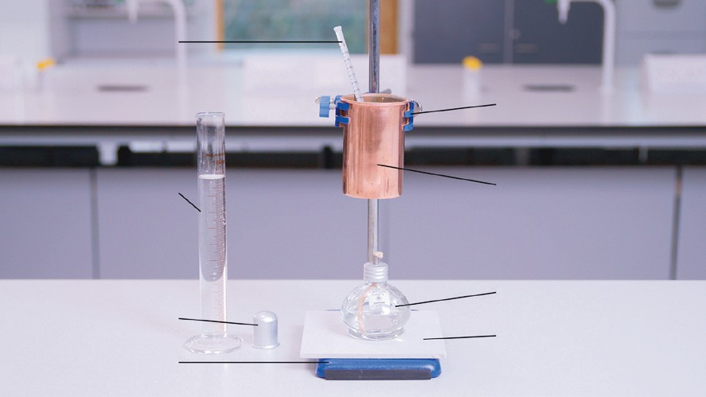

1. Put the following statements in order. The first and last ones are completed for you.

|  |  |
| --- | --- |
|  | a) Set up the apparatus as shown in the diagram above. |
| Find the mass of a spirit burner and lid containing ethanol. | b) |
| Stir the water every 30 s with a glass stirring rod. | c) |
| Place the lid on the spirit burner to put out the flame when the water temperature reaches 70°C. | d) |
| Record the starting temperature of the water. | e) |
| Measure 100 cm3 of water and pour it into a calorimeter. | f) |
| Light the spirit burner. | g) |
|  | h) Find the mass of the spirit burner and lid containing ethanol. |

1. Use your results or the video to complete the table.

Volume of water used (this is the same as mass, *m*, of water) = cm3

|  |  |  |  |  |  |
| --- | --- | --- | --- | --- | --- |
| Temperature of water (°C) | | | Mass of alcohol and spirit burner (g) | | Mass of alcohol used (g) |
| Start | End | Temperature change, ∆*T* | Before | After |
|  |  |  |  |  |  |

1. Calculate the heat energy change of the reaction in joules, *Eh* (J).

Heat energy change (J) = mass of water (g) × 4.2 (J g-1 °C-1) × temperature change Heat energy change (J) = *m* × *c* × ∆*T*

Write in the values from your results table.

*m* = g

*c* = 4.2 J g-1 °C-1

∆*T* =

Using the equation above, work out the heat energy change in joules for this experiment. Heat energy change =

Heat energy change = J

1. Calculate the heat energy change of the reaction in kilojoules, *Eh* (kJ), and per gram of ethanol, kJ g-1.

Chemists compare energy in kJ. To convert the heat energy change from joules to kilojoules, divide by 1000. Use your answer from Q4.

Heat energy change = 1000 = kJ

To work out the heat energy change in kilojoules per gram, kJ g-1, you divide the heat energy change in kJ by the mass of ethanol used.

Write down the mass of ethanol used from the results table.

Mass of ethanol used = g

Heat energy change (kJ g-1) = heat energy change (kJ) = kJ g-1

mass of ethanol used (g)

#### Questions

1. It is useful to compare different alcohols. Which variable would you be changing in this experiment if you repeated it with different alcohols?
2. The heat energy change for this reaction should be much larger than the answer obtained by this experiment. List two changes you can make to the apparatus to improve the results.

### Challenge

1. Label the apparatus used to measure the enthalpy of combustion of ethanol.

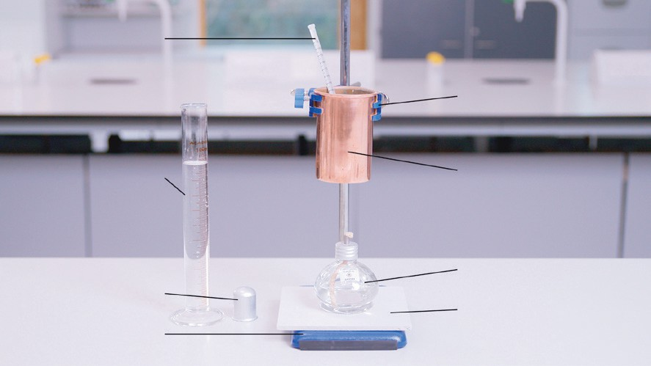

1. Write a method for this experiment. The first statement has been completed for you.
   1. Set up the apparatus as shown in the diagram above.
   2. …
2. Use your results or the video to complete the table. Volume of water used = cm3

|  |  |  |  |  |  |
| --- | --- | --- | --- | --- | --- |
| Temperature of water (°C) | | | Mass of alcohol and spirit burner (g) | | Mass of alcohol used (g) |
| Start | End | Temperature change | Before | After |
|  |  |  |  |  |  |

1. Calculate the heat energy change of the reaction, *Eh* (J). Remember to include units.

Heat energy change (J) = #mass of water (g) × specific heat capacity (J g-1 °C-1) × temperature change

#The density of water is 1 g cm-3 so 1 g of water has a volume of 1 cm3. You can therefore use the volume of water heated for this value.

*m* = g

*c* = J g-1 °C-1

∆*T* =

Using the equation above, work out the heat energy change in joules transferred in this experiment. Remember to include the unit.

Heat energy change = J

1. Calculate the heat energy change in kilojoules per gram, kJ g-1.

Mass of ethanol used = g

Heat energy change = heat energy change (kJ) =

mass of ethanol used (g)

1. Work out the heat energy change of combustion per mole of ethanol.

To do this question, you need to work out the number of moles of ethanol.

*Mr* ethanol =

Mass of ethanol used =

Number of moles of ethanol used = mass = =

*Mr*

The heat energy change = J

= kJ

Heat energy change per mole of ethanol = heat energy change (kJ) =

moles of ethanol

=

*The heat energy change per mole that you have just worked out is also called the molar enthalpy change of combustion of ethanol and has the symbol* ∆*Hc.*

This is an exothermic reaction. Add a sign to your enthalpy value. ∆*Hc* =

#### Questions

1. It is useful to compare different alcohols. Which variable would you be changing in this experiment if you repeated it with different alcohols?
2. The data book value for the enthalpy of combustion of ethanol is -1371 kJ mol-1. Why is your answer different? List two reasons.
3. Extension – use the following enthalpies of combustion to draw a graph.

|  |  |  |  |  |
| --- | --- | --- | --- | --- |
|  | Methanol | Ethanol | Propan-1-ol | Butan-1-ol |
| Number of carbons | 1 | 2 | 3 | 4 |
| Enthalpy of combustion kJ mol-1 | -715 | -1371 | -2010 | -2673 |

* 1. Using the axes below, plot the number of carbons against enthalpies of combustion listed in the table above.

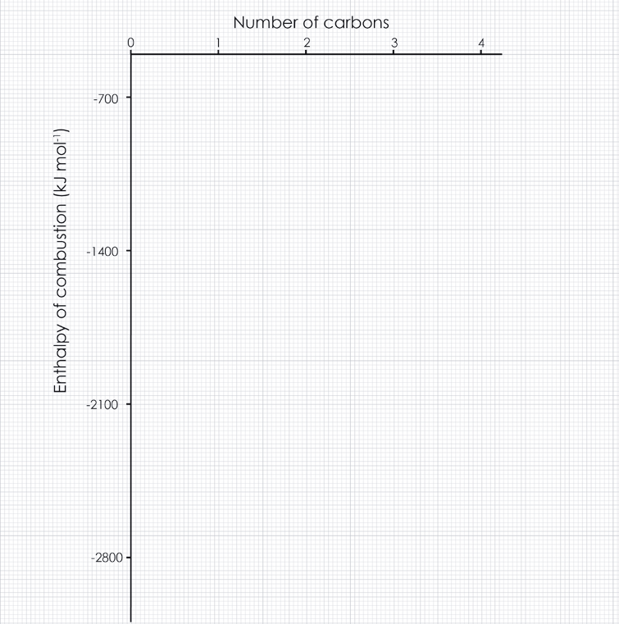

* 1. Draw a line of best fit.
  2. Describe the relationship between the number of carbons and the enthalpy of combustion.

1. Extension – using your answer to ciii), explain why the enthalpy of combustion changes like this as the number of carbons in the alcohols increase?

## Follow-up worksheet answers (support and challenge)

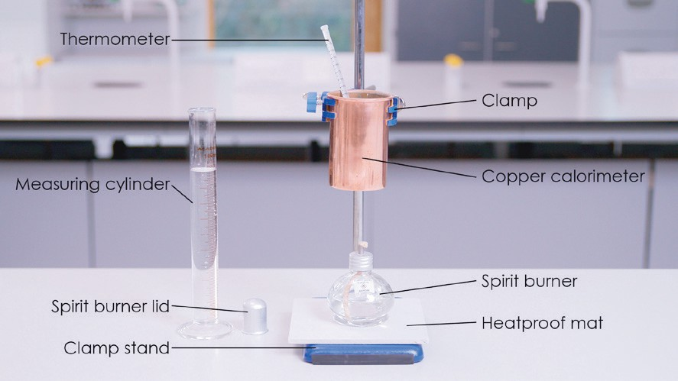

1. Note: b) and c) can be in reverse order.
   1. Set up the apparatus as shown in the diagram above.
   2. Measure 100 cm3 of water and pour it into a calorimeter.
   3. Find the mass of a spirit burner and lid containing ethanol.
   4. Record the starting temperature of the water.
   5. Light the spirit burner.
   6. Stir the water every 30 s with a glass stirring rod.
   7. Place the lid on the spirit burner to put out the flame when the water temperature reaches 70°C.
   8. Find the mass of a spirit burner and lid containing ethanol.
2. Volume of water used = 100 cm3

|  |  |  |  |  |  |
| --- | --- | --- | --- | --- | --- |
| Temperature of water (°C) | | | Mass of alcohol and spirit burner (g) | | Mass of alcohol used (g) |
| Start | End | Temperature change, ∆*T* | Before | After |
| 22.0 | 70.0 | 48.0 | 237.25 | 230.33 | 6.92 |

1. Calculate the heat energy change of the reaction, *Eh* (J).

Heat energy change (J) = #mass of water (g) × 4.2 (J g-1 °C-1) × temperature change

#The density of water is 1 g cm-3 so 1 g of water has a volume of 1 cm3. You can therefore use the volume of water heated for this value.

Write in the values from your results table.

*m* = 100 g

*c* = 4.2 J g-1 °C-1

∆*T* = 48.0 (from the results table)

Using the equation above, work out the heat energy change in joules transferred in this experiment. Heat energy change = 100 × 4.2 × 48.0

Heat energy change = **20,160 J**

1. Calculate the heat energy change in kilojoules per gram, kJ g-1.

Chemists compare energy in kJ. To convert the heat energy change from joules to kilojoules, divide by 1000. Use your answer from Q4.

Heat energy change = 20,160 = **20.16 kJ**

1000

To work out the heat energy change in kilojoules per gram, kJ g-1, you divide the heat energy change in kJ by the mass of ethanol used.

Write down the mass of ethanol used from the results table.

Mass of ethanol used = 6.92 g

Heat energy change (kJ g-1) = heat energy change (kJ) = 20.16 **= 2.91 kJ g-1**

mass of ethanol used (g) 6.92

1. Challenge question – work out the heat energy change of combustion per mole of ethanol.

To do this question you need to work out the number of moles of ethanol.

*Mr* ethanol = **46**

Mass of ethanol used (from results table) = **6.92 g**

Number of moles of ethanol used = mass = 6.92 = **0.15 moles**

*Mr*

46

The heat energy change (from Q4) = **20,160 J**

= **20.16 kJ**

Heat energy change per mole of ethanol = heat energy change (kJ) = 20.16 = **134.4 kJ mol-1**

moles of ethanol

0.15

The heat energy change per mole that you have just worked out is also called the enthalpy change of combustion of ethanol and has the symbol Δ*Hc.*

This is an exothermic reaction. Add a sign to your enthalpy value. Δ*Hc* = **-134.4 kJ mol-1**

#### Questions

1. The independent variable.
2. Incomplete combustion.

Heat is transferred to the calorimeter (not insulated) and air instead of the water. Evaporation of the water causes heat to transfer to the air as there is no lid present.

1. i) Correct plotting of the number of carbons against enthalpies of combustion listed in the table above.
   1. Line of best fit.
   2. As the number of carbons increases the enthalpy of combustion gets more negative (allow ‘the enthalpy becomes more exothermic’).

*Be careful to correct a learner if they say that the enthalpy value increases as it is a negative number.*

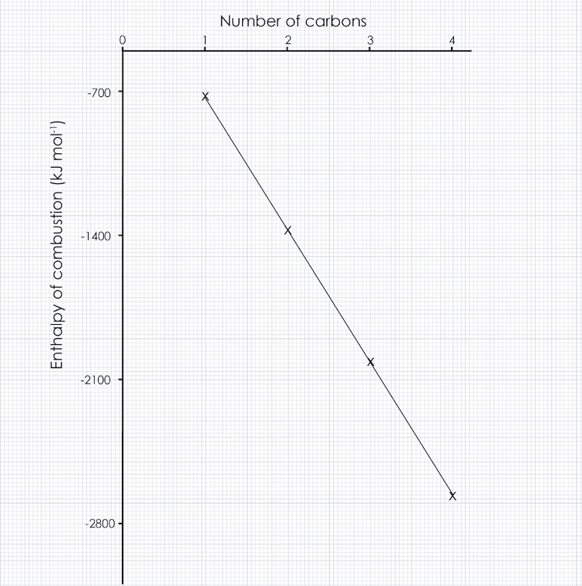

1. Challenge question

More bonds are broken and made as the number of carbons in the alcohols increases as the molecules are bigger. The difference between the energy required to break bonds and the energy given out when bonds are made is also bigger.

*Do not accept just that there are more bonds to be broken. Do not accept increasing intermolecular forces as this refers to the melting.*

## Structure strip: suggested answer

Writing about chemistry encourages learners to reflect on their understanding, formulate new ideas and make links between ideas in new ways. Learners also need to practice for long-answer questions in examinations. The structure strip can be stuck in the margin of a page to provide prompts and overcome ‘fear of the blank page’. Use it to consolidate learning after the practical and/or for revision. Read more at [rsc.li/2P0JDlW](http://rsc.li/2P0JDlW) and see structure strips for other practical videos at: [rsc.li/47fDhGS](http://rsc.li/47fDhGS).

Question: Describe an experiment to measure the enthalpy change of combustion of propan-1-ol. You do not need to do any calculations, but you do need explain how you could use your results to find the heat energy change per mole (molar enthalpy).

|  |  |
| --- | --- |
| Enthalpy of combustion of propan-1-ol Structure strip | Example answer |
| Draw a labelled diagram to show how you set up a copper calorimeter containing water and a spirit burner filled with propan-1-ol. | Diagram shows a clamped copper calorimeter containing water, a thermometer and a spirit burner. |
| Describe simply what you will do. | I will add a measured volume of water (can actually state a value such as 100 cm3) and heat until it reaches a certain temperature (can give a value but it must be at least 10 degrees below 1000C), stirring every so often. |
| Describe what measurements you will take. | I will take the temperature of the water before and after the experiment. I will measure the mass of the spirit burner before and after the experiment. |
| Describe any control variables you need so that any repeats will be a similar value. | I will try and make sure the flame is touching the bottom of the calorimeter and is kept the same distance from the bottom. I will make sure that when I repeat the experiment, I start with the same volume of water at the same starting temperature. |
| Write down the equation you will use to find the heat energy change and explain each term. Use 4.2 J g-1 °C-1 for the specific heat capacity. | I will use *Eh* = *mc*Δ*T*  *Eh* is the heat energy change, in joules  *m* is the mass of water, in grams  *c* is the specific heat capacity for water, in joules per gram per degree Celsius Δ*T* is the temperature change of the water |
| Once you have worked out the heat energy change in joules, how will you calculate the heat energy change per mole/molar enthalpy change in kJ mol-1? | I will calculate the mass of propan-1-ol used in moles by dividing by the molar mass of propanol. I will convert *Eh* from joules to kilojoules then divide the *Eh* in kilojoules by the number of moles of propan-1-ol. |

|  |  |  |  |  |
| --- | --- | --- | --- | --- |
| Enthalpy of combustion of propan-1-ol Structure strip | Enthalpy of combustion of propan-1-ol Structure strip | Enthalpy of combustion of propan-1-ol Structure strip | Enthalpy of combustion of propan-1-ol Structure strip | Enthalpy of combustion of propan-1-ol Structure strip |
| Draw a labelled diagram to show how you set up a copper calorimeter containing water and a spirit burner filled with propan-1-ol. | Draw a labelled diagram to show how you set up a copper calorimeter containing water and a spirit burner filled with propan-1-ol. | Draw a labelled diagram to show how you set up a copper calorimeter containing water and a spirit burner filled with propan-1-ol. | Draw a labelled diagram to show how you set up a copper calorimeter containing water and a spirit burner filled with propan-1-ol. | Draw a labelled diagram to show how you set up a copper calorimeter containing water and a spirit burner filled with propan-1-ol. |
| Describe simply what you will do. | Describe simply what you will do. | Describe simply what you will do. | Describe simply what you will do. | Describe simply what you will do. |
| Describe what measurements you will take. | Describe what measurements you will take. | Describe what measurements you will take. | Describe what measurements you will take. | Describe what measurements you will take. |
| Describe any control variables you need so that any repeats will be a similar value. | Describe any control variables you need so that any repeats will be a similar value. | Describe any control variables you need so that any repeats will be a similar value. | Describe any control variables you need so that any repeats will be a similar value. | Describe any control variables you need so that any repeats will be a similar value. |
| Write down the equation you will use to find the heat energy change and ex-plain each term. Use  4.2 J g-1 °C-1 for the specific heat capacity. | Write down the equation you will use to find the heat energy change and ex-plain each term. Use  4.2 J g-1 °C-1 for the specific heat capacity. | Write down the equation you will use to find the heat energy change and ex-plain each term. Use  4.2 J g-1 °C-1 for the specific heat capacity. | Write down the equation you will use to find the heat energy change and ex-plain each term. Use  4.2 J g-1 °C-1 for the specific heat capacity. | Write down the equation you will use to find the heat energy change and ex-plain each term. Use  4.2 J g-1 °C-1 for the specific heat capacity. |
| Once you have worked out the heat energy *Eh*, how would you change that into heat energy change per mole/molar enthalpy change in  kJ mol-1. | Once you have worked out the heat energy *Eh*, how would you change that into heat energy change per mole/molar enthalpy change in  kJ mol-1. | Once you have worked out the heat energy *Eh*, how would you change that into heat energy change per mole/molar enthalpy change in  kJ mol-1. | Once you have worked out the heat energy *Eh*, how would you change that into heat energy change per mole/molar enthalpy change in  kJ mol-1. | Once you have worked out the heat energy *Eh*, how would you change that into heat energy change per mole/molar enthalpy change in  kJ mol-1. |