**Carboxylic acids: knowledge check**

1. The image shows a molecular model of a carboxylic acid molecule.

Draw a circle around the carboxylic acid functional group and use the words provided to label the parts of the molecule.

**oxygen atom carbon atom double covalent bond**

**single covalent bond hydrogen atom**

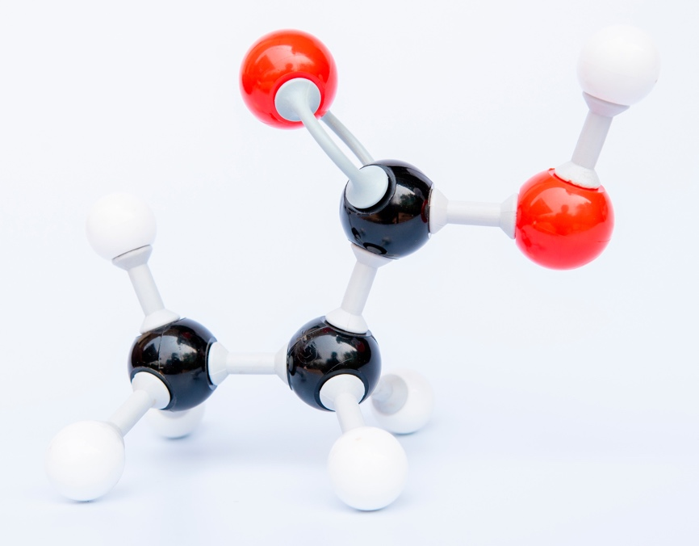

1. The table includes images of molecular models of the first four carboxylic acids. Use the names and molecular formulas provided to complete the table. The first row has been completed for you.

**propanoic acid butanoic acid ethanoic acid**

|  |  |  |
| --- | --- | --- |
| **Molecular model** | **Name** | **Molecular formula** |
| There is an image of a molecular model. The model has one black sphere in the middle. This is connected to one white sphere by a single bond and a single bond to a red sphere which is also connected to one white sphere by a single bond. The black sphere is also connected to a red sphere with a double bond. | methanoic acid |  |
| There is a photograph of a molecular model. The model has two black spheres in the middle. The first black sphere has three white spheres connected to it by single bond and has a single bond to the second black sphere. The second black sphere is connected to two red spheres. One red sphere is connected by a double bond. The other red sphere is connected to the second black sphere by a single bond and also to a white sphere by a single bond. |  |  |
| There is a photograph of a molecular model. The model has three black spheres in the middle. The first black sphere has three white spheres connected to it by single bonds and has a single bond to the second black sphere. The second black sphere is connected to two white spheres by single bonds and to the third black sphere by a single bond. The third black sphere is connected to two red spheres. One red sphere is connected by a double bond. The other red sphere is connected to the third black sphere by a single bond and also to a white sphere by a single bond. |  |  |
| There is a photograph of a molecular model. The model has four black spheres in the middle. The first black sphere has three white spheres connected to it by single bonds and has a single bond to the second black sphere. The second black sphere is connected to two white spheres by single bonds and to the third black sphere by a single bond. The third black sphere is connected to two white spheres by single bonds and to the third black sphere by a single bond. The fourth black sphere is connected to two red spheres. One red sphere is connected by a double bond. The other red sphere is connected to the third black sphere by a single bond and also to a white sphere by a single bond. |  |  |

1. Decide whether each of the following statements is true or false and tick the box.
   1. Carboxylic acid molecules only partially ionise in water. **True False**
   2. Carboxylic acids are strong acids. **True False**
   3. Solutions of carboxylic acids in water have a pH above 7. **True False**
   4. The functional group of carboxylic acids is –COO. **True False**
   5. The general formula for carboxylic acids is . **True False**

**1.4** Carboxylic acids have typical acid properties.

Use the terms provided to complete the sentences describing the typical chemical reactions of carboxylic acids. Some terms may be used more than once.

**hydrogen gas fully salt higher**

**water carbon dioxide gas partially**

Hydrochloric acid is a strong acid and ________________________ ionises in water.

Ethanoic acid is a weak acid and ________________________ ionises in water.

A solution of ethanoic acid has a ________________________ pH than a solution of hydrochloric acid with the same concentration.

Carboxylic acids react with:

* metals to form _________________________ and _________________________ gas
* bases to form ___________________________ and ___________________________
* carbonates to form ____________________________, ____________________________ and ____________________________ gas.

**Carboxylic acids: test myself**

1. Which molecular formula represents a carboxylic acid? Circle the answer.

1. Which image shows the displayed formula for ethanoic acid? Circle the answer.

|  |  |
| --- | --- |
| **A.** | There is a displayed formula. It has three capital letters C connected by single lines in the middle. The first C has single lines to three capital letters H. The second C has single lines to two capital letters H. The third letter C has two lines to a capital letter O and a single line to a second letter O which also has a single line to a capital letter H. |
| **B.** | There is a displayed formula. It has two capital letters C connected by a single line in the middle. The first C has single lines to three capital letters H. The second letter C has two lines to a capital letter O and a single line to a second letter O which also has a single line to a capital letter H. |
| **C.** | There is a displayed formula. It has two capital letters C connected by a single line in the middle. The first C has single lines to three capital letters H. The second letter C has two lines to capital letters H and a single line to a letter O which also has a single line to a capital letter H. |
| **D.** | There is a displayed formula. It has two capital letters C connected by a single line in the middle. The first C has single lines to three capital letters H. The second letter C has one line to a capital letter O and a single line to a second letter O which also has a single line to a capital letter H. |

1. What type of ions are produced by all carboxylic acids when they ionise?

*Hint: These ions are responsible for acidic properties.*

**oxide ions carbonate ions carbon ions hydrogen ions**

1. Use the names of the chemicals provided to complete the word equations representing the reactions of ethanoic acid. The names may be used once, more than once or not at all.

**ethanol hydrogen magnesium ethanoate**

**oxygen magnesium propanoate water**

**magnesium carbonate magnesium**

* 1. ethanoic acid + __________________ → magnesium ethanoate + __________________
  2. ethanoic acid + magnesium oxide → __________________ + __________________
  3. ethanoic acid + __________________ → __________________

+ __________________

+ carbon dioxide

1. Which of the following word equations represents the general reaction between a carboxylic acid and an alcohol?
2. carboxylic acid + alcohol → ester + hydrogen
3. carboxylic acid + alcohol → ester + water

**C.** carboxylic acid + alcohol → water + hydrogen

**D.** carboxylic acid + alcohol → salt + hydrogen

1. Esters are a homologous series.

Which of the following formulas shows their functional group?

1. The image shows the reaction between ethanoic acid and ethanol to form an ester:

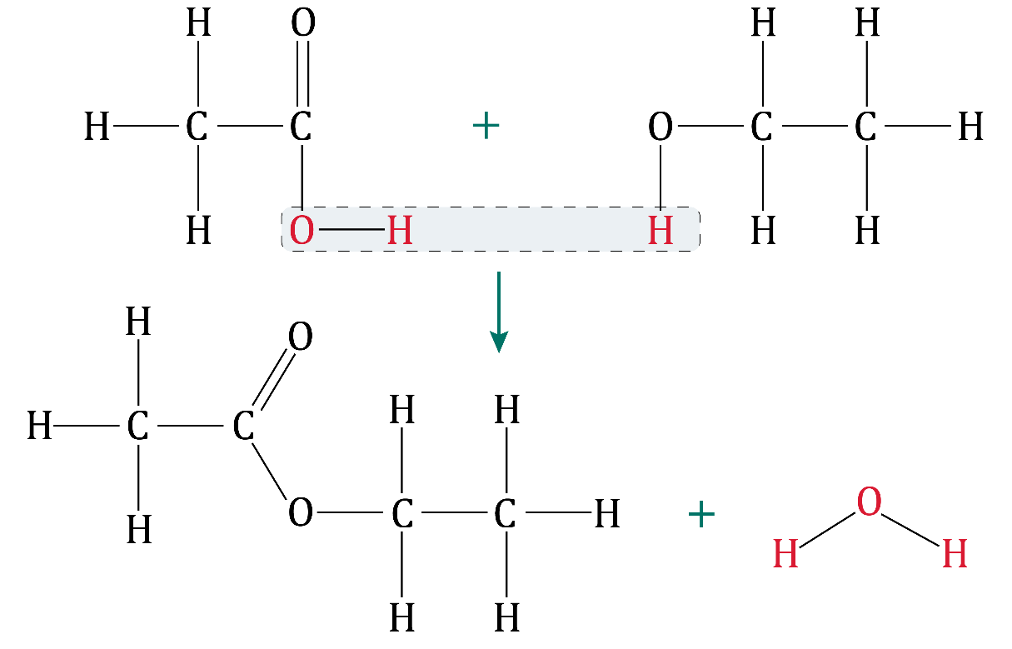

What is the name of the ester formed? Circle the answer.

**methyl ethanoate ethyl methanoate**

**ethyl ethanoate propyl ethanoate**

1. Ethanol, , reacts with an oxidising agent to produce ethanoic acid and a second product.

Use some of the numbers and formulas provided to complete the balanced symbol equation representing this reaction.

__________________ + 2[O] → __________________ + __________________

**Carboxylic acids: feeling confident?**

1. Diagram **A** represents a weak acid and diagram **B** represents a strong acid.

The formula HA is used to represent the acid molecule in diagram **A**.

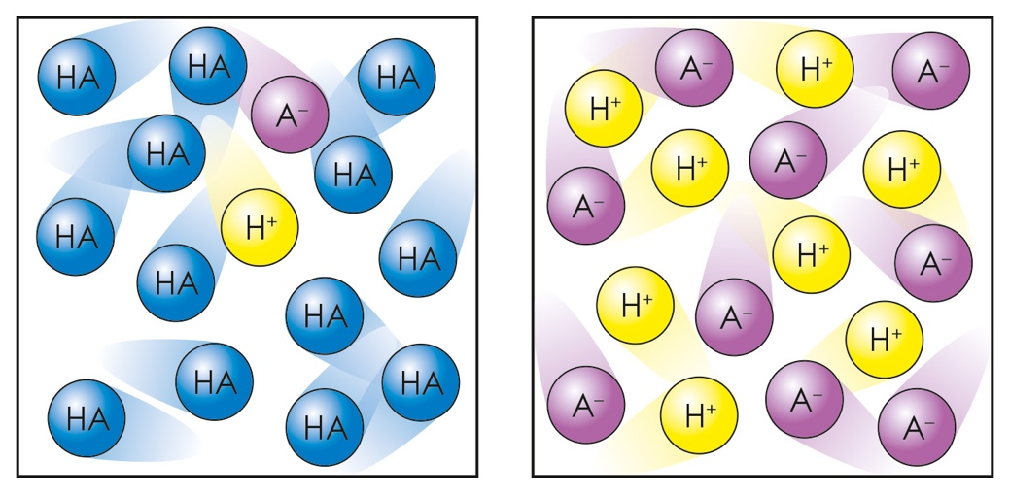

**A B**

* 1. What does the H+ in each diagram represent?
  2. Which diagram represents the acid that ionises the most?
  3. If the two acids were ethanoic acid and hydrochloric acid, which of the two acids is represented by diagram **A**?
  4. Which diagram represents the acid that would react the fastest with magnesium ribbon?

1. The diagram shows the displayed formula of an ester.

Use this image to answer the questions.

*Hint: The name of the alcohol always comes first and ends in ‘–yl’. The name of the acid comes second and ends in ‘–oate’.*

There is an image of an ester. On the left there is a C with single bonds to three capital letters H . It also has a single bond to a second C which has a double bond to an O and a single bond to another O. That O then has a second single bond to a C with two single bonds to two H and a single bond to another C with two single bonds to H and a single bond to a final C with three single bonds to H. The molecule has a total of two carbon atoms to the right of the oxygen atom in the middle and three carbon atoms to the right of it.

There is an orange circle around the CH3C=O on the left pointing to a text box which says 'This part of the molecule came from the carboxylic acid'. There is a red circle around the O-CH2CH2CH3 on the right hand side pointing to a text box which says 'This part of the molecule came from the alcohol'.

This part of the molecule came from the carboxylic acid.

This part of the molecule came from the alcohol.

* 1. Name the carboxylic acid used to form this ester.
  2. Name the alcohol used to form this ester.
  3. Name the ester shown in the diagram.

**Carboxylic acids: what do I understand?**

Think about your answers and confidence level for each mini-topic. Decide whether you understand it well, are unsure or need more help. Tick the appropriate column.

|  |  |  |  |
| --- | --- | --- | --- |
| **Mini-topic** | **I understand  this well** | **I think I understand this** | **I need more  help** |
| I can identify the functional group and general formula of carboxylic acids. |  |  |  |
| I can write the molecular formulae and draw the displayed formulae of the first four carboxylic acids. |  |  |  |
| I know that carboxylic acids are weak acids. |  |  |  |
| I can describe the reactions of carboxylic acids with metals, bases and carbonates. |  |  |  |
| I can describe the reactions of carboxylic acids with alcohols to produce esters and identify the functional group of an ester. |  |  |  |
| I can name an ester and identify the displayed formula of ethyl ethanoate. |  |  |  |
| I can write an equation for the reaction between ethanol and an oxidising agent. |  |  |  |
| **Feeling confident? topics** | **I understand  this well** | **I think I understand this** | **I need more  help** |
| I can describe the difference between strong and weak acids. |  |  |  |
| I can name esters. |  |  |  |