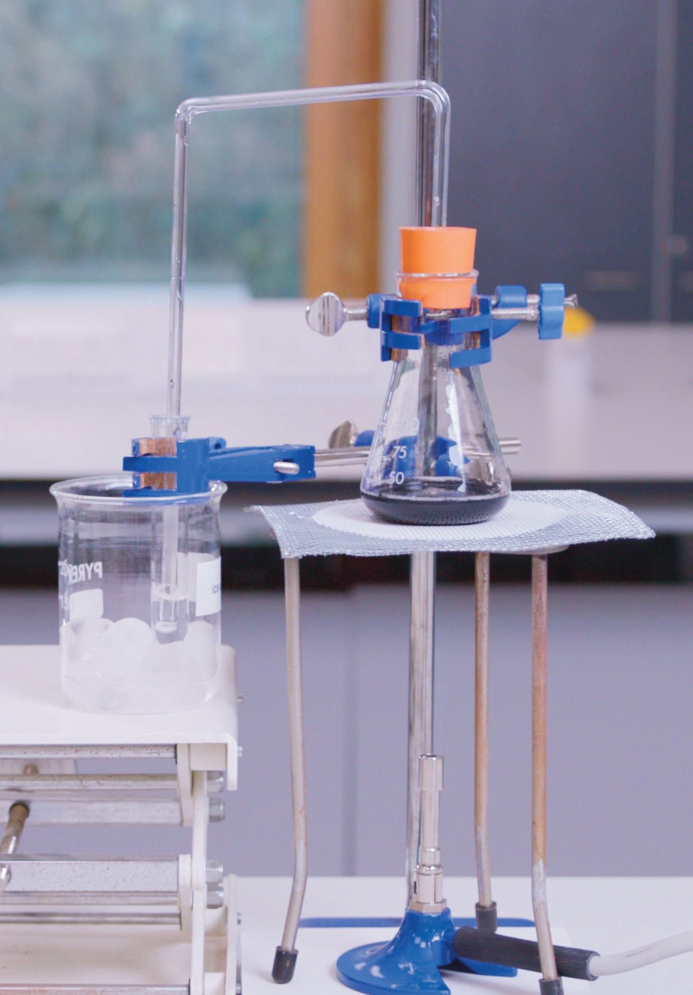

Simple

distillation

Practical video

Supporting resources

Registered charity number: 207890

**Contents**

Teacher notes 1

How to use this video 1

Notes on running the practical experiment 1

Key terms 2

Prior knowledge 3

Common misconceptions 3

Real-world contexts 3

Cross-curriculum links and skills 4

How to use the additional resources 4

Intended outcomes 5

Additional resources 6

Pause-and-think questions 6

Follow-up worksheet 10

Support 10

Core 11

Follow-up worksheet answers 13

Support 13

Core 14

Structure strip: suggested answer 15

Also available:

* Technician notes
* Integrated instructions
* Frayer models
* Johnstone’s triangle

Download the PDF and editable PowerPoint slides at [rsc.li/3sEJuwX](http://rsc.li/3sEJuwX).

# Teacher notes

This resource supports the practical video Simple distillation, available here: [rsc.li/3sEJuwX](http://rsc.li/3sEJuwX).

The value of experiencing live practical work cannot be overstated. Numerous studies provide evidence of its value in terms of learner engagement, understanding, results and the likelihood of continuing to study chemistry or work in a related field.

Use this video to complement live practical work, or to help learners understand the methods, equipment and skills when they cannot access the lab.

## How to use this video

The video and additional resources are designed for you to use flexibly but read on for suggestions of how to use them with your learners.

Flipped learning

Show learners the video before the live practical lesson to help it run more smoothly and keep objectives in focus. This will build learners’ confidence and improve their outcomes in the lesson. Use questions from the set provided as part of the preparation task (for more on flipped learning, see [rsc.li/3On7DQF](http://rsc.li/3On7DQF)).

Consolidation and revision

Show learners the video before the live practical lesson to help it run more smoothly and keep objectives in focus.

Revisiting the practical with a different focus

Practical experiments support many learning outcomes. Focusing on just one or two of those in a lesson will ensure you achieve the lesson’s aims. Use the video to revisit the experiment with a different focus.

Home learning

Whether it is remote teaching, homework, or individual learner absence, give learners an opportunity to engage with a practical experiment and the associated skills when they are not in the lab.

Other tips

#### Provide your own commentary

Mute the voice over and provide your own commentary. This will allow you to better engage with learners and adapt the video to the needs and objectives of your lesson.

#### Use questions

There are pause-and-think questions in two formats, one for teacher-led questions and discussion and a student worksheet for learners to use independently. Select from the list or create your own questions to engage learners and target specific aims.

## Notes on running the practical experiment

Ask learners to work in pairs. Demonstrate how to set up the equipment first (either in-person or via the video), so that you can emphasise health and safety issues. Remind learners that they must wear eye protection and direct them to the relevant student safety sheets (SSS): [bit.ly/3T9fcwP](http://bit.ly/3T9fcwP).

Do not run the practical for too long as the ice-water can heat up and it is possible to get scalding steam coming out of the test tube. If this happens, learners will not get any solid in the flask that they are heating. You can show the solid at the end more safely using the Liebig condenser and quickfit apparatus.

See [rsc.li/3QHuZjG](http://rsc.li/3QHuZjG) for detailed instructions of this demonstration.

It is important that learners clamp the flask in the correct place and do not overtighten it. Learners can practise turning the Bunsen burner (SSS092) flame down to ensure gentle boiling of the coloured solution. If they turn down the gas too quickly, the flame will go out and they will need to relight the Bunsen. When testing their sample, learners should be aware of anhydrous copper(II) sulfate’s hazards (SSS040).

Technician notes including the equipment list, safety notes and disposal are available here: [rsc.li/3sEJuwX](http://rsc.li/3sEJuwX). Read our standard health and safety guidance (available from: [rsc.li/3IAmFA0](http://rsc.li/3IAmFA0)) and carry out a risk assessment before running any live practical.

Procedure for simple distillation

1. Place a clamp stand on a heatproof mat and set up a Bunsen burner on the stand and mat.
2. Place a tripod and gauze above the Bunsen burner.
3. Stand a conical flask on the gauze and carefully clamp the neck of the flask to keep it stable.
4. Using a second clamp and boss, clamp a test tube and stand it in a beaker of ice-water.
5. Measure out 20 cm3 of the solution in a measuring cylinder and pour it into the conical flask.
6. Add a couple of anti-bumping granules to the flask.
7. Take the delivery tube and place the bung in the top of the conical flask and the other end of the delivery tube in the test tube in the beaker of ice-water.
8. Light the Bunsen burner on the yellow safety flame, then open the air hole so you have a blue flame.
9. Heat the solution until it boils, then turn down the Bunsen burner flame at the gas tap so it boils gently. Remove the Bunsen from under the flask if the solution starts to boil rapidly.
10. When you have collected 1 cm3 of distillate, stop heating and remove your sample from the beaker of ice-water. Take care when handling hot glassware as it can cause burns.
11. Test your sample for water by putting a small spatula of white anhydrous copper(II) sulfate onto a watch glass and adding a few drops of the distillate.

Integrated instructions

Integrated instructions use clear numbering, arrows and simple pictograms, like an eye to show when to make observations. They were developed using cognitive load theory and remove unnecessary information. Therefore, the instructions reduce extraneous load on learners, increasing the capacity of their working memory to think about what they are doing and why. Download the integrated instructions for this experiment at [rsc.li/3sEJuwX](http://rsc.li/3sEJuwX).

## Key terms

* + Simple distillation – the process of separating a liquid from a solution through evaporation followed by condensation.
  + Separation – the process of dividing a mixture up into its component parts.
  + Solution – a mixture formed by a solute dissolved in solvent.
  + Solvent – the liquid a solute (solid) dissolves in to form a solution.
  + Solute – a substance that will dissolve in a solvent.
  + Dissolve – when a solute mixes completely with a solvent to produce a solution.
  + Soluble – a substance that will dissolve.
  + Mixture – two or more different substances, not chemically joined together.
  + Pure – a substance made of only one element or compound.
  + Evaporate – a change of state from liquid to gas.
  + Condense – a change of state from a gas to a liquid.
  + Vapour – a gas or small drops of liquid suspended in a gas.
  + Distillate – the liquid collected at the end of a distillation experiment.

You will find a template and example Frayer model for the term ‘distillation’ on the PowerPoint slides, available from: [rsc.li/3sEJuwX](http://rsc.li/3sEJuwX).

## Prior knowledge

* + Mixtures are impure materials containing two or more different chemical substances mixed (but not chemically joined) together, eg air is a mixture of gases.
  + Matter is made from particles that cannot be destroyed. The arrangement of particles of a substance in the solid, liquid and gaseous state is different.
  + Physical changes are reversible and occur when a substance is heated, cooled or dissolved in a solvent.
  + A solution is formed when a solute dissolves in a solvent.
  + Substances have different physical properties and these determine which method is used to separate them.
  + Pure substances have specific boiling/condensation points and melting/freezing points.

## Common misconceptions

Substances disappear when they dissolve. Evaporation shows this is not true. Use scientific language

to avoid introducing the idea of chemicals disappearing. Carry out a quick experiment to show that the mass stays the same if you weigh a solvent and solute before and after they are mixed to form a solution.

Many learners will say that sodium chloride is now a liquid since it has dissolved in water. Technically, it did not melt and undergo a state change into a liquid, rather it was pulled into solution. Highlight the differences between the states, such as ‘liquids’, and ‘aqueous/in solution’.

All mixtures are separated using only one separating technique. Provide learners with examples to show this is not the case, eg a mixture of iron filings and sulfur can be separated by a magnet or water (the iron filings sink and the sulfur floats).

Evaporation and boiling are the same thing. Use everyday contexts to explain the difference, eg a puddle dries up on a sunny day as water molecules evaporate (changes state from a liquid to a gas) but you don’t see bubbles in the water indicating that it is boiling. Use scientific language to emphasise their meaning and avoid confusion.

Filtration can separate solutions. Carry out a quick demo to show that it can’t. Pour a solution into a filter funnel and paper. Observe the solution run through the filter paper into the conical flask unchanged. Point out that there is no residue left on the filter paper. Then repeat using a suspension.

A solution is a single substance. Ask learners to make a solution by dissolving copper chloride or sodium chloride in water and then ask them to heat the solution until the water evaporates off leaving the copper chloride or sodium chloride crystals. Use scientific language to reinforce the idea that a solution is formed when a solute dissolves in a solvent.

Boiling points increase as a substance is heated. Ask learners to make careful observations as they heat up some water until it boils. They should record the temperature at regular intervals and note down any observations about the liquid.

The boiling/condensation point is different. Eg if it boils at 100°C, it must condense at 99°C.

Water goes around the condenser. Demonstrate how water flows through outer sleeve of the condenser, going in at the lower end and out at the higher end to promote more effective cooling. Point out the condenser’s inner tube and explain that this is where the vapour is cooled and condenses back to a liquid, ie the distillate.

## Real-world contexts

* + Read this CPD article to find relevant contemporary contexts, such as medicine and fragrances, to share with your learners and develop their appreciation of chemistry in their lives: [rsc.li/3OnBlVD](http://rsc.li/3OnBlVD).
  + Show your learners how astronauts survive in space ([rsc.li/3XYztWt](http://rsc.li/3XYztWt)) by using compression distillation on their urine.
  + Add depth to a sequence of lessons on separation techniques with the context of caffeine: [rsc.li/46ZwnFJ](http://rsc.li/46ZwnFJ).
  + Highlight different career pathways with Olivia’s job profile: [rsc.li/48eYdxB](http://rsc.li/48eYdxB). She did a Scottish Vocational Qualification (SVQ) and is a senior laboratory technician who uses distillation in her work.

## Cross-curriculum links and skills

This practical develops:

* + Accurate observation and measurement skills.
  + Manipulative skills to set up and use complex apparatus.
  + Problem solving skills and finding solutions to common issues that occur during distillation.

## How to use the additional resources

Pause-and-think questions

Pause-and-think questions are supplied in two formats: a teacher version for ‘live’ questioning and a learner version that can be used during independent study. The timestamps allow you to pause the video when presenting it to your class, or learners to use the video for active revision.

#### Teacher version

The questions are in a table. You can use as many as are appropriate for your class and the learning objectives. Some questions have two timestamps to allow you to adapt the questions for different classes or scenarios. Pause the videos at the earlier timestamp to ask a question before you hear/see the answer, useful for revision or to challenge learners. Pause at the later timestamp to ask a question reflectively and assess whether learners have understood what they have just heard or seen. This would be useful when introducing a topic, for flipped learning or to provide additional support and encouragement.

Think about how you will ask for responses. Variation in how you ask for responses may help increase engagement. Learners could write and hold up short answers or they could discuss questions in groups. Not all answers are in the video. Some of the questions will extend learners’ thinking beyond its content or draw on prior learning.

#### Learner version

Provide the worksheet with the same questions in situations where there is not a teacher present to guide discussion during the video, eg homework, revision or remote learning.

Using the structure strip

Writing about chemistry encourages learners to reflect on their understanding, formulate new ideas and make links in new ways. Learners also need to practise for long-answer questions in exams. They can stick the structure strip in the margin and use the prompts to overcome ‘fear of the blank page’. Use it to consolidate learning after the practical and/or for revision. Read more at [rsc.li/2P0JDlW](http://rsc.li/2P0JDlW).

Using the follow-up worksheet

There are two versions of the follow-up worksheet you can use to reinforce learning. The support version of the follow-up sheet focusses on the key terminology needed to describe distillation and the experimental set up shown in the video. Questions are scaffolded to provide additional support. The core version of the follow up sheet initially looks at the quickfit distillation apparatus before asking learners to spot the errors made by learners when setting up the simplified method.

The answers to both versions of the student sheet are at the end of this document.

For further challenge, learners can answer the extended response question without access to the structure strip.

Use the Johnstone’s triangle, available to download as a PowerPoint from [rsc.li/3sEJuwX](http://rsc.li/3sEJuwX), to help learners link their observations to what’s going on at the submicroscopic level.

## Intended outcomes

It’s important that the purpose of each practical is clear from the outset. Defining the intended learning outcomes consolidates this. Outcomes can be categorised as ‘hands on’ – what learners are going to do with objects – and ‘minds on’ – what learners are going to do with ideas to show their understanding. We have offered some differentiated suggestions for this practical. You can focus on just one or two, or make amendments based your learners’ needs (read more at [rsc.li/2JMvKa5](http://rsc.li/2JMvKa5)).

Consider how you will share outcomes and evaluation with learners to empower them to direct their own learning.

Hands on Minds on

Effective at a lower level

Effective at

a higher level

Learners correctly:

* Investigate the composition of inks using simple distillation.
* Use and handle substances and appropriate heating devices safely.
* Develop accurate observation, measurement and manipulative skills.

Learners correctly:

* Assemble the distillation equipment piece by piece.
* Use problem solving skills to find solutions to common issues that occur during distillation.

Learners correctly:

* Describe the types of mixtures that can be separated using simple distillation.
* Describe how distillation works.

Learners correctly:

* Explain the types of mixtures that can be separated using simple and fractional distillation.
* Explain how distillation works.

# Additional resources

## Pause-and-think questions

Teacher version

|  |  |  |  |
| --- | --- | --- | --- |
| Timestamp(s) | | Question | Answer/discussion points |
| 00:23 | 00:29 | What are the two physical changes in distillation? | Evaporation and condensation. |
| 00:48 | 00:58 | Define solution. | A mixture formed by a solute dissolved in a solvent. |
| 01:59 | 02:04 | Why is it important not to over tighten clamps? | It could crack the glass tubes/flasks. |
| 02:37 | | Why were anti-bumping granules added to the flask? | To prevent the mixture from ‘bumping’ or ‘jumping up’ the flask due to uneven heating. |
| 02:58 | | Suggest a reason why the test tube is stood in a beaker of ice-water. | To cool down any vapours reaching the test tube. |
| 03:26 | 03:33 | Explain why you should reduce the size of the Bunsen burner flame. | To ensure that the solution boils gently and doesn’t accidently rise too far up the flask and enter the condenser. |
| 03:37 | 03:43 | What is the liquid you collect called? | Distillate |
| 03:48 | 03:54 | Describe what happens to the water particles during distillation. | As the temperature of the solution increases, the rate of movement increases until they have enough energy to become a gas. They rise through the flask and enter the condenser, where they start to slow down as they move down the cool tube.  Eventually they return to the liquid phase and are collected in a test tube. |
| 03:54 | 03:59 | Describe what happens to the coloured dye particles during distillation. | As the temperature of the solution increases, the rate of movement increases but they remain in the flask in the liquid phase. |
| 04:51 | | State a benefit of a using a Liebig condenser. | * It doesn’t get hot during distillation. * It is efficient at removing heat. * Cold water is constantly going into the bottom of the outer sleeve to keep it cool. |
| 04:59 | 05:27 | State the test for water used. What do you observe for a positive result? | Anhydrous copper(II) sulfate changes colour from white to blue. |
| 05:32 | | What further physical test could you carry out to confirm that the collected water is pure? | Measure the boiling point of the distillate, which is 100°C for pure water. |

## Pause-and-think questions

Learner version

Pause the video at the time stated to test or revise your knowledge of this practical experiment.

Time Question

00:29 What are the two physical changes in distillation?

00:58 Define solution.

02:04 Why is it important not to over tighten clamps?

02:37 Why were anti-bumping granules added to the flask?

02:58 Suggest a reason why the test tube is stood in a beaker of ice-water.

03:33 Explain why you should reduce the size of the Bunsen burner flame.

03:43 What is the liquid you collect called?

03:54 Describe what happens to the water particles during distillation.

03:59 Describe what happens to the coloured dye particles during distillation.

04:51 State a benefit of a using a Liebig condenser.

05:27 State the test for water used. What do you observe for a positive result?

05:32 What further physical test could you carry out to confirm that the collected water is pure?

## Follow-up worksheet

This worksheet accompanies the RSC Simple distillation video, available at [rsc.li/3sEJuwX](http://rsc.li/3sEJuwX). The practical investigates how to obtain a sample of pure water from a coloured solution, but you can also use it if you’ve completed a similar distillation experiment in your chemistry lessons.

### Support

1. Draw a line to connect the key words with their correct meaning.

Key word Meaning

Evaporate Result of a solute dissolving in a solvent.

Condense Two or more substances mixed together that are not chemically joined.

Distillate When a substance changes from the liquid state to the gaseous state.

Mixture Process of evaporation followed by condensation.

Solution When a substance changes from the gaseous state to the liquid state.

Distillation The liquid collected during distillation.

1. Use the words to label the diagram.

Gauze Distillate

Delivery tube/condenser Clamp stand

Heatproof mat Coloured solution Ice water

Bunsen burner

Clamps Bung Tripod

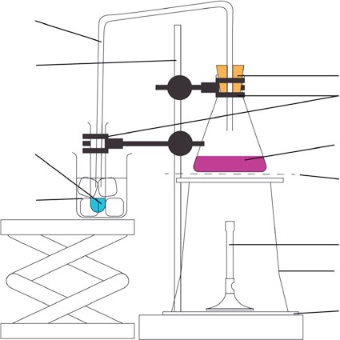

1. Note down three things you observed during the practical.
2. Complete the sentences using the following words:

Condenser Water vapour

Coloured solution

Colourless liquid Boiled Evaporated

Distillation Cooled

During the experiment was used to collect a sample of pure water from a . The solution was heated until it and the water . The filled the flask before entering the . Here it was down and condensed back to

a , which was collected in a test tube.

### Core

1. Define distillation.
2. Use the words to label the diagram.

Coloured solution Inner tube

Water in Water out

Distillate Thermometer Distillation flask Heating mantle

Liebig condenser Test tube

Cooling water in outer sleeve

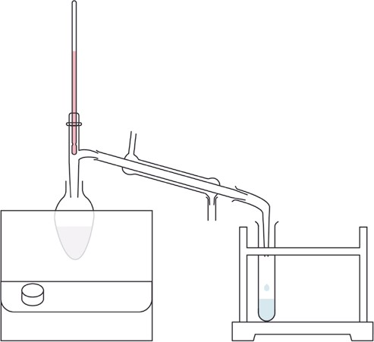

1. Describe how a Liebig condenser works.
2. Explain why it is important to control the Bunsen burner during the experiment.
3. Some learners set up their own experiment using simple equipment, but they made some errors.

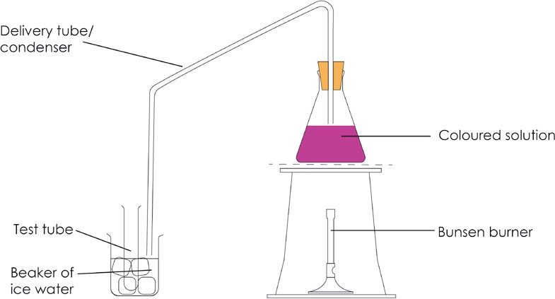

* 1. Identify three errors.

i.

ii.

iii.

* 1. For each identified error, describe the problems it might lead to.

i.

ii.

iii.

## Follow-up worksheet answers

### Support

1. Draw a line to connect the key words with their correct meaning.

Key word Meaning

Evaporate Result of a solute dissolving in a solvent.

Condense Two or more substances mixed together that are not chemically joined.

Distillate When a substance changes from the liquid state to the gaseous state.

Mixture Process of evaporation followed by condensation.

Solution When a substance changes from the gaseous state to the liquid state.

Distillation The liquid collected during distillation.

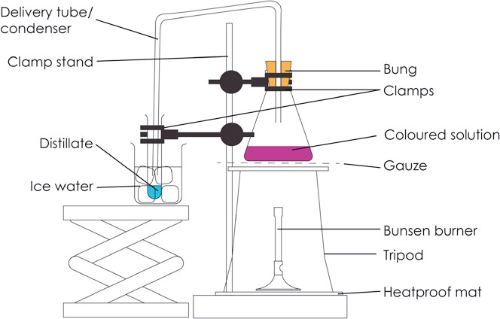

1. Any three of:
   * Bubbles in the coloured solution.
   * As the experiment progresses the colour gets deeper or more intense.
   * Vapours rising up and filling the conical flask.
   * Colourless liquid is collected in the test tube.
2. During the experiment distillation was used to collect a sample of pure water from a coloured solution. The solution was heated until it boiled and the water evaporated. The water vapour filled the flask before entering the condenser. Here it was cooled down and condensed back to a colourless liquid, which was collected in a test tube.

### Core

1. A technique used to separate a solvent from a solution or a mixture of two liquids using the physical change of evaporation followed by condensation.

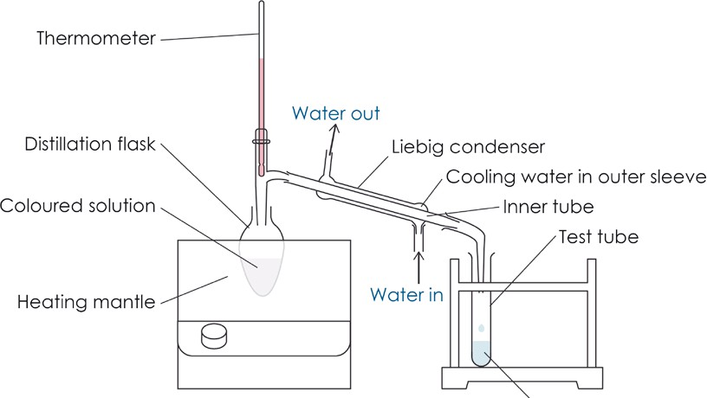

1. Cold water flows through the outer sleeve of the condenser providing a cold surface on the inner tube which the hot vapours flow through. As heat energy from the hot vapours is transferred to the cold surface and water which is constantly replaced, the vapour cools down until it eventually condenses back to a liquid.
2. So that the coloured solution does not ‘boil over’ and some of the coloured solution enters the condenser. 5.

a)

* 1. No clamp.

ii Conical flask almost full to the top with coloured solution.

iii. End of condenser in the beaker of ice-water and not the test tube.

b)

1. Equipment will be unstable and could fall over
2. The coloured solution will go into the condenser/delivery tube when it boils.
3. The distillate will mix with the ice-water and nothing will be collected.

## Structure strip: suggested answer

Writing about chemistry encourages learners to reflect on their understanding, formulate new ideas and make links between ideas in new ways. Learners also need to practice for long-answer questions in examinations. The structure strip can be stuck in the margin of a page to provide prompts and overcome ‘fear of the blank page’. Use it to consolidate learning after the practical and/or for revision. Read more at [rsc.li/2P0JDlW](http://rsc.li/2P0JDlW) and see structure strips for other practical videos at: [rsc.li/47fDhGS](http://rsc.li/47fDhGS).

Question: The area you live in is in a prolonged drought and the reservoir has dried up. You live near the sea. Explain how you could use your laboratory skills to make some pure drinking water from seawater.

|  |  |
| --- | --- |
| Distillation Structure strip | Example answer |
| What is sea water? | A mixture/solution of dissolved salts in water. |
| Name the solvent and solute in sea water solution. | The solvent is water. Solutes include sodium chloride and some other salts. |
| How would you remove any insoluble impurities? | By filtration. |
| What process would you use to obtain the pure water from the filtrate? | Distillation. |
| List the equipment you would need to obtain the water. | Due to context of the question, accept general answers as well as scientific equipment.   * Bunsen burner or a heat source. * Flask or container for sea water. * Clamp. * A condenser or delivery tube fitted to the water container. * Test tube or container to collect the distillate or pure water. |
| How would you use the equipment? Write a list of steps or draw a diagram. | 1. Pour the sea water into the flask. 2. Fit the condenser or delivery tube into the top of the flask. 3. Clamp into place. 4. Place the test tube/container beneath the delivery tube. 5. Place the Bunsen burner/heat source under the flask. 6. Gently heat the flask and collect the distillate. |

|  |  |  |  |  |
| --- | --- | --- | --- | --- |
| Distillation Structure strip | Distillation Structure strip | Distillation Structure strip | Distillation Structure strip | Distillation Structure strip |
| What is sea water? | What is sea water? | What is sea water? | What is sea water? | What is sea water? |
| Name the solvent and solute in sea water solution. | Name the solvent and solute in sea water solution. | Name the solvent and solute in sea water solution. | Name the solvent and solute in sea water solution. | Name the solvent and solute in sea water solution. |
| How would you remove any insoluble impurities? | How would you remove any insoluble impurities? | How would you remove any insoluble impurities? | How would you remove any insoluble impurities? | How would you remove any insoluble impurities? |
| What process would you use to obtain the pure water from the filtrate? | What process would you use to obtain the pure water from the filtrate? | What process would you use to obtain the pure water from the filtrate? | What process would you use to obtain the pure water from the filtrate? | What process would you use to obtain the pure water from the filtrate? |
| List the equipment you would need to obtain the water. | List the equipment you would need to obtain the water. | List the equipment you would need to obtain the water. | List the equipment you would need to obtain the water. | List the equipment you would need to obtain the water. |
| How would you use the equipment? Write a list of steps or draw a diagram. | How would you use the equipment? Write a list of steps or draw a diagram. | How would you use the equipment? Write a list of steps or draw a diagram. | How would you use the equipment? Write a list of steps or draw a diagram. | How would you use the equipment? Write a list of steps or draw a diagram. |