Diffusion and dissolving

Introduction

These questions are designed to help you to develop your mental models (pictures in your head) of the diffusion of particles of a liquid in water. These questions are also designed to help you to connect your understanding of diffusion with the idea of dissolving.

|  |  |
| --- | --- |
| An icon used to indicate the Macroscopic part of Johnstone's triangle. | **Macroscopic:** what we can see. Think about the properties that we can observe, measure and record. |
| An icon used to indicate the Sub-microscopic part of Johnstone's triangle. | **Sub-microscopic:** smaller than we can see. Think about the particle or atomic level. |
| An icon used to indicate the Symbolic part of Johnstone's triangle. | **Symbolic:** representations. Think about how we represent chemical ideas including symbols and diagrams. |

Questions

1. A student carefully adds a drop of blue dye to the centre of a dish containing water. The student places a lid on the dish.

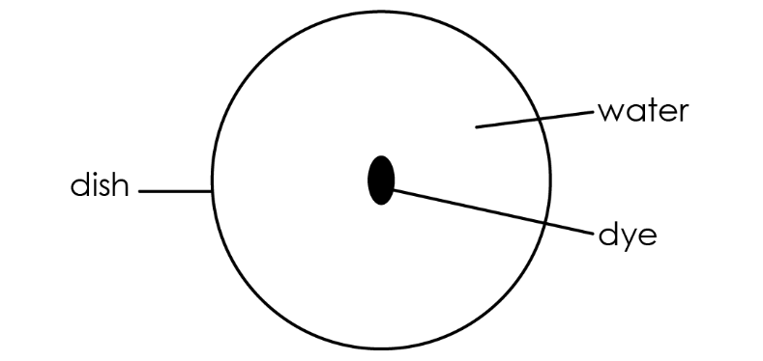

1. Complete the diagram to show what you would expect to observe after
2. 10 minutes

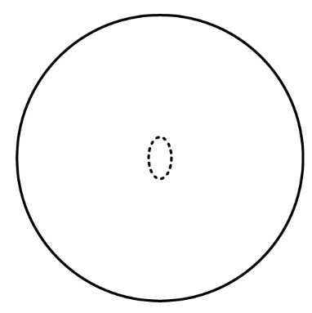

1. 10 hours
2. The diagram shows particles of water and particles of the blue dye.

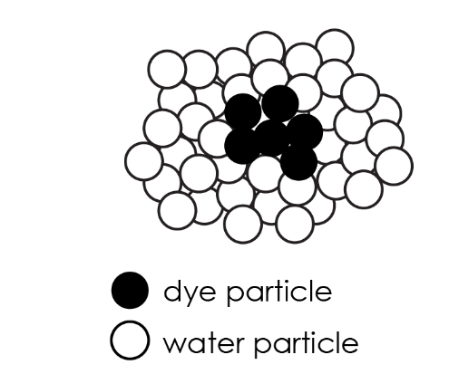

Draw a diagram to show the particles after 10 hours.

The particles move in all directions, bump into each other and change direction. This means that over time the particles move randomly.

1. Select the diagram that shows random movement of a particle.

|  |  |  |  |
| --- | --- | --- | --- |
| A black circle with a straight arrow pointing away from the circle and up towards the right. | A black circle with an arrow pointing away from the circle and up towards the right. The arrow follows a zig zag path of straight, regular lines and angles. | A black circle with a straight arrow pointing away from the circle. The arrow follows a straight path that changes direction at irregular intervals and irregular angles, eventually doubling back across its own path. | A black circle with a curved arrow pointing away from the circle and spiralling outwards in increasingly larger clockwise circles. |
| **A** | **B** | **C** | **D** |

1. Explain the why the blue dye eventually mixes with all the water in the dish, without being stirred.

__________________________________________________________________________________

__________________________________________________________________________________

__________________________________________________________________________________

__________________________________________________________________________________

1. A student adds a purple crystal to the centre of a dish of water.

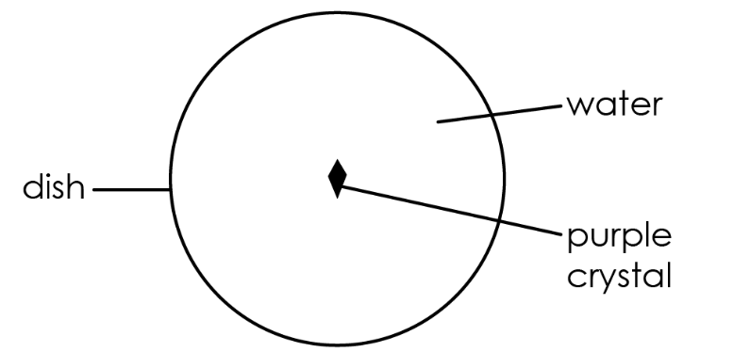

1. Describe what will happen to the size of the crystal.

__________________________________________________________________________________

__________________________________________________________________________________

1. Describe what will happen to the colour of the liquid in the dish.

__________________________________________________________________________________

__________________________________________________________________________________

1. Explain why these changes are happening.

Use the words **dissolve** and **diffuse** in your answer.

__________________________________________________________________________________

__________________________________________________________________________________

__________________________________________________________________________________