**Solubility: knowledge check**

1. The diagram shows a solid dissolving in a liquid.

Label the diagram with the name of the solid and the liquid and then identify which is the **solute**, **solvent** and **solution**.

__________________ __________________ __________________

eg __________________ eg __________________ eg glucose solution

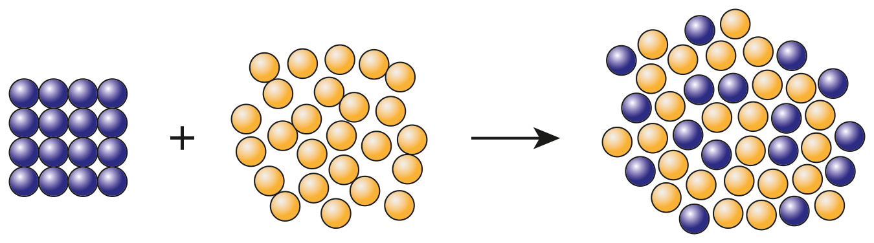

1. Choose the correct term from the words to match each of the definitions included in the table.

**dilute saturated soluble**

**concentrated insoluble**

|  |  |
| --- | --- |
| A substance that will dissolve in a solvent. |  |
| A substance that will not dissolve in a solvent. |  |
| A solution that contains a high amount of solute dissolved in it. |  |
| A solution that contains a relatively low amount of solute dissolved in it. |  |
| A solution that has the maximum mass of solute dissolved in it. |  |

1. Decide whether each of the following statements is true or false and write your answer in the box provided.
   1. The units for concentration are dm3/g. **True False**
   2. The particles of the solute disappear when a solute   
      dissolves in a solvent. **True False**
   3. 500 cm3 ofa solution with a concentration   
      of 4.50 g dm-3 will contain 2.25 g of solute. **True False**
   4. Most substances are more soluble at higher temperatures. **True False**
   5. All soluble substances have the same solubilities. **True False**
2. When sodium hydroxide solution is added to some metal cation solutions, a metal hydroxide precipitate is formed.

Use the words to complete the following sentences to explain why these precipitates are useful.

**blue insoluble colour**

**iron solution**

The metal hydroxide precipitate formed is an __________________ solid.

The __________________ of the precipitate formed can be used to identify the cations present.

For example, if sodium hydroxide solution is added to copper(II) sulfate __________________, a precipitate of __________________ copper(II) hydroxide forms.

If sodium hydroxide solution is added to iron(II) sulfate solution, a grey/green precipitate of __________________ (II) hydroxide is produced.

**Solubility: test myself**

**Answer questions 2.1 to 2.5 by circling the correct answer.**

1. Which of the following is a correct expression of the unit for concentration?

**g/dm**

**dm/g**

**g dm-3**

**dm-3 g**

1. What method is used to separate an insoluble substance from a mixture of the substance and water?

**crystallisation**

**simple distillation**

**fractional distillation**

**filtration**

1. What method is used to separate water from a salt solution?

**filtration**

**simple distillation**

**chromatography**

**crystallisation**

1. A solution of sodium hydroxide has a concentration of 10 g dm-3. What mass of sodium hydroxide is present in 100 cm3 of the solution?
   1. **g**
2. **g**

**10 g**

**100 g**

1. What is the concentration, in g dm-3, of a solution of sodium carbonate made by dissolving 2.5 g of sodium carbonate in 500 cm3 of water?

**0.25** **g dm-3**

**5.0 g dm-3**

**25 g dm-3**

**50 g dm-3**

1. Sodium chloride solution reacts with acidified silver nitrate solution to form a precipitate of silver chloride and sodium nitrate solution.

Complete the equation by adding the correct state symbols from those given. The state symbols may be used once, more than once or not at all.

**(g) (s) (l) (aq)**

NaCl + AgNO3 → AgCl + NaNO3

1. The concentration of a solution, in g dm-3, can be calculated using the equation:

* **Solution** **A** contains 0.5 g solute dissolved in 10 cm3 of solvent.
* **Solution** **B** contains 0.7 g solute dissolved in 20 cm3 of solvent.

Use the equation and the information provided to work out which of the two solutions, **A** or **B**, has the higher concentration. The calculation steps have been laid out to help you.

*(Hint: Remember, 1 dm3 1000 cm3, so to convert the volume from cm3 to dm3 you need to divide the volume in cm3 by 1000.)*

**Solution A**

volume

concentration

concentration dm3

**Solution B**

volume

concentration

concentration dm3

The solution with the higher concentration is solution __________________ .

**Solubility: feeling confident?**

1. The graph shows how the solubilities of two salts, potassium nitrate, KNO3, and sodium chloride, NaCl, vary with temperature.

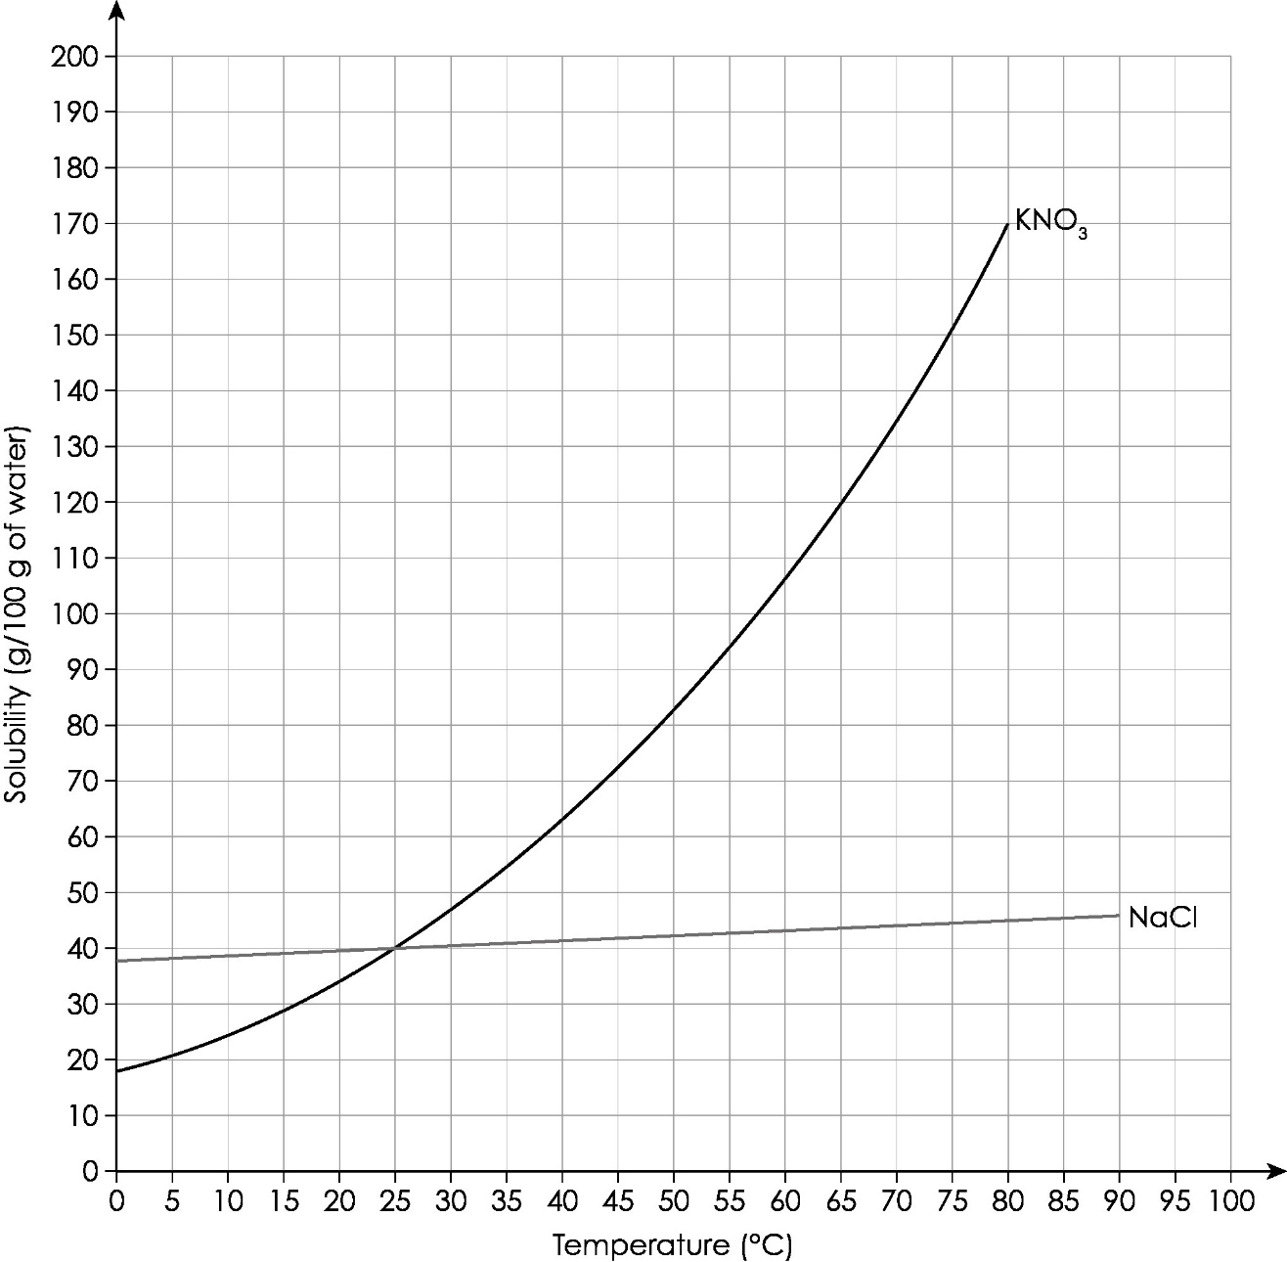

What conclusions can you make about the solubilities of potassium nitrate and sodium chloride?

Choose the correct terms from the brackets to complete the three conclusions given.

The two salts have the same solubility at a temperature of **10°C / 25°C /**

**50°C / 80°C**.

At a temperature of 10°C, **potassium nitrate / sodium chloride** has the highest solubility.

The solubilities of both salts **decrease / increase** as the temperature increases.

Use the solubility curve in **question 3.1** to work out the mass of potassium nitrate that would crystallise out if a saturated solution of the salt was cooled from 80°C to 10°C.

Select the correct masses from those given to complete the calculation. You may not need to use all masses.

**20 g 50 g 170 g 190 g**

Mass of potassium nitrate in 100 g water at 80°C = __________________

Mass of potassium nitrate in 100 g water at 10°C = __________________

Mass of potassium nitrate that crystallises out = __________________

**Solubility: what do I understand?**

Think about your answers and confidence level for each mini-topic. Decide whether you understand it well, are unsure or need more help. Tick the appropriate column.

|  |  |  |  |
| --- | --- | --- | --- |
| **Mini-topic** | **I understand  this well** | **I think I understand this** | **I need more  help** |
| I can use the correct words to describe solubility and solutions. |  |  |  |
| I know the difference between dilute and concentrated solutions. |  |  |  |
| I can measure the concentration of solutions in g dm-3. |  |  |  |
| I can calculate the mass of solute in different volumes of solution. |  |  |  |
| I know how to define the term saturated solution. |  |  |  |
| I can describe precipitate formation. |  |  |  |
| I can select the correct method of separation based on solubilities (filtration, distillation, crystallisation). |  |  |  |
| **Feeling confident? topics** | **I understand  this well** | **I think I understand this** | **I need more  help** |
| I can understand solubility curves. |  |  |  |
| I know how to use solubility curves to calculate the mass of a solute that crystallises out when a saturated solution cools. |  |  |  |