**Amino acids: knowledge check**

1. Amino acids contain two different functional groups. The image below shows the general structural formula of an amino acid.

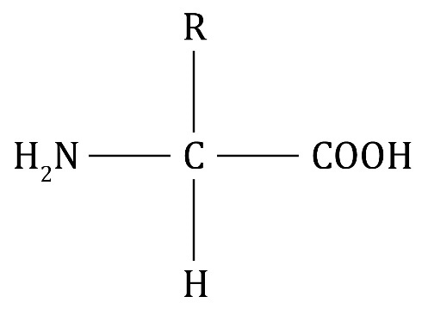

Circle the two functional groups on the diagram above and choose words from the list below to name them.

**hydroxyl group carboxylic acid group amine group**

**alkene group ester group amide group**

1. The images show the structure of two amino acids – glycine and alanine.

|  |  |
| --- | --- |
| There is a diagram showing a capital letter C in the middle. There are four single lines connected to two capital letters H, a carboxyl group and an amino group. | There is a diagram showing a capital letter C in the middle. There are four single lines connected to a capital letter H, a carboxyl group, a methyl group and an amino group. |
| **glycine** | **alanine** |

Use these images, along with the image shown in **question** **1.1**,to match each of the sentences with their correct endings.

|  |  |  |  |
| --- | --- | --- | --- |
|  | The ‘R’ in the general structure represents a… |  | …COOH group. |
|  | All amino acids have the same general structure but… |  | …H atom. |
|  | The acidic functional group of the amino acid is the… |  | … group. |
|  | The group of the amino acid is… |  | …side group. |
|  | The ‘R’ in glycine represents the… |  | …basic. |
|  | The ‘R’ in alanine represents the… |  | …different side groups. |

1. The diagram shows the polymerisation reaction that occurs when two amino acids join together.

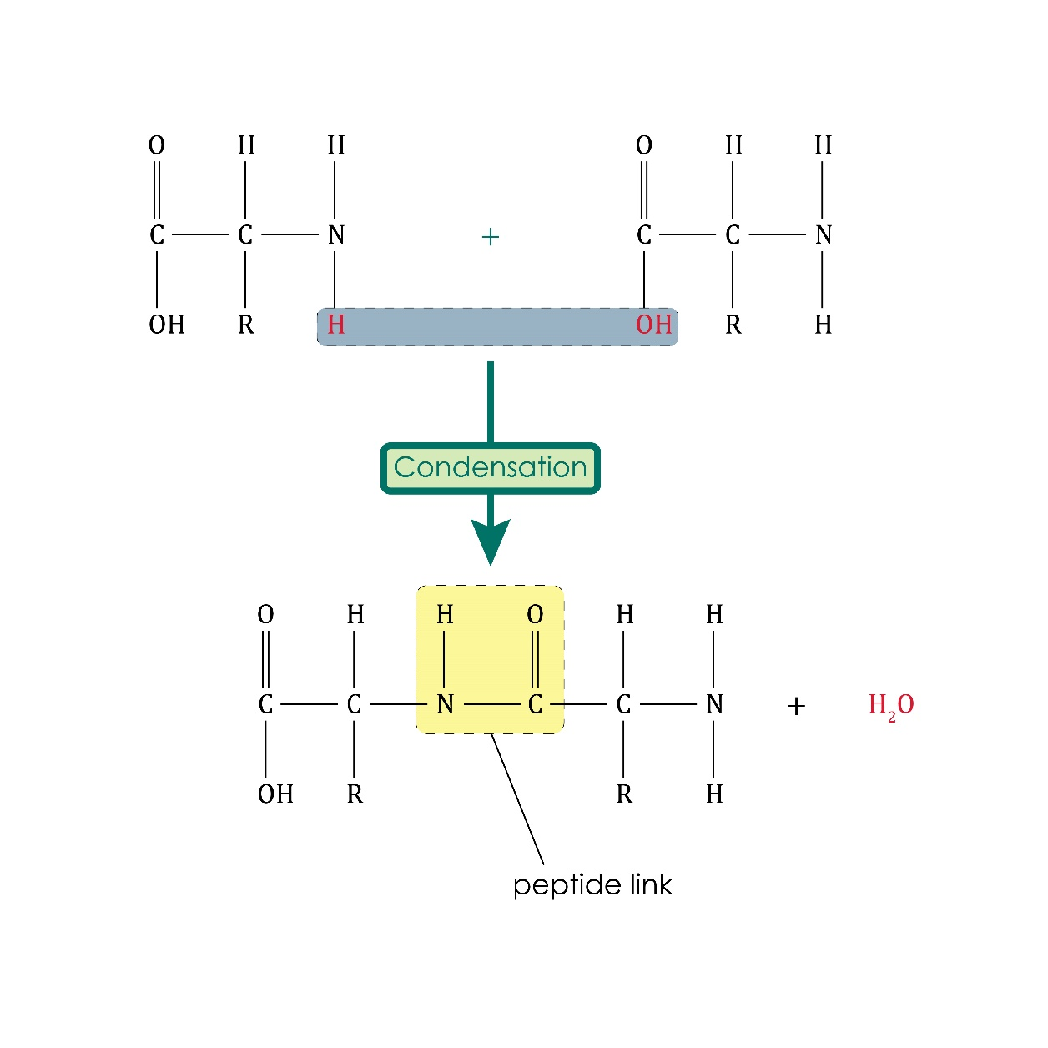

Using the diagram, choose the correct word from those provided to complete the sentences describing this reaction. Not all words will be used.

**proteins ester peptide hydrogen nitrogen**

**carboxylic acid addition condensation monomers**

**oxygen water polymers hydroxyl**

Proteins, or polypeptides, are biological __________________ produced when many amino acid __________________ join together in a __________________ polymerisation reaction.

A molecule of __________________ is also produced in the reaction.

Different amino acids make different __________________ .

The link between two amino acid monomers is a __________________ link where the carbon atom of the __________________ group joins with the __________________ atom of the amine group.

**Amino acids: test myself**

1. Which statement is correct? Circle the correct answer.
2. Amino acid have only acidic properties.
3. Amino acid have only basic properties.
4. Amino acids have both acidic and basic properties.
5. Amino acids have neither acidic nor basic properties.
6. Which statement is correct? Circle the correct answer.
7. All proteins have COOH groups.
8. All proteins have groups.
9. All proteins have OH groups.
10. All proteins have peptide links.
11. The image shows the amino acid alanine.

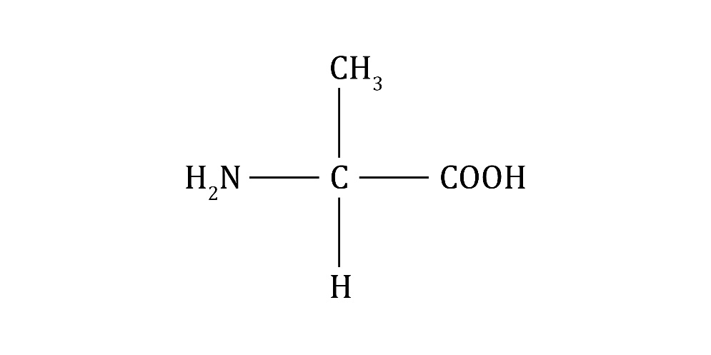

What is alanine’s structural formula?

*Hint: Remember, the structural formula describes the order in which the atoms are arranged in the molecule.*

1. What is produced when amino acids polymerise?
2. Why is the polymerisation of amino acids described as a condensation reaction?

*Hint: Think about the meaning of the term condensation.*

1. The equation represents the polymerisation of an amino acid.

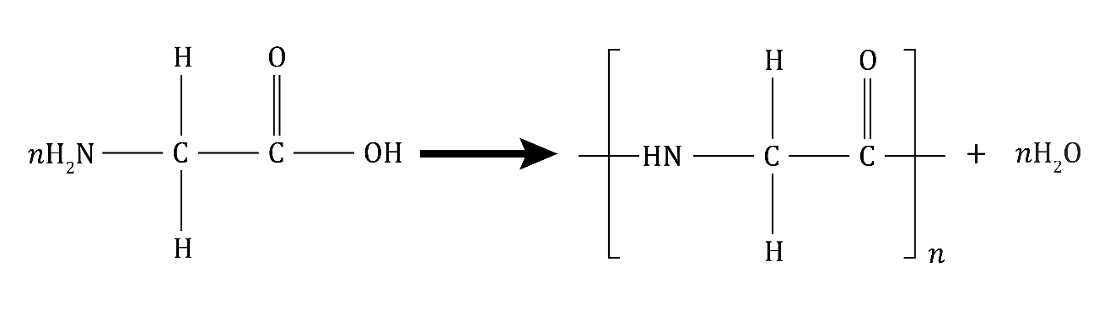

glycine polypeptide water

What does ‘*n*’ represent?

1. Draw the repeating unit in **question** **2.6**.

**Amino acids: feeling confident?**

1. (a) Complete the equation to represent the polymerisation of alanine.

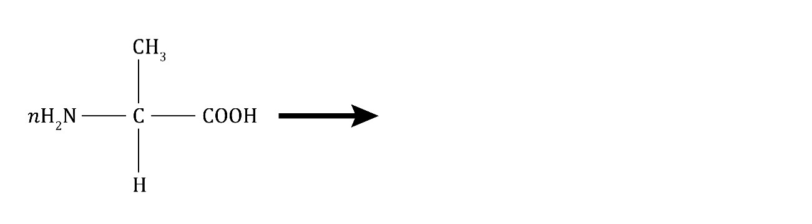

+

* 1. Label the monomer and the repeating unit.

1. The image represents the polymerisation of amino acids to form a protein.

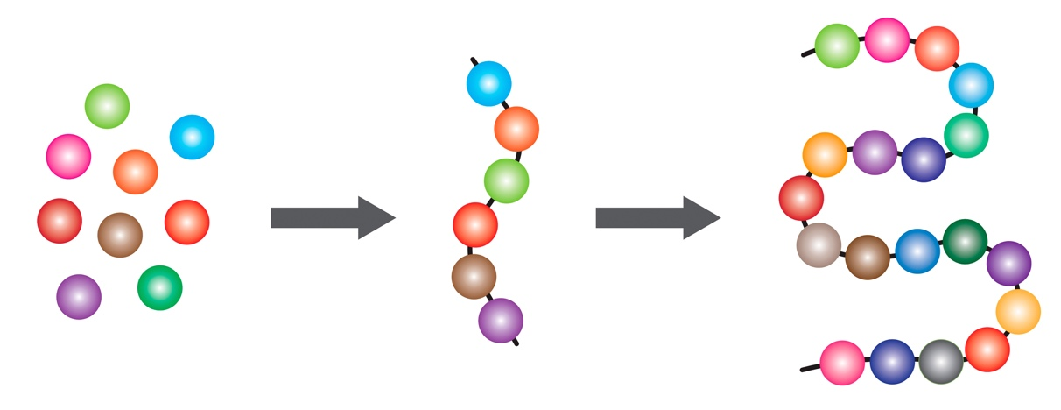

Complete the table describing the image:

|  |  |
| --- | --- |
| **Part of image** | **What does it represent?** |
| individual spheres |  |
| different shaded spheres |  |
| the chain of six spheres |  |
| the twisted chain of spheres |  |
| the lines connecting the spheres |  |

**Amino acids: what do I understand?**

Think about your answers and confidence level for each mini-topic. Decide whether you understand it well, are unsure or need more help. Tick the appropriate column.

|  |  |  |  |
| --- | --- | --- | --- |
| **Mini-topic** | **I understand  this well** | **I think I understand this** | **I need more  help** |
| I can describe the general structure of amino acids. |  |  |  |
| I can interpret the structure of glycine and alanine. |  |  |  |
| I can describe the polymerisation of amino acids to form polypeptides and proteins. |  |  |  |
| I can use equations to represent the polymerisation of amino acids. |  |  |  |
| **Feeling confident? topics** | **I understand  this well** | **I think I understand this** | **I need more  help** |
| I can complete equations to represent the polymerisation of amino acids. |  |  |  |
| I can understand diagrams that explain protein formation. |  |  |  |