Isotopes of hydrogen: Johnstone’s triangle

This resource is from the **Johnstone’s triangle** series which can be viewed at: [rsc.li/43jMfSn](https://rsc.li/43jMfSn) It will help learners to understand the different ways you need to think in chemistry, building their mental models and understanding.

Learning objectives

1 Determine the number of protons, neutrons and electrons in an atom from the atomic symbol.

2 Recognise similarities and differences in the number of protons, neutrons and electrons between atoms and their different isotopes.

How to use Johnstone’s triangle

Use Johnstone’s triangle to develop learners’ thinking about scientific concepts at three different conceptual levels:

* 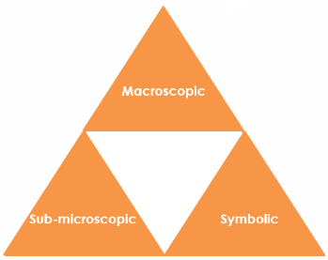Macroscopic – what we can see. Think about the properties you can observe, measure and record.
* Sub-microscopic – smaller than we can see. Think about the particle and atomic level.
* Symbolic – representations. Think about how we represent chemical ideas including symbols and diagrams.

For learners to gain a deeper awareness of a topic, they need to understand it at all three levels.

When introducing a topic, do not try to introduce all three levels of thinking at once. This will overload working memory. Instead complete the triangle over a series of lessons, beginning with the macroscopic level and introducing other levels, in turn, once understanding is secure.

The three levels are interrelated. For example, learners need visual representation of the sub-microscopic to develop mental models of the particle or atomic level.

Find further reading about Johnstone’s triangle and how to use it in your teaching at [rsc.li/45bB6pv](https://rsc.li/45bB6pv).

Scaffolding

It is important to share the structure of the triangle with learners prior to use. Tell them why you want them to use the triangle and how it will help them to develop their understanding. Use an ‘I try, we try, you try’ approach when you are introducing Johnstone’s triangle for the first time.

More resources

To further develop learner’s thinking in all areas of Johnstone’s triangle, try our **Developing understanding** **of atoms and isotopes** worksheets (available from: [rsc.li/43na3ov](https://rsc.li/43na3ov)). These include icons in the margin referring to the conceptual level of thinking needed to answer the question. 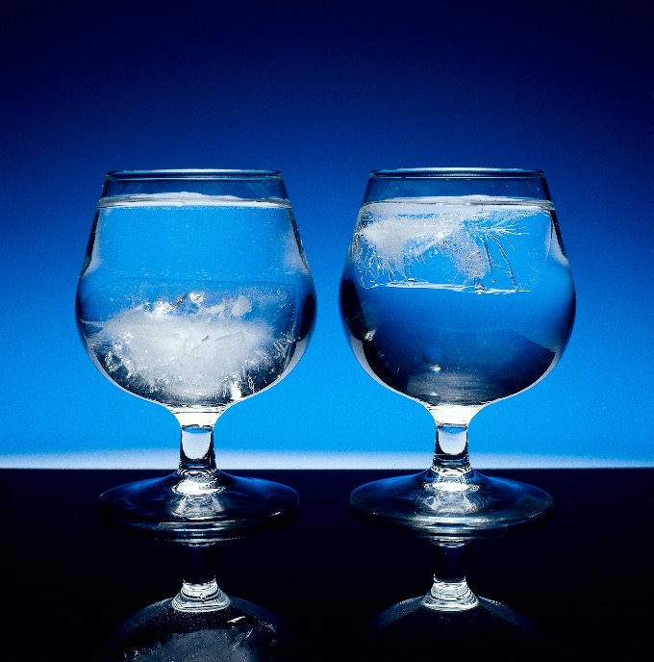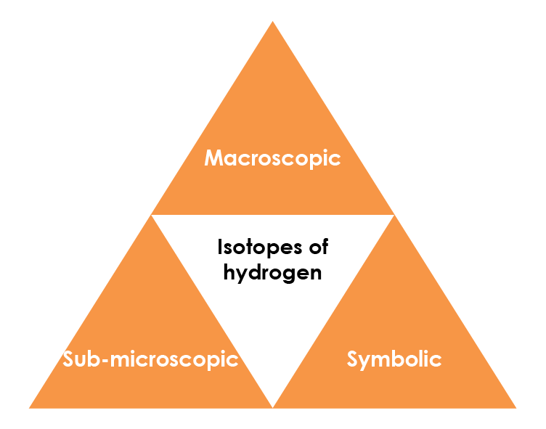

© Charles D. Winters/Science Photo Library

Macroscopic – what we can see

Look at the image. It shows an ice cube made of ‘heavy water’ (deuterium oxide, ) in a glass of water. has the same structure as water, but with the hydrogen atom () replaced by deuterium ().

What do you notice about the position of the ice cube?

**The ‘heavy water’ (deuterium oxide) ice cube sinks to the bottom of the beaker.**

Is this what you would expect?

**This is different from what you see with an H2O ice cube, which would float. This is because D2O(s) has a higher density than H2O(s).**

Sub-microscopic – smaller than we can see

Complete the following sentences about atoms and ions.

Isotopes of the same element have the same number of **protons/electrons** and **protons/electrons** but different numbers of **neutrons.**

This means the **atomic number** of different isotopes is the same but the **mass number** differs.

If the proton number is different it is a different **element.**

Symbolic – representations

We show the number of subatomic particles using atomic symbols. Hydrogen exists as two different naturally occurring isotopes, , and .

Complete the table to show the number of each subatomic particle in these isotopes:

|  |  |  |  |
| --- | --- | --- | --- |
|  | **Protons** | **Neutrons** | **Electrons** |
|  | **1** | **0** | **1** |
|  | **1** | **1** | **1** |
|  | **1** | **2** | **1** |