Metallic structure and bonding

1. The diagram shows how metal atoms bond together to form a metal solid.

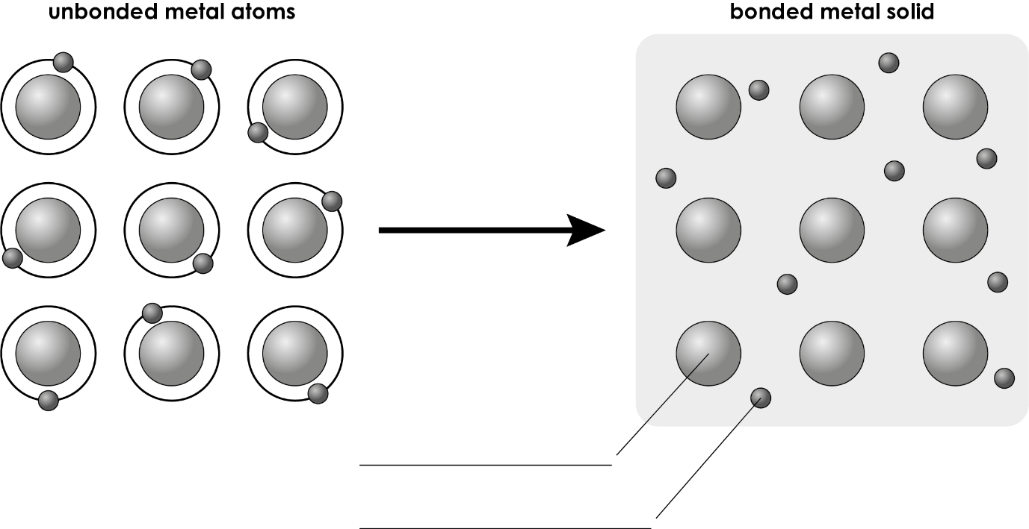

* 1. Label the diagram. **(2 marks)**
  2. Name the type of bonding in the bonded metal solid.

_____________________________________________________________________________________ (1 mark)

* 1. Which group in the periodic table does this metal belong to?

_____________________________________________________________________________________ (1 mark)

* 1. Give two differences between the particles in the unbonded metal atoms and the particles in the bonded metal solid.
* ____________________________________________________________________________________________

________________________________________________________________________________________________

* ____________________________________________________________________________________________

_______________________________________________________________________________________ (2 marks)

* 1. Name the force that exists between the two different types of particles in the bonded metal solid.

_____________________________________________________________________________________ (1 mark)

* 1. Describe how:

1. the positively charged particles move in a bonded metal solid

_____________________________________________________________________________________ (1 mark)

1. the negatively charged particles move in a bonded metal solid.

_____________________________________________________________________________________ (1 mark)

Name the type of structure shown in the diagram of a bonded metal solid.

_____________________________________________________________________________________ (1 mark)

* 1. Give two ways in which the diagram would differ if it represented the bonding in magnesium metal.

_______________________________________________________________________________________________

_____________________________________________________________________________________ (2 marks)

* 1. Explain your answer to part (h).

_______________________________________________________________________________________________

_____________________________________________________________________________________ (2 marks)

1. The table shows some physical properties of copper:

|  |  |
| --- | --- |
| **Melting point/°C** | 1083 |
| **Boiling point/°C** | 2595 |
| **Electrical and heat conductivity** | copper is an excellent conductor of electricity and heat |
| **Malleability** | copper is malleable |

Explain each property. You should refer to metallic bonding and structure.

* 1. Melting point: __________________________________________________________________________

_______________________________________________________________________________________________

______________________________________________________________________________________ (2 marks)

* 1. Boiling point: ___________________________________________________________________________

_______________________________________________________________________________________________

______________________________________________________________________________________ (2 marks)

* 1. Electrical and heat conductivity: ____________________________________________________

_______________________________________________________________________________________________

______________________________________________________________________________________ (2 marks)

* 1. Malleability: ____________________________________________________________________________

_______________________________________________________________________________________________

______________________________________________________________________________________ (2 marks)

1. These diagrams represent the particles in a pure metal and in an alloy.

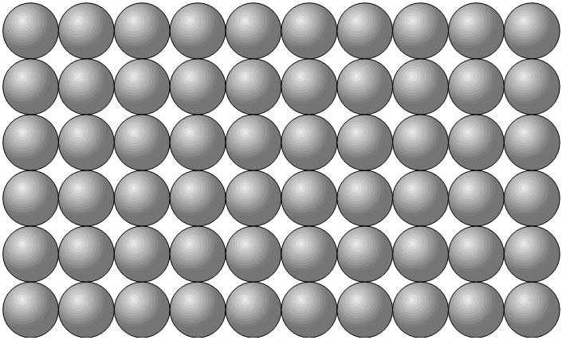 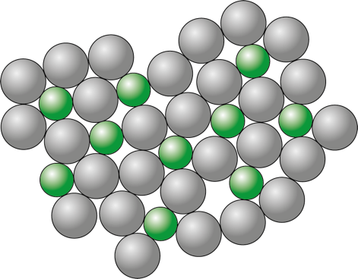

What is an alloy?

_______________________________________________________________________________________________

______________________________________________________________________________________ (1 mark)

Describe what will happen when a force is applied horizontally to the pure metal.

_______________________________________________________________________________________________

______________________________________________________________________________________ (1 mark)

i. Describe what will happen when a force is applied horizontally to the alloy.

_______________________________________________________________________________________________

______________________________________________________________________________________ (1 mark)

* + 1. Explain why this is.

_______________________________________________________________________________________________

______________________________________________________________________________________ (1 mark)

* 1. Explain why alloys have different uses to pure metals.

_______________________________________________________________________________________________

______________________________________________________________________________________ (1 mark)

[Total: 27 marks]

Which question(s) did you get wrong? Why?

What will you do next time you’re asked a similar question?