F5 Light and electrons in energy levels

Revision: models of the atom

You have learned about the model of the atom we use today and how it was developed over time. In order to move on and look at how electrons move within atoms, it will help to revise the models of atomic structure.

1. Four models of the atom are drawn below. For each one, explain what it shows about an atom and what the limitations are.

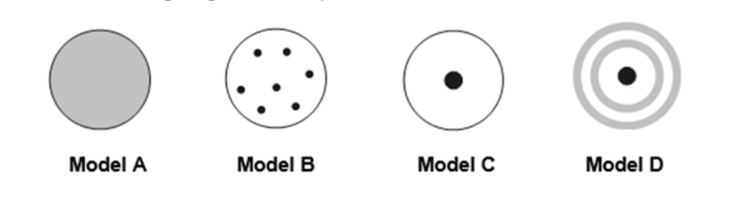

**A B C D**

|  |  |  |  |
| --- | --- | --- | --- |
| **Model** | **Name of model** | **What it shows** | **Limitations** |
| A |  |  |  |
| B |  |  |  |
| C |  |  |  |
| D |  |  |  |

New content: electrons moving within atoms

Electromagnetic radiation (e.g. visible light, UV light) can be used to change the energy of electrons within atoms. In chemistry, you will need to use two equations to do with electromagnetic radiation:

**wave speed = wavelength x frequency**

**energy = Planck’s constant x frequency**

1. State the units for all of the terms in both equations.
2. Rearrange the wave speed equation to make wavelength the subject.
3. Use the first equation to complete these wave calculations.
4. A boat sends waves travelling across water at a frequency of 2.0 Hz with a wavelength of 3.0 m. Calculate the speed of the waves.
5. If the waves in (a) had been produced at a frequency of 1.0 Hz and at the same speed, what would the wavelength be?
6. Light and other electromagnetic waves travel at 300,000,000 m s-1.
7. Write the speed of light (usually given the symbol *c* in equations) in standard form.
8. Show that the wavelength of radio waves of frequency 600 million Hz is 0.5 m.
9. Show that the frequency of microwaves of wavelength 0.30 m is 1 x 109 Hz.
10. A photon of blue light has a frequency of 6.66 x 1014 Hz. How much energy does this photon have? (Planck’s constant is 6.63 x 10-34 J Hz-1).