**A practical investigation of *cis–trans* isomerism in transition metal complexes**

**Learning objectives**

1. Recognise why transition metal complexes can show geometric isomerism.
2. Identify further examples of structural and stereoisomerism in transition metal complex ions and other species.
3. Apply your knowledge and understanding of transition metal chemistry to the synthesis of the two geometric isomers of copper(II) aminoethanoate.

**Introduction**

*Cis-trans* isomerism, a type of E/Z isomerism (sometimes called geometric isomerism), is exhibited in square planar and octahedral transition metal complexes with two pairs of different ligands. Octahedral transition metal complex ions with two or more bidentate ligands exhibit optical isomerism if there is no plane of symmetry. The diagram below shows an example of each type of isomerism.

**Cis-trans** isomers

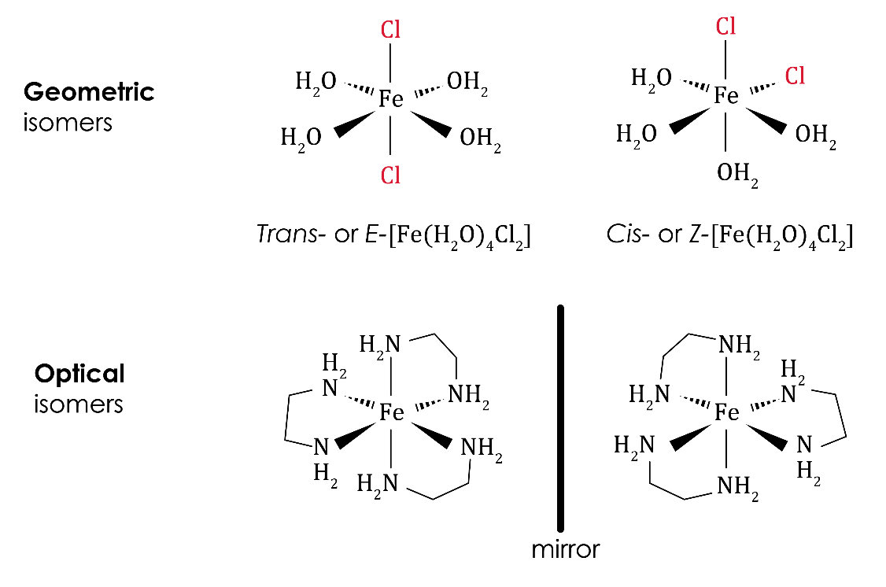

**Optical** isomers

This activity focuses on *cis–trans* isomerism in the octahedral complex, copper(II) aminoethanoate, . You will first synthesise and isolate the *cis*-isomer then isomerise some of your sample to form the *trans*-isomer.

First, complete the pre-lab questions on the linked PowerPoint.

At the end of the PowerPoint there are four post-lab synoptic questions. You can complete these at any point during the activity. They provide a good opportunity to recap prior learning on isomerism more widely.

Before carrying out each synthesis, read through the method and plan a record of your results.

**Equipment and materials for both preparations**

* Splash-proof goggles
* Hot water bath or electric heating mantle
* 25 cm3 measuring cylinder
* 2 × 100 cm3 conical flasks
* 2 × 250 cm3 conical flasks
* Water bath
* -10–110°C thermometer
* Filter funnel and fluted filter paper
* 2 × watch glasses
* 50 cm3 round-bottom flask (Quickfit)
* Condenser (Quickfit) to fit the 50 cm3 round-bottom flask
* Bunsen burner, tripod and gauze
* 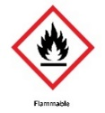2 × sample tubes
* 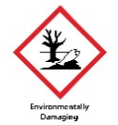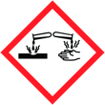Ethanol (DANGER: flammable), 25 cm3
* Copper(II) ethanoate monohydrate (DANGER: harmful; irritant), 2.0 g
* Glycine, 2.5 g
* Distilled water, 50 cm3
* Ice

**Safety and hazards**

* Wear splash-proof goggles.
* Work in a well-ventilated laboratory.
* Ethanol is flammable: work away from naked flames. Note, if IDA is used, it is also harmful if swallowed and may cause damage to organs.

Part 1 – synthesis of *cis*-

**Method**

1. Using a measuring cylinder, measure out 25 cm3 of ethanol into a 100 cm3 conical flask and place the flask in a hot water bath at 65°C.
2. Using a measuring cylinder, measure 25 cm3 of distilled water into a 250 cm3 conical flask. Weigh out 2.0 g (0.01 mol) of copper(II) ethanoate monohydrate and add it to the flask. Place the flask in the water bath and stir the mixture until the solid dissolves. When the solution reaches 65°C, pour the warm ethanol into the copper(II) ethanoate solution.
3. Using a measuring cylinder, measure 25 cm3 of distilled water into a 100 cm3 conical flask. Weigh out 1.5 g (0.02 mol) of glycine and add it to the flask. Place the flask in the water bath. Stir the mixture until the solid dissolves. When the solution reaches 65°C, pour it into the flask containing the copper(II) ethanoate solution.
4. Cool the mixture in an ice bath. Light blue needles should crystallise. Filter the cold mixture through a fluted filter paper. Collect the filtrate in a clean 250 cm3 conical flask and keep it for the synthesis of *trans*-.
5. Open up the filter paper and lay it on a watch glass. Cover the crystals with a piece of clean filter paper and leave to dry in a fume cupboard at room temperature.
6. Label a sample tube with the name of the product, your name and the date. Weigh the labelled sample tube and record its mass.
7. Scrape the dried crystals into the weighed sample tube. Weigh the tube again. Record its mass.

Calculations

Calculate the theoretical yield and the percentage yield. Support for this calculation is available in the PowerPoint.

Part 2 – synthesis of *trans*-

**Method**

1. Weigh 1.5 g of *cis*- and 1 g of glycine into a 50 cm3 round-bottom flask.
2. Use a measuring cylinder to pour 10 cm3 of the filtrate from the synthesis of *cis*- into the flask, fit a condenser and reflux the mixture for one hour (use a hot water bath or electric heating mantle).
3. Filter the hot mixture through a fluted filter paper to obtain blue-violet platelets of *trans*-. Note that if the mixture all dissolves during the reflux, then the *cis*-product will re-precipitate not the *trans* isomer.
4. Open up the filter paper and lay it on a watch glass. Cover the crystals with a piece of clean filter paper and leave to dry in a fume cupboard at room temperature.
5. Label a sample tube with the name of the product, your name and the date.
6. Scrape the dried crystals into the weighed sample tube. It is not possible to get a meaningful value for the percentage yield as the exact quantity of *cis*- is not known.

Extension activity: copper(II) aminoethanoate as a fertiliser

Copper is one of eight essential plant micronutrients.

Copper is required for many enzymatic activities in plants and for chlorophyll and seed production. A deficiency of copper can lead to stunted plant growth and decreased fruit formation.

Copper(II) aminoethanoate is used as a fertiliser as a source of the micronutrient copper. Are there any benefits to using one isomer rather than the other as a source of copper?