Marshmallow models
Education in Chemistry
September 2018
rsc.li/2BXmKNh
Niki Kaiser
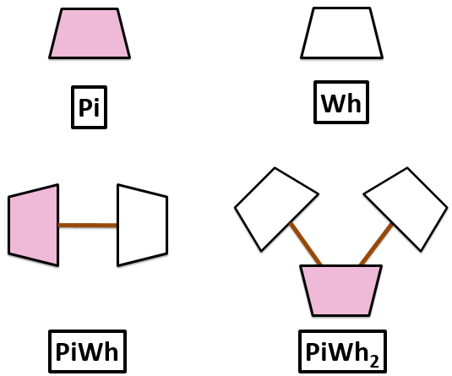

Using the examples above to help you, build these molecules using white and pink marshmallows:

- Pi₂
- Pi₃
- Pi₂Wh
- Pi₂Wh₂
- 2Pi
- 3Pi
- 2PiWh
- PiWh₃
When you have finished, make your own molecules and ask your partner to write down the formula.

