Popping good chemistry

Learning objectives

1. Describe chemical reactions as the rearrangement of atoms.
2. Represent chemical reactions using formulas and equations.

Introduction

A chemical reaction is **effervescent** if it produces bubbles of gas. Effervescent vitamin C tablets are a common way for people to increase the vitamin C they obtain from their diet. In this investigation, you will find out more about the chemical reaction that occurs when these tablets dissolve in water. This is a **neutralisation** reaction. Your teacher will discuss with you what chemical substances are present in vitamin C tablets and how they react together when added to water.

Activity

Write a word equation for the effervescent reaction that occurs when a vitamin C tablet dissolves in water. Always remember to write all the reactants on the left-hand side of the arrow and the products on the right-hand side of the arrow.

You can choose to:

1. Write the word equation independently.
2. Use the word bank to write a word equation in your notes or on a mini whiteboard.
3. Cut out the chemical substances, arrange them into a word equation and stick it into your notes.
4. Extension: you might want to write the chemical formulas underneath each of the words in the word equation.

|  |  |
| --- | --- |
| carbon dioxide | + |
| citric acid | + |
| water | + |
| sodium hydrogen carbonate | 🡪 |
| sodium citrate |  |

Cut out each box and rearrange the boxes into the correct word equation.

|  |  |
| --- | --- |
| carbon dioxide | + |
| citric acid | + |
| water | + |
| sodium hydrogen carbonate | 🡪 |
| sodium citrate |  |

Cut out each box and rearrange the boxes into the correct chemical equation.

|  |  |
| --- | --- |
| 3CO2 | + |
| C6H8O7 | + |
| 3H2O | + |
| 3NaHCO3 | 🡪 |
| Na3 C6H5O7 |  |

Investigation

Learning objectives

1. Make predictions, observations and measurements.
2. Identify variables and how to make an experiment fair.
3. Identify patterns and make conclusions from results.
4. Evaluate the reliability of methods and suggest improvements.

Introduction

A chemical reaction is **effervescent** if it produces bubbles of gas. Effervescent vitamin C tablets are a common way for people to increase the vitamin C they obtain from their diet. In this resource, you will investigate how one **variable** affects the speed (or rate) of the reaction between two of the chemicals found in vitamin C tablets.

Practical activity

Safety and hazards

* The tablet tube lid pops off suddenly; wear safety glasses or goggles at all times.
* Never look directly down at the tubes once the reaction has started.
* Keep tubes upright, do not point them directly at anyone.
* If a lid does not pop off within the expected time, let your teacher know so they can safely dispose of the reaction mixture.
* Never eat or drink when in a laboratory.
* Wash your hands at the end of the experiment.

Method

1. Remember to follow the safety instructions.
2. Fill the empty tube with water, then pour it into a measuring cylinder or jug. Write down the volume and calculate half. This is the volume of water you will use for each repeat.
3. Measure the volume of water from step 2 and pour it into the tablet tube. Place the tablet tube in a test tube rack.
4. Put one tablet in the tube and put the lid on firmly. Work with a partner to make sure you start the timer as soon as the lid is on.
5. Stop the timer when the lid pops off.
6. Record the time taken.
7. Change your independent variable at least twice (making sure you still have a fair test) and repeat steps 3–6.

Think: how could you make your experiment more reliable?

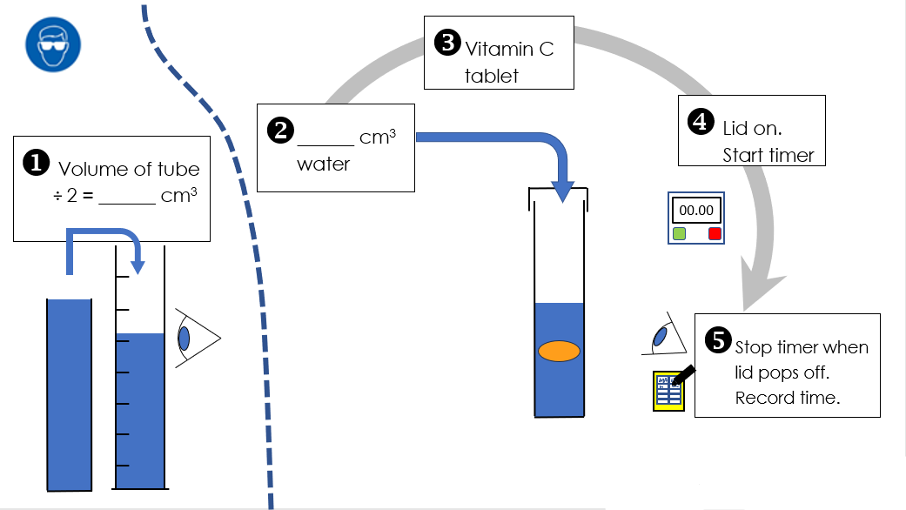Integrated instructions

Results table

Independent variable ________________________________________________

Dependent variable __________________________________________________

Complete the results table. Don’t forget to add units.

|  |  |  |  |
| --- | --- | --- | --- |
|  | Attempt 1 | Attempt 2 | Mean |
|  |  |  |  |
|  |  |  |  |
|  |  |  |  |