Metallic structure and bonding

This resource is from the **Johnstone’s triangle** series which can be viewed at: [rsc.li/3YE7pdl](https://rsc.li/3YE7pdl). In this series you will also find our **Metallic bonding in copper: Johnstone’s triangle** worksheet which introduces the triangle in the context of the transition metal copper and its uses: [rsc.li/3LY2IDz](https://rsc.li/3LY2IDz)

Learning objectives

|  |  |  |
| --- | --- | --- |
| **LO** | **Objective** | **Where assessed** |
| **1** | Use an appropriate model to explain the properties of a metal or alloy. | Q1 and 2 |
| **2** | Explain why a positive ion is charged. | Q3 |
| **3** | Use an atomic structure diagram to interpret a metallic bonding diagram. | Q4 |
| **4** | Describe the nature of metallic bonding. | Q5 |
| **5** | Evaluate a model of metallic bonding. | Q6 |

How to use the resource

This resource aims to develop learners’ understanding of metallic bonding. The questions encourage learners to connect different models and representations with sub-microscopic understanding. As a result, learners should develop more secure mental models to support their thinking about this topic.

|  |  |  |  |  |
| --- | --- | --- | --- | --- |
| **When to use?** | Enter with solid fill Introduce | Watering pot with solid fill **Develop** | Arrow circle with solid fill **Revise** | Clipboard Mixed with solid fill Assess |
| Use after initial teaching or discussion of this topic to develop ideas further. You can also use as a revision activity. | | | |
| **Group size?** | Head with gears with solid fill **Independent** | Group brainstorm with solid fill **Small group** | Classroom with solid fill **Whole class** | Work from home house with solid fill **Homework** |
| Suitable for independent work either in class or at home. Or use the questions for group or class discussions. | | | |
| **How long?** | Stopwatch 25% with solid fillArrow Right outlineStopwatch 50% with solid fill | | 15–30 mins | |

Johnstone’s triangle

Johnstone’s triangle is a model of the three different conceptual levels in chemistry: macroscopic, symbolic and sub-microscopic. You can use Johnstone’s triangle to build a secure understanding of chemical ideas for your learners.

Find further reading about Johnstone’s triangle and how to use it in your teaching at [rsc.li/4hd9kMI](https://rsc.li/4hd9kMI).

Johnstone’s triangle and this resource

The icons in the margin indicate which level of understanding each question is developing to help prompt learners in their thinking.

|  |  |
| --- | --- |
| An icon used to indicate the Macroscopic part of Johnstone's triangle. | **Macroscopic:** what we can see. Think about the properties that we can observe, measure and record. |
| An icon used to indicate the Sub-microscopic part of Johnstone's triangle. | **Sub-microscopic:** smaller than we can see. Think about the particle or atomic level. |
| An icon used to indicate the Symbolic part of Johnstone's triangle. | **Symbolic:** representations. Think about how we represent chemical ideas including symbols and diagrams. |

The levels are interrelated, for example, learners need visual representation of the sub-microscopic in order to develop mental models of the particle or atomic level. Our approach has been to apply icons to questions based on what the learners should be thinking about.

Questions may be marked with two or all three icons, indicating that learners will be thinking at more than one level. However, individual parts of the question may require learners to think about only one or two specific levels at a time.

Support

This worksheet is ramped so that the earlier questions are more accessible. The activity becomes more challenging in the later questions. You can give extra explanations for the more challenging questions. If completing as an in-class activity it is best to pause and check understanding at intervals, as often one question builds on the previous one.

It is useful for learners to observe macroscopic properties first-hand. You could circulate examples of substances in the classroom, run a class practical of a chemical reaction or show a teacher demonstration of properties.

Give learners physical models to use and manipulate, such as a Molymod™ kits or counters.

Additional support may be needed for any learners still lacking in confidence in the required symbolic representation, for example by sharing and explaining a diagram or a simulation that can show movement of the particles.

Answers

1. Guidance: This question supports learners to explain macroscopic properties of copper with an appropriate sub-microscopic model.
2. Model A.
3. Copper is ductile because the atoms can move across each other.
4. Electrons
5. The metallic structure model does not show any (delocalised) electrons.



1. Guidance: This question supports learners to explain the macroscopic properties of the alloy brass with an appropriate sub-microscopic model.
2. Model B
3. An alloy is strong because the atoms are different sizes. This distorts the structure and makes it more difficult for atoms to move past each other. This is shown most clearly by model B.
4. A
5. Model A shows delocalised electrons.



1. Guidance: This question supports learners to use an electron configuration diagram to explain why a sodium ion is charged.

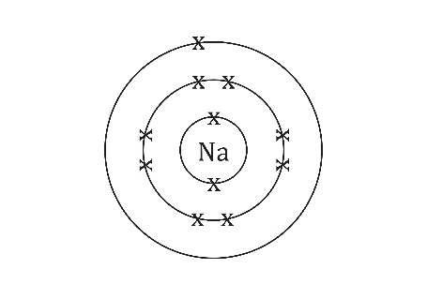

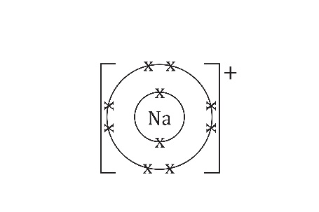

1. +11
2. The charge of a sodium nucleus is +11. A sodium ion has only 10 negatively charged electrons. The overall charge of a sodium ion is therefore 11-10 = +1.
3.  Guidance: This question supports learners to connect an electron configuration diagram with a typical diagram of a model for the structure of a metal to help develop understanding of the model.
4. outer electrons
5. nucleus and inner electrons



1. Guidance: This question uses aluminium as another example to support learners to continue developing their understanding of what is represented by a diagram of metallic structure.

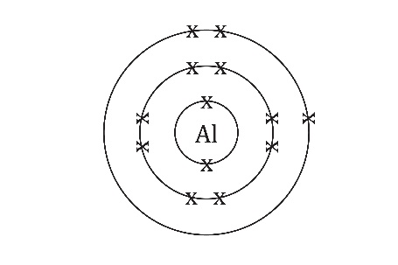

1. 13
2. +3

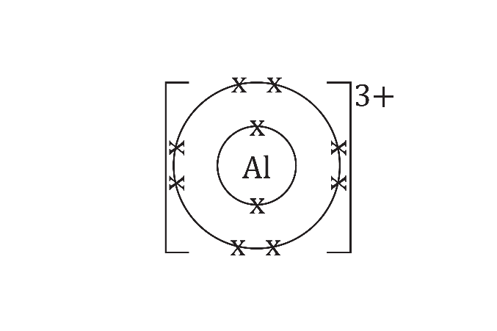

1. There will be three delocalised electrons because an aluminium atom has three outer electrons.
2. Metallic bonding arises from the electrostatic attraction between the negative delocalised electrons and the remaining positively charged ion (made up of the nucleus and inner electrons).



1. Guidance: This question challenges learners to use and evaluate a different version of a metallic structure diagram.
2. This model represents the delocalised electrons as a ‘sea of electrons’. This analogy gives the idea that the electrons are free to move which can help to explain why a metal can conduct electricity.
3. One disadvantage of this model is that the negative charge of the delocalised electrons is not made clear.  
   Another disadvantage is that this model shows the metal ions being spaced out when for a solid metal they should be touching.