Earth’s atmosphere

The **atmosphere** surrounds and protects Earth, making life possible.

Earth was formed around 4.6 billion years ago. When the Earth was very young, **carbon dioxide** (CO2) made up most of the atmosphere and there was no free **oxygen** (O2).

Over billions of years, **oxygen levels increased** (and **carbon dioxide decreased**) because plants grew and used the carbon dioxide for **photosynthesis** while producing oxygen.

Did you know …?

Oceans formed when the **water vapour** in Earth’s early atmosphere cooled and **condensed**. Carbon dioxide **dissolved** in the oceans and became **locked up** in **sedimentary** **rocks.**

**Nitrogen** gas (N2) formed when the **ammonia** (NH3) in Earth’s early atmosphere reacted with the oxygen produced by plants. Nitrogen is a very stable gas, which is why it now makes up most of the atmosphere.

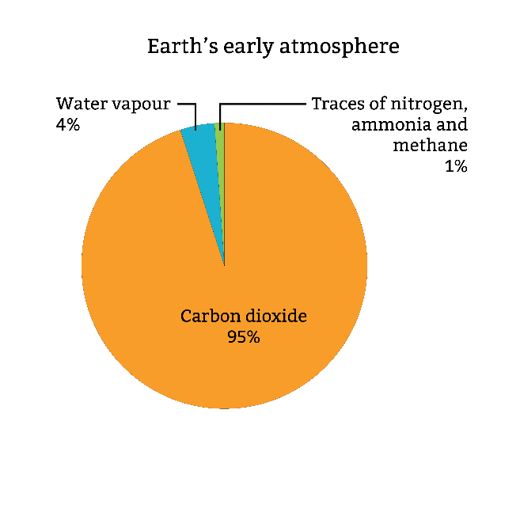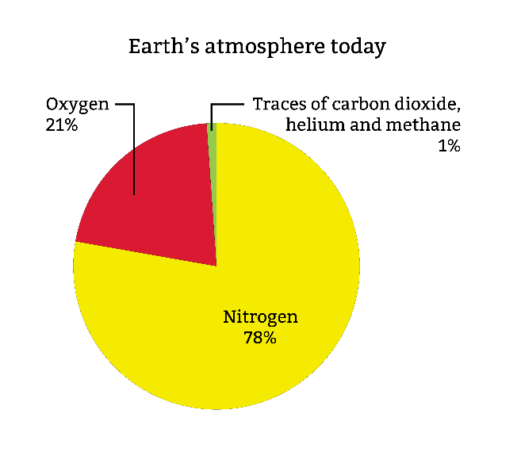

Today, Earth’s atmosphere has five main layers; let’s take a journey through them.

Troposphere

Range: from Earth’s surface up to about 12 kilometres depending on the location (higher at the equator and lower at the poles).

* Most of Earth’s **weather** happens here.
* The **temperature decreases** with altitude.

Stratosphere

Range: from the top of the troposphere to about 50 kilometres above Earth’s surface.

* Contains the **ozone layer**, which absorbs and scatters **ultraviolet radiation** from the Sun and therefore protects us from its harmful rays.

Did you know …?

**Ozone** (O₃) is a molecule made up of **three oxygen atoms**. It's relatively rare in the atmosphere but its presence is vital. Human activities, particularly the release of chemicals called chlorofluorocarbons (CFCs), have damaged the ozone layer. CFCs mostly come from air conditioning and refrigeration.

Mesosphere

Range: from the top of the stratosphere to about 80 kilometres above Earth’s surface.

* The coldest layer.
* Most **meteors** burn up here after entering the atmosphere. So, when you see a shooting star, it’s happening in the **mesosphere**!

Thermosphere

Range: from the top of the mesosphere to about 700 kilometres above Earth’s surface.

* The temperature is increased significantly by the absorption of solar radiation.
* **Auroras** (northern and southern lights) happen in the thermosphere.
* The **International Space Station** orbits here.

Exosphere

Range: from the top of the thermosphere to about 10,000 kilometres above Earth’s surface.

* The outermost layer.
* Particles are very sparse here. They can travel hundreds of kilometres without colliding with each other and they gradually escape into space.
* **Satellites** orbit Earth here.

Did you know …?

The **Kármán line** – considered to be the boundary between the Earth's atmosphere and **outer space** – is 100 kilometres above Earth’s surface, in the lower part of the thermosphere. When astronauts cross the Kármán line they officially become space travellers.