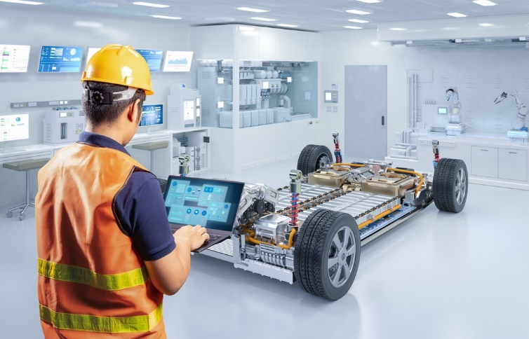Metallic structure and bonding in electric cars

Source: © Shutterstock

Many different metals are used to manufacture electric cars. Most car bodies are made from iron and aluminium, but different metals are needed to make the batteries and other components.

1. Sheets of metal are pressed into shape by robots to make the bodies of cars.
   1. Which of the following statements is correct? Circle the correct answer.
2. Metals consist of negative ions in a sea of positive delocalised electrons.
3. Metals consist of positive metal ions in a sea of negative delocalised electrons.
4. Metals consist of positive metal ions and negative non-metal ions.
5. Metals consist of delocalised electrons in a sea of positive metal ions.
   1. Why can sheets of metal can be pressed into shape without breaking? Circle the correct answer.
      1. Metals are not malleable.
      2. Layers of regularly arranged metal ions can move over each other.
      3. Metal ions are arranged irregularly.
      4. Metals have weak metallic bonds.
   2. Car bodies need to be strong. Metals are strong because they have strong metallic bonds.

Complete the sentences about metallic bonds.

Metals have giant metallic structures of positive __________________ __________________ and delocalised __________________ . They are attracted to each other by strong __________________ forces. These are metallic bonds.

1. Aluminium magnesium alloys are used in the manufacture of many electric cars. The percentages by mass of metals in a typical alloy and the diameters of their ions are shown in the table.

|  |  |  |
| --- | --- | --- |
| **Metal** | **Percentage () by mass** | **Diameter of an ion/pm** |
| aluminium | 90 | 53 |
| magnesium | 10 | 71 |

* 1. Use the data shown in the table to work out how many kilograms of magnesium there are in 1000 kg of the aluminium magnesium alloy.
  2. Draw and label a diagram to show the arrangement of particles in an aluminium magnesium alloy.

Hint: think about the relative sizes of the two types of particles.

* 1. Which statement explains why the aluminium magnesium alloy is less malleable than pure aluminium? Circle the correct answer.

1. Magnesium is a harder metal than aluminium.
2. Aluminium ions and magnesium ions are the same size and the layers of metal ions easily roll over each other.
3. The larger aluminium ions disrupt the regular arrangement of metal ions and the layers cannot roll over each other so easily.
4. The larger magnesium ions disrupt the regular arrangement of metal ions and the layers cannot roll over each other so easily.
5. The table below gives the amounts of some other metals used to manufacture electric cars. These are average amounts.

|  |  |
| --- | --- |
| **Metal** | **Amount used in average electric car/kg** |
| copper | 53 |
| lithium | 10 |

* 1. Copper is used in electric circuits because it is an excellent conductor of electricity. How does copper conduct electricity? Circle the correct answer.
     1. Malleable materials conduct electricity.
     2. Layers of regularly arranged metal ions can move over each other.
     3. The delocalised electrons move through the structure and carry the charge.
     4. The negative metallic ions move through the structure and carry the charge.
  2. Lithium is in group 1 of the periodic table. The outer shell electrons in lithium metal are delocalised.

1. What is the charge on a lithium ion?
2. How many delocalised electrons will 100 lithium atoms produce?
   1. Copper ions have a 2 charge. How many delocalised electrons will 100 copper atoms produce?

Which question(s) did you get wrong? Why?

What will you do next time you’re asked a similar question?