Covalent bonding: Johnstone’s triangle

This resource is from the **Johnstone’s triangle** series which can be viewed at: [rsc.li/3LWofwD](https://rsc.li/3LWofwD). It will help learners understand the different ways you need to think in chemistry, building their mental models and understanding.

Learning objectives

1. Describe a covalent compound based on observations.
2. Use symbolic models to represent a covalent compound.
3. Explain how the type of bonding in a covalent compound relates to the properties you can observe.

How to use Johnstone’s triangle

Use Johnstone’s triangle to develop learners’ thinking about scientific concepts at three different conceptual levels:

* 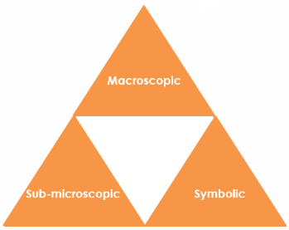Macroscopic – what we can see. Think about the properties we can observe, measure and record.
* Symbolic – representations. Think about how we represent chemical ideas including symbols and diagrams.
* Sub-microscopic – smaller than we can see. Think about the particle or atomic level.

For learners to gain a deeper awareness of a topic, they need to understand it at all three levels.

When introducing a topic, do not try to introduce all of the levels of thinking at once. This will overload working memory. Instead complete the triangle over a series of lessons, beginning with the macroscopic level and introducing other levels, in turn, once secure.

All of the levels are interrelated, for example, learners need visual representation of the sub-microscopic in order to develop mental models of the particle or atomic level.

Find further reading about Johnstone’s triangle and how to use it in your teaching at [rsc.li/3WXETCj](https://rsc.li/3WXETCj).

Scaffolding

It is important to share the structure of the triangle with learners prior to use. Tell them why you want them to use the triangle and how it will help them to develop their understanding. Use an ‘I try, we try, you try’ approach when you are introducing Johnstone’s triangle for the first time.

More resources

To further develop learner’s thinking in all areas of Johnstone’s triangle, try our **Developing understanding** worksheets ([rsc.li/4eWHa7d](https://rsc.li/4eWHa7d)). These include icons in the margin referring to the conceptual level of thinking needed to answer the question. 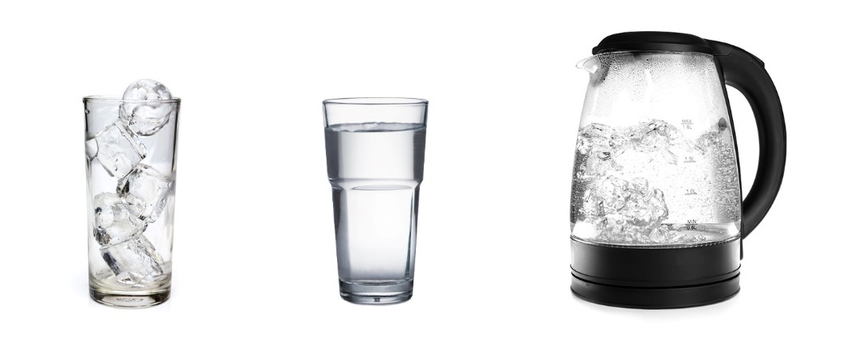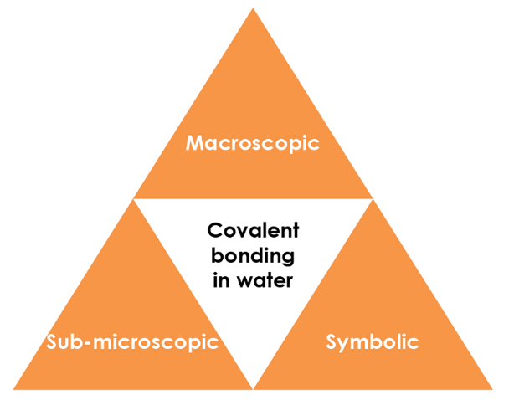

Macroscopic – what we can see

Observe water in the solid, liquid and gas state.

Note to teacher: *if possible, demonstrate these during the lesson.*

What are the freezing and boiling temperatures of water?

**Freezing point = 0°C, Boiling point = 100°C**

What state is water in at room temperature?

**Water is a liquid at room temperature.**

What do you see when water boils?

**Bubbles of water vapour form throughout the liquid and rise  
to the surface**.

Sub-microscopic – smaller than we can see

Is water a simple covalent molecule or a giant covalent compound?

**Simple covalent molecule**

Which of these are the strongest in water?

**covalent bond intermolecular force**

Explain why simple covalent compounds have relatively low or very low boiling points.

**Simple covalent compounds have low boiling points because the weak intermolecular forces between the molecules do not need much energy to overcome. The covalent bonds are not broken.**

Symbolic – representations

Draw a dot and cross diagram for a water molecule. The formula of water is .

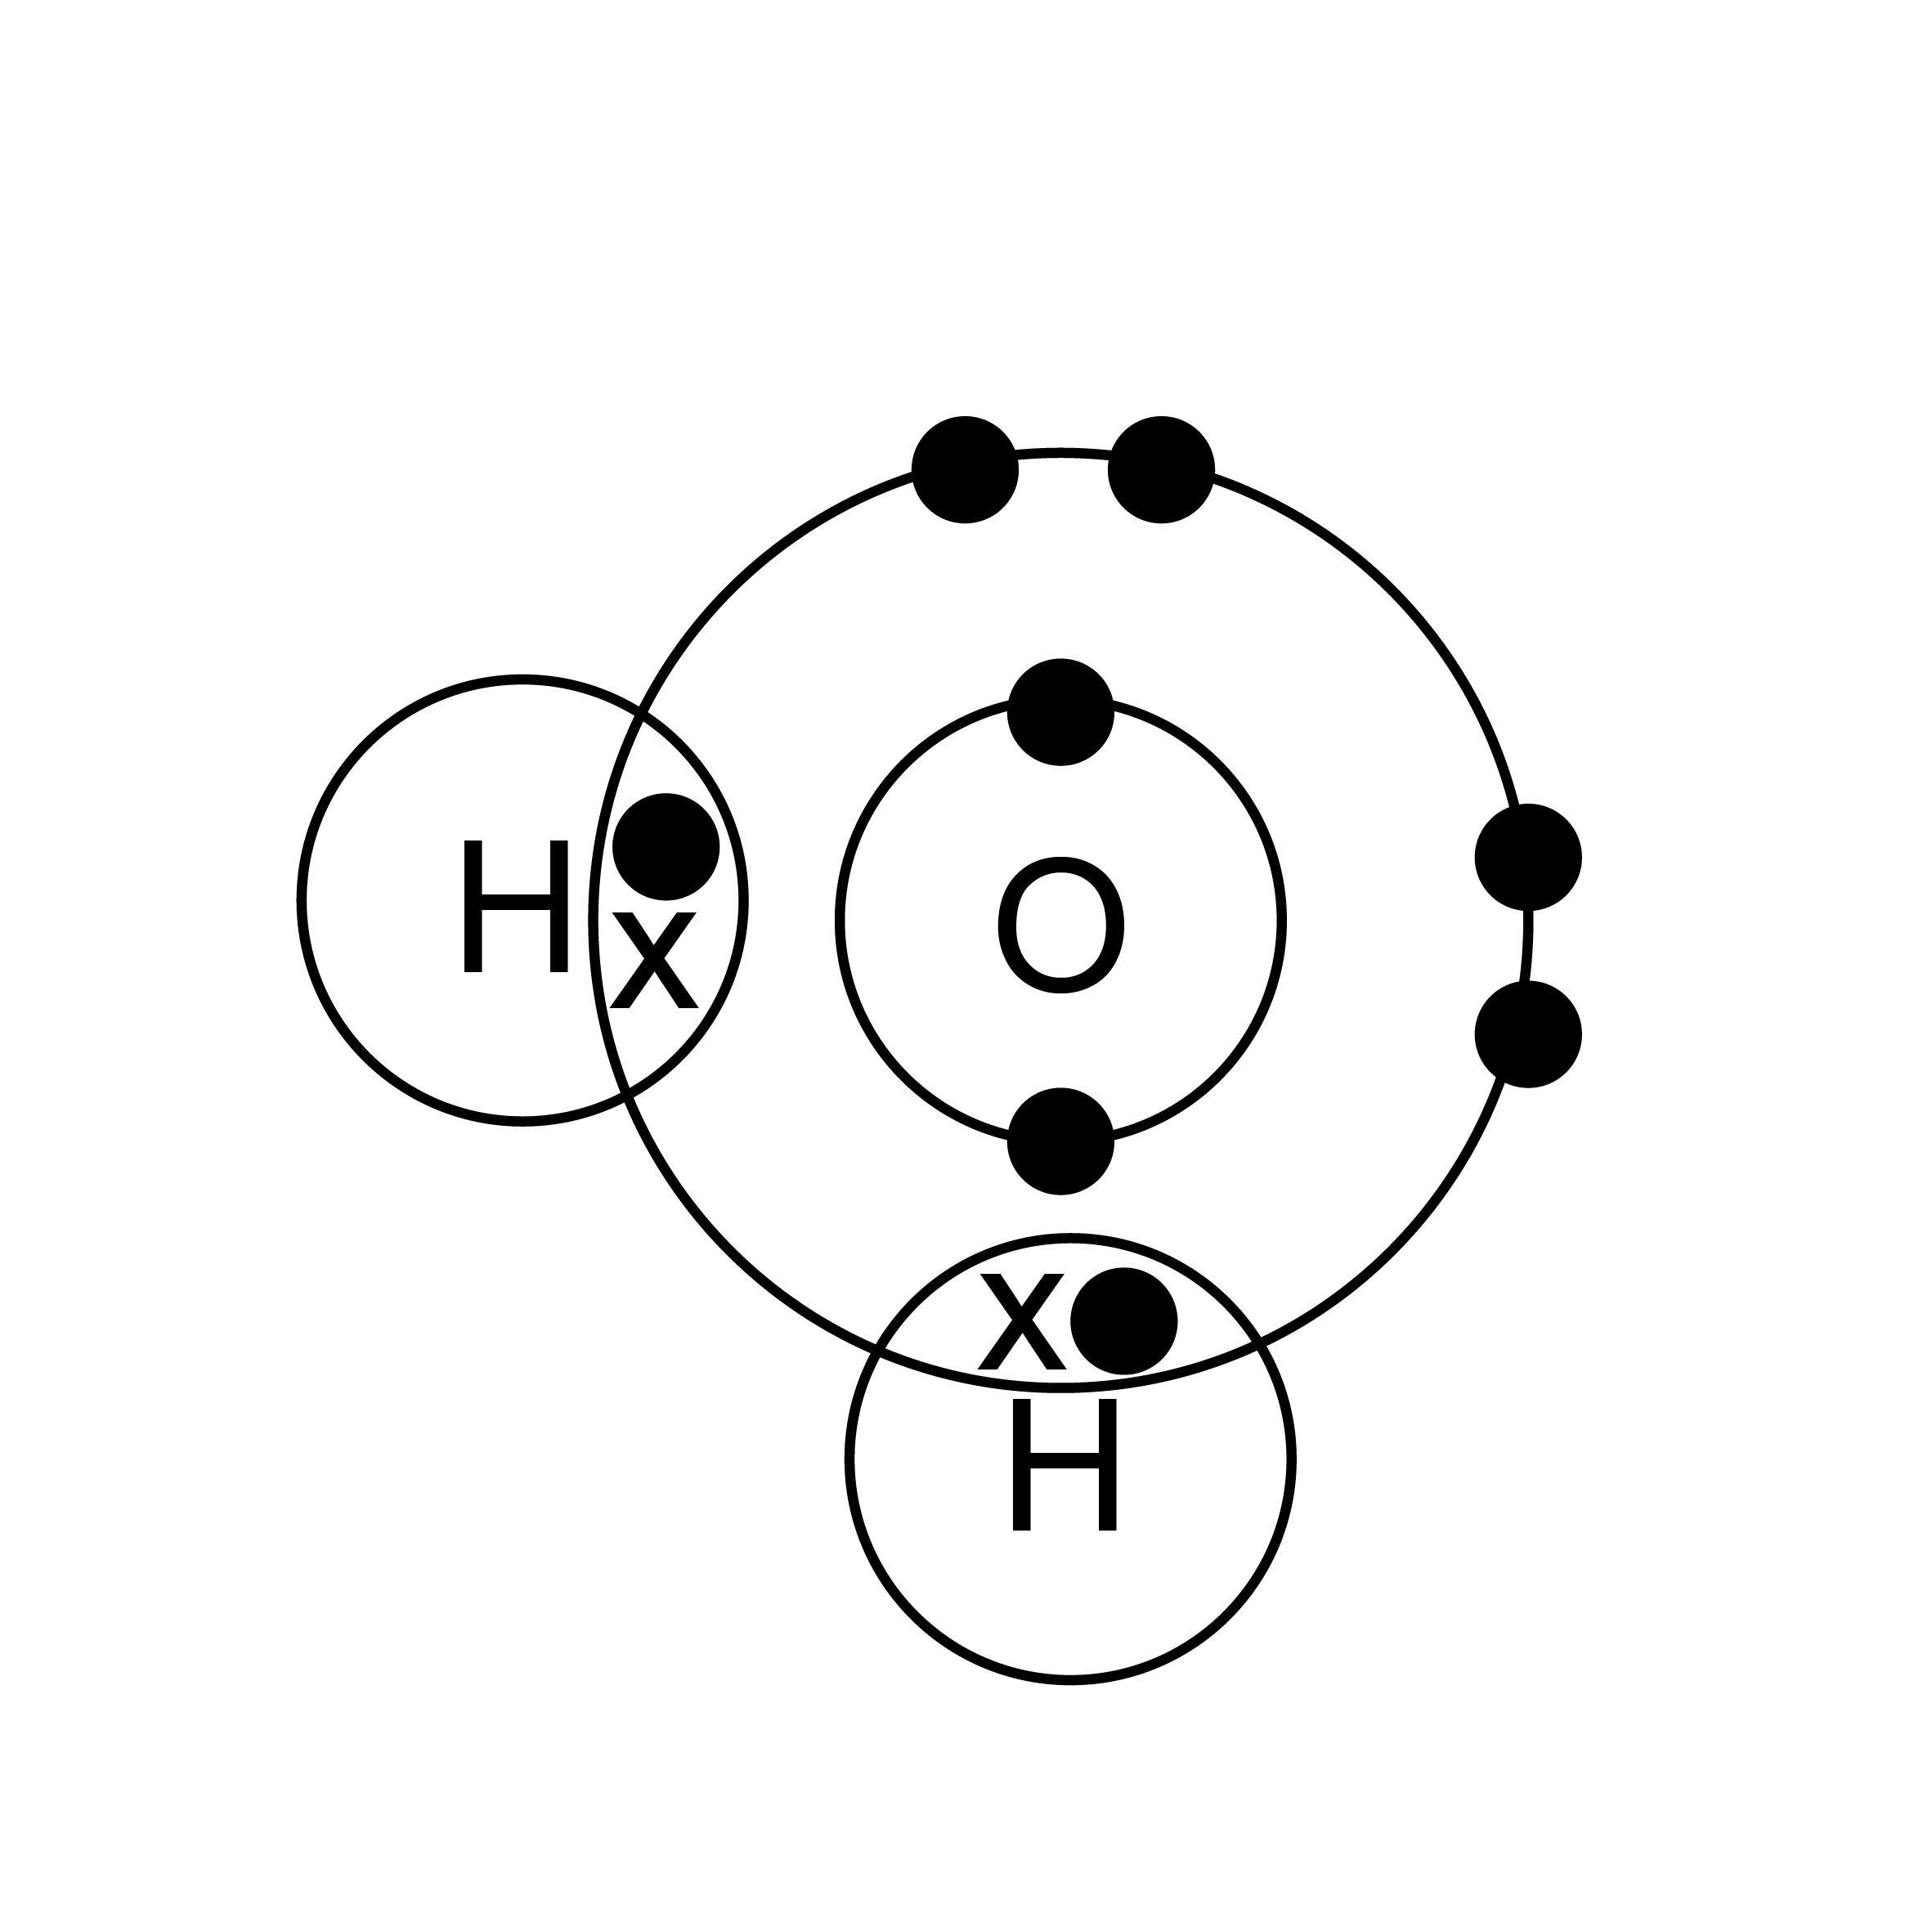

On the diagram below label a covalent bond and an intermolecular force.

