F3 Nuclear fusion

This is the third lesson in an introductory course for post-16 chemistry learners covering key ideas in order of scale. Find out more about the course and approach here: [**rsc.li/4kGyaoN**](https://rsc.li/4kGyaoN)

Before each lesson, ask learners to complete the preparation worksheet to revise knowledge from their 14–16 courses or previous lessons and introduce the topic for the lesson.

Then, get them to complete the student sheet during the lesson. It includes all key content and challenges misconceptions. Each student sheet has a scale and a Johnstone’s triangle diagram at the top. Use these to help learners think about the relative scale of different aspects of chemistry and connect their understanding of sub-microscopic, macroscopic and symbolic representations.

This icon indicates that students will need access to learning materials e.g. textbook or online resources to support their learning, see [**rsc.li/4nUROjR**](https://rsc.li/4nUROjR) for links.

Begin each lesson by checking learners have completed the preparation work. Share the answers and ask learners to mark their own worksheets as part of their independent work.

Topics in this lesson

|  |  |  |
| --- | --- | --- |
| Beginning with solid fill | **Last lesson** | F2 Counting protons, neutrons and electrons |
|  | **Preparation worksheet** | Revision: protons, neutrons and electrons  New content: nuclear fusion |
|  | **Lesson worksheet** | Nuclear fusion; nuclear equations |
| End with solid fill | **Next lesson** | F4 Modelling radioactive decay |

Answers

Revision: protons, neutrons and electrons

1. Mass number is larger and often is not a whole number.

|  |  |  |  |  |
| --- | --- | --- | --- | --- |
| **Element** | **Rh** | **Rf** | **Pb** | **Cr** |
| Name | **rhodium** | **rutherfordium** | **lead** | **chromium** |
| Protons | **45** | **104** | **82** | **24** |
| Neutrons | (of isotope with mass 103)  **58** | (of isotope with mass 103)  **163** | (of isotope with mass 103)  **125** | (of isotope with mass 103)  **28** |
| Electrons | **45** | **104** | **82** | **24** |

1. Because the relative atomic mass is an average of the masses of all the isotopes of an element, taking into account their abundances.

New content: nuclear fusion

1. Fusion increased the number of protons in a nucleus so therefore the element is different.

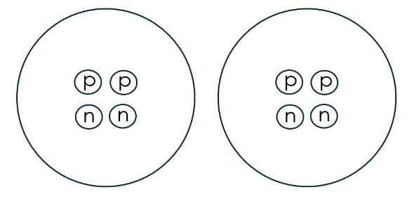

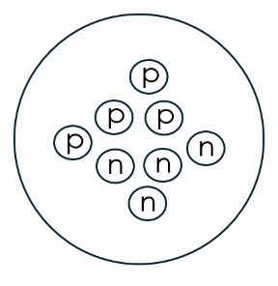

2p + 2p = 4p; 2n + 2n = 4n; 4 protons, 4 neutrons

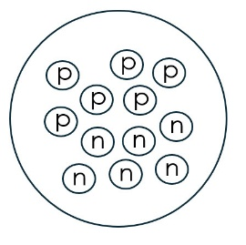

Three He nuclei needed

1. neon-20 + helium-4 = magnesium-24

Worksheet

Scale

|  |  |  |  |
| --- | --- | --- | --- |
| **Subatomic** | **Atom** | **Molecule** | **Giant structure** |
| Nuclei, protons, neutrons, alpha particles |  |  |  |

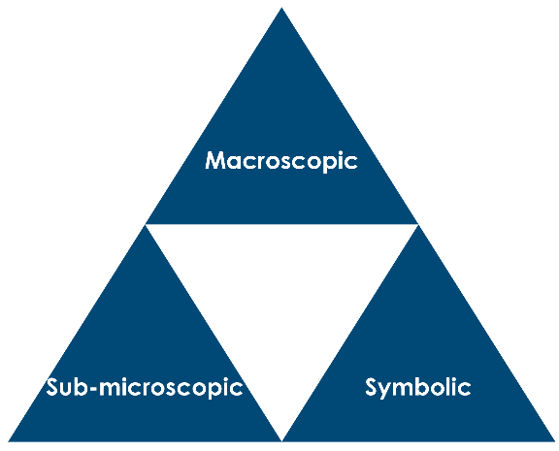

Nuclei, protons, neutrons, alpha particles

Equation for fusion

1. Nuclei
2. Two nuclei join/combine to form a larger, more massive nucleus. The new nucleus is a new element.
3. Very high temperature and pressure (approximately 10–15 million K).
4. Nuclei are positively charged, so will repel each other. High temperatures and pressures are needed to force the nuclei close together.
5. Human mass is ~70 kg, so 70,000 g

Volume , so:

Volume (similar to a medium sized bottle of water)

1. 1 cm3 core material has mass 150 g (0.15 kg).
2. So, number of hydrogen nuclei

|  |  |  |  |  |
| --- | --- | --- | --- | --- |
| **Particle** | **Alpha particle** | **Beta particle** | **Proton** | **Neutron** |
| Alternative name | helium nucleus | electron | 1H nucleus | n/a |
| Nuclear symbol |  |  |  |  |

1. 12C + 12C
2. The formation of einsteinium-248 from uranium and nitrogen nuclei.

1. The formation of californium-246 from uranium and carbon nuclei.

1. The formation of lawrencium-257 from californium and boron nuclei.

1. The formation of americium-241 from plutonium and neutrons.

|  |  |  |
| --- | --- | --- |
| **Isotope** | **Number of protons** | **Number of neutrons** |
| 13N | 7 | 6 |
| 13C | 6 | 7 |

1. P =

Q =

Nuclear fusion in stars

1. 0.01 years = 0.01 x 365 = 3.65 or ~4 days
3. After the first step, the alpha particles are not drawn in, one is added for each stage.
4. Heavier nuclei have more protons and hence greater positive charge. The repulsion is therefore greater, so higher temperatures and pressures are needed to force them to join/fuse.
5. There is more than one way to complete this table – depending on how the cards are arranged in the lesson.