Particle diagrams for water: Johnstone’s triangle

This resource is from the **Johnstone’s triangle** series which can be viewed at: [rsc.li/43jMfSn](https://rsc.li/43jMfSn) It will help learners to understand the different ways they need to think in chemistry, building their mental models and understanding.

Learning objectives

1. Describe macroscopic properties of water as a solid, liquid and gas.
2. Draw particle diagrams to represent solids, liquids and gases.
3. Explain differences between solids, liquids and gases using particle diagrams.

How to use Johnstone’s triangle

Use Johnstone’s triangle to develop learners’ thinking about scientific concepts at three different conceptual levels:

* 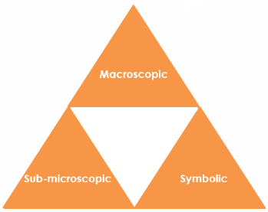Macroscopic – what we can see. Think about the properties you can observe, measure and record.
* Sub-microscopic – smaller than we can see. Think about the particle or atomic level.
* Symbolic – representations. Think about how we represent chemical ideas including symbols and diagrams.

For learners to gain a deeper awareness of a topic, they need to understand it at all three levels.

When introducing a topic, do not try to introduce all three levels of thinking at once. This will overload working memory. Instead complete the triangle over a series of lessons, beginning with the macroscopic level and introducing other levels, in turn, once understanding is secure.

The three levels are interrelated. For example, learners need visual representation of the sub-microscopic to develop mental models of the particle or atomic level.

Find further reading about Johnstone’s triangle and how to use it in your teaching at [rsc.li/4jiulpH](https://rsc.li/4jiulpH)

Scaffolding

It is important to share the structure of the triangle with learners prior to use. Tell them why you want them to use the triangle and how it will help them to develop their understanding. Use an ‘I try, we try, you try’ approach when you are introducing Johnstone’s triangle for the first time.

More resources

To further develop learner’s thinking in all areas of Johnstone’s triangle, try our **Developing understanding** worksheets: [rsc.li/43jMfSn](https://rsc.li/43jMfSn). These include icons in the margin referring to the conceptual level of thinking needed to answer the question. 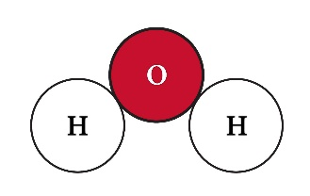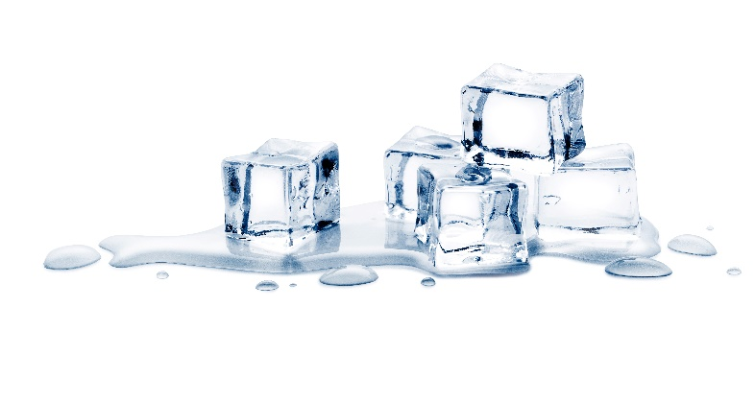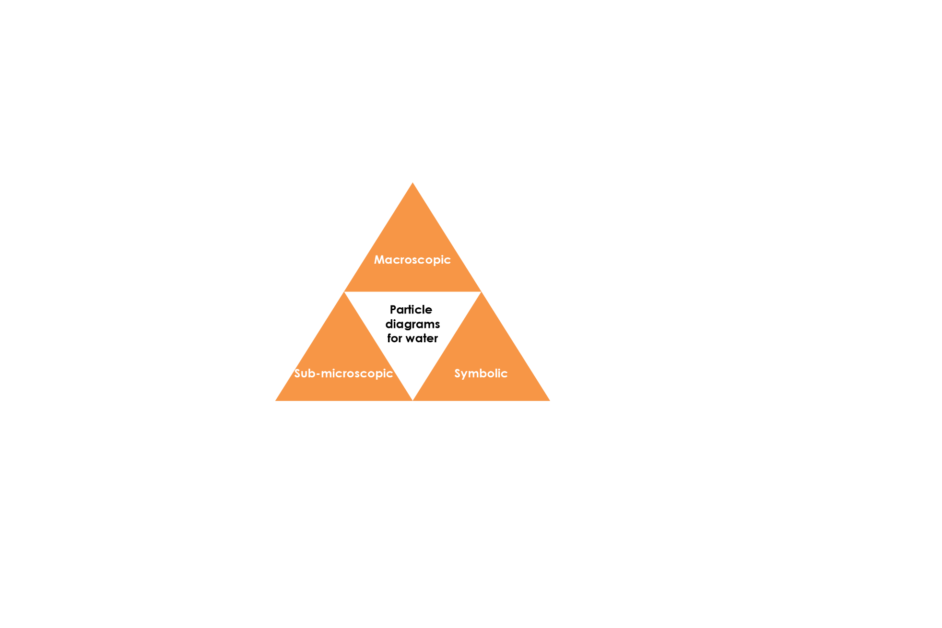

Source: © Shutterstock / 19 STUDIO

Sub-microscopic – smaller than we can see

Use your understanding of the arrangement of the particles in solid and liquid water, and the intermolecular forces present, to explain why liquid water flows, whilst solid water does not:  
**The particles in a solid are arranged in a lattice and are tightly held in this arrangement through strong intermolecular forces.**

**In a liquid, the particles are not held as tightly because some of the intermolecular forces are broken. This means the particles can move past each other, allowing the liquid to flow.**

Macroscopic – what we can see

Observe the demonstration of water in the solid, liquid and gaseous state. Use this to complete the table below:

|  |  |  |
| --- | --- | --- |
| **State** | **Has a fixed shape?** | **Can flow?** |
| Solid state | **yes** | **no** |
| Liquid state | **no** | **yes** |
| Gas state | **no** | **yes** |

**<Fill in the model answer using Bradley Hard ITC, font size 14,   
font colour #4F81BD>**

Symbolic – representations

Complete the diagrams below to represent the arrangement of the particles in solid, liquid and gaseous water:

Particle diagram of a solid: identical pale grey circles in 5 rows of 5. The rows are regularly arranged and touching.

Particle diagram of a liquid: identical pale grey circles, the same size and colour as in the diagram of a solid. The circles are randomly arranged, touching and overlapping, filling the bottom 2/3rds of the square.

Particle diagram of a gas: six identical pale grey circles, the same as those in the diagram of a solid and liquid. The circles are irregularly arranged. None of them are touching.

**solid liquid gas**

In water, each particle represents an molecule. Draw a water molecule below:

*Accept any recognisable model of a water molecule, e.g.*