Scientists find hazardous pigments in tattoo ink

*Original article by Celeste Brady. Adapted by Nina Notman.*

Several common tattoo inks sold and used in Europe contain banned pigments, US chemists have found

US chemists have found that several common tattoo inks sold and used in Europe contain banned pigments.

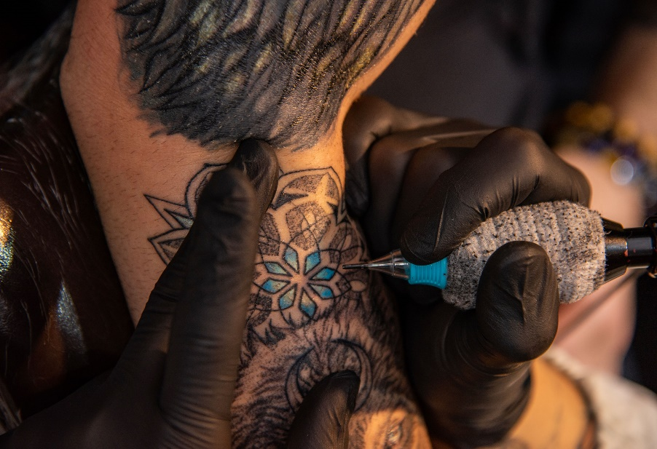

*Source: © Ttart/Getty Images*

*Revealed: banned substances in tattoo inks used in Europe*

The team, led by John Swierk at Binghamton University, looked at five green and five blue tattoo inks from five separate manufacturers that are sold in Europe. All 10 are marketed as being compliant with the region’s chemicals regulatory framework, known as Reach (registration, evaluation, authorisation and restriction of chemicals).

Tattoo inks typically contain one or more pigments – the components that give the ink its colour – suspended in a liquid. In 2022, Reach banned the pigments Blue 15:3 and Green 7 in tattoo ink over concerns that they cause cancer or genetic mutations. Reach also mandates that tattoo ink labels have an accurate ingredient list with relevant hazard warnings.

Only one of the 10 inks analysed by the US chemists was Reach compliant. Nine contained material not listed on their labels. Four of the inks contained Green 7, and the researchers found Blue 15 in two of them, but were unable to determine if it was 15:3 or another subtype of that pigment.

The team previously examined tattoo inks from nine US manufacturers and discovered major discrepancies between the ingredients and the labels in more than 80% of them.

This is adapted from the article Banned pigments found in tattoo inks sold in the EU in *Chemistry* *World.* Read the full article at [bit.ly/3V4ABYd](https://bit.ly/3V4ABYd).