Covalent structure and bonding

1. Covalent bonding involves the sharing of electrons.
   1. Which of the following usually have covalent bonding?

Circle the **two** correct answers.

(2 marks)

**A** compounds of metals and non-metals

**B** compounds of non-metals only

**C** molecules of non-metals

**D** mixtures of two metals

**E** pure metals

* 1. How many electrons are shared in:

1. a single covalent bond

________________________________________________________________________________ (1 mark)

1. a double covalent bond

________________________________________________________________________________ (1 mark)

1. a triple covalent bond?

________________________________________________________________________________ (1 mark)

* 1. What does each dot represent in a dot and cross diagram? Circle the correct answer.

(1 mark)

**A** a neutron

**B** a nucleus

**C** a proton

**D** an electron

* 1. Hydrogen atoms have one electron in their outer shell.

1. Use dots and crosses to complete the diagram to show the covalent bond in a hydrogen molecule.

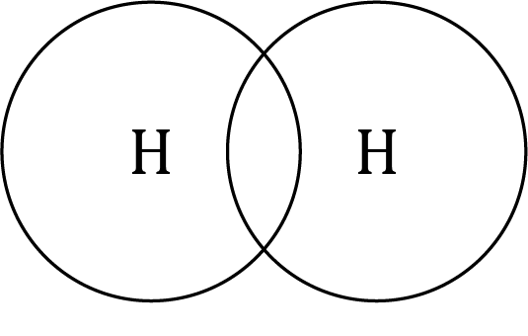

(2 marks)

1. What is the chemical formula for this molecule?

___________________________________________________________________________

(1 mark)

* 1. A water molecule contains two hydrogen atoms and one oxygen atom. Draw a dot and cross diagram to show the electron arrangement in a water molecule. Show the outer electrons only.

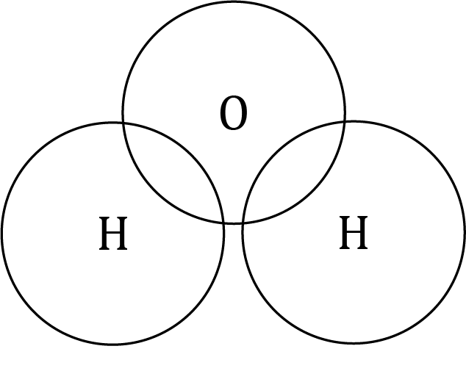

(2 marks)

1. Substances with covalent bonding may be any of the following types of structure:

**simple molecule**  **giant covalent structure** **polymer**

* 1. Choose from the list above to complete the table and identify the types of structure for each substance.

|  |  |  |
| --- | --- | --- |
| **Substance** | **Diagram of structure** | **Type of structure** |
| poly(ethene) | A section of a poly(ethene) molecule showing several black spheres joined to each other and to two white spheres through single bonds. |  |
| ammonia | A computer image of a blue ball connected by three blue and white sticks to three white balls. |  |
| graphite | A section of graphite showing three layers of black spheres connected in interconnected hexagons through single bonds. |  |

(3 marks)

* 1. The melting point of ammonia is –78°C.

Use some of the words provided to complete the sentences. You do not have to use all the words.

covalent bonds weak ionic bonds

metallic bonds strong intermolecular forces

In an ammonia molecule, one nitrogen atom forms _______________________________ covalent bonds with three hydrogen atoms. Ammonia molecules are attracted to each other by _______________________________ intermolecular forces. When ammonia melts, enough energy is needed to overcome the _______________________ __________________________ to separate the molecules.

(3 marks)

* 1. The melting point of poly(ethene) is approximately 110°C.

Use some of the words provided to complete the sentences. You do not have to use all the words.

less more weaker

stronger lower higher

In poly(ethene) molecules, carbon atoms have covalent bonds between each other and with hydrogen atoms. Poly(ethene) molecules have __________________ intermolecular forces than ammonia molecules. Therefore, poly(ethene) has a __________________ melting point than ammonia because __________________ energy is needed to overcome the intermolecular forces.

(3 marks)

1. The table includes different ways of representing an ammonia molecule.

Add ticks (✓) and crosses (🗶) in each box to identify the details shown by each representation. Some boxes have been completed for you.

|  |  |  |  |  |
| --- | --- | --- | --- | --- |
| **Does the representation show:** |  | Full displayed formula of ammonia showing a central nitrogen atom connected to three hydrogen atoms through single bonds. | Dot and cross diagram of an ammonia molecule showing a central nitrogen atom surrounded by three hydrogen atoms. The outer shell of each hydrogen atom overlaps with the nitrogen outer shell and there is a dot and a cross in each of the three areas of overlap. The outer shell of nitrogen also has two dots separately. | A computer image of a blue ball connected by three blue and white sticks to three white balls. |
| the types of atoms in the molecule? |  |  |  | ✓ |
| the number of each type of atom? | ✓ |  |  |  |
| how the electrons are shared? |  | 🗶 |  |  |
| the 3-D structure? |  |  | 🗶 |  |

(4 marks)

[Total: 24 marks]

Which question(s) did you get wrong? Why?

What will you do next time you’re asked a similar question?