Ionic structure and bonding

1. Sodium metal reacts with chlorine gas to form the ionic compound sodium chloride. The diagram shows how the electrons are rearranged in the ions formed.

At the top left there is a sodium atom shown with two dots on the inner circle, eight dots on the second circle and one dot on the outer circle. 
On the right there is a chlorine atom shown with two crosses on the inner circle, eight crosses on the second circle and seven crosses on the outer circle. There is an arrow pointing from the one electron on the outer circle of sodium to the outer circle of the chlorine atom.
There is an arrow going downwards from the two atoms to a sodium ion and a chloride ion. 
The sodium ion has two dots on the inner shell, eight dots on the second shell and no dots on the outer shell and is enclosed in square brackets with a plus on the top right corner on the outside of the right bracket.
The chloride ion has two crosses on the inner shell, eight crosses on the second shell and seven crosses and one dot on the outer shell, and is enclosed in square brackets with a minus on the top right corner on the outside of the right bracket.

* 1. What is the electronic configuration of:

1. a sodium atom? ______________________
2. a chlorine atom? ______________________
3. a sodium ion? ______________________
4. a chloride ion? ______________________

(4 marks)

* 1. Which statement about a chloride ion is true?

Circle the correct answer.

(1 mark)

**A** A chloride ion has equal numbers of electrons and protons.

**B** A chloride ion has more electrons than protons.

**C** A chloride ion has more electrons than protons.

**D** A chloride ion has fewer electrons than a chlorine atom.

* 1. Describe how sodium and chlorine atoms form sodium and chloride ions. Use the words to complete the sentences.

positive stable seven negative one

A sodium atom has __________________ electron in its outer shell. A chlorine atom has __________________ electrons in its outer shell. The outer electron from a sodium atom is transferred to a chlorine atom. The sodium ion formed has a __________________ charge. The chloride ion has a __________________ charge. Both ions have a _________________electronic configuration.

(5 marks)

* 1. The reaction between sodium and chlorine can be represented as:

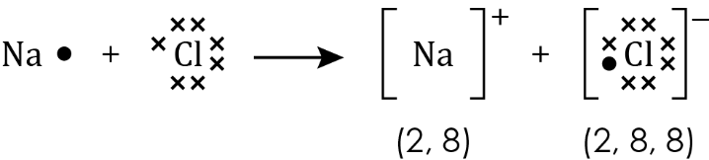

Draw a similar diagram to show how lithium (2, 1) and fluorine (2, 7) form lithium fluoride.

(3 marks)

1. This question is about magnesium oxide and magnesium chloride.
   1. Magnesium is in group 2. State the charge on a magnesium ion.

_____________________________________________________________________________________ (1 mark)

* 1. Oxygen is in group 6. State the charge on an oxide ion.

_____________________________________________________________________________________ (1 mark)

* 1. Complete the diagram to show the formation of magnesium oxide. Add the dots and crosses to represent the electrons and add the charges on the ions formed.

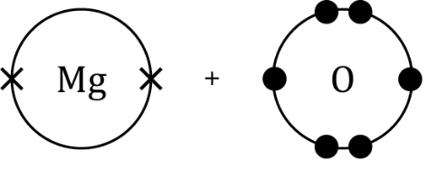

(2 marks)

* 1. Complete the dot and cross diagram for magnesium chloride.   
     Show the outer electrons only.

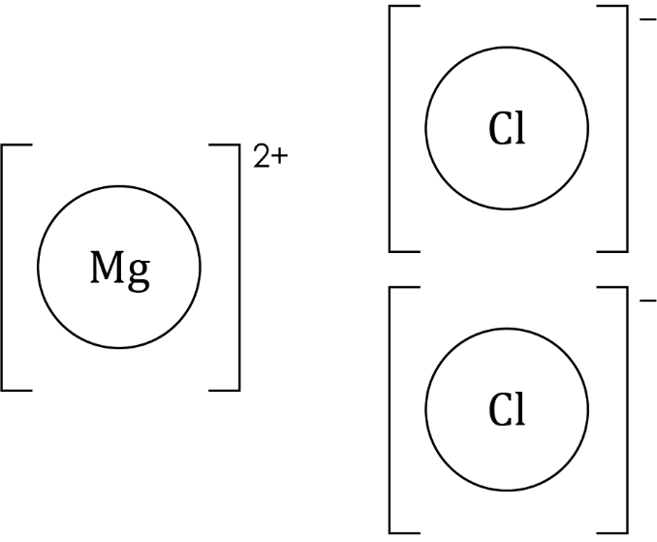

(3 marks)

1. This diagram represents the giant ionic structure of sodium chloride.

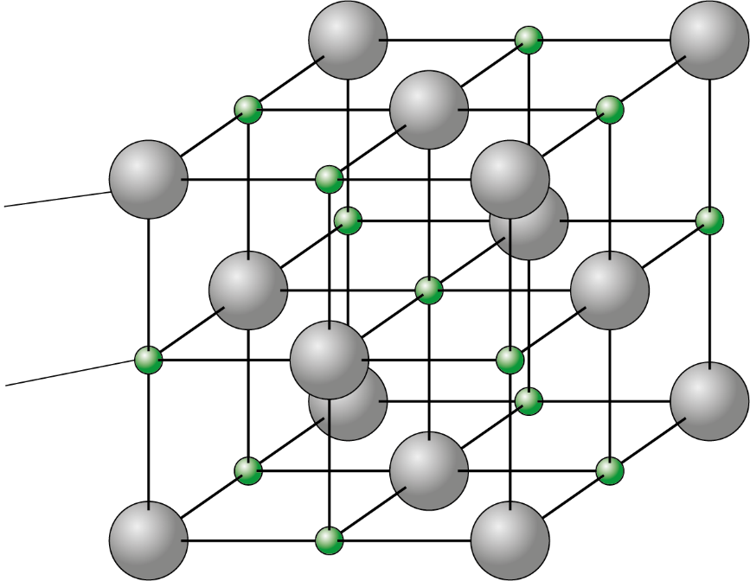

* 1. What forces hold the giant structure together?   
     Circle the correct answer.

**A** atomic forces

**B** covalent forces

**C** electrostatic forces

**D** intermolecular forces

(1 mark)

* 1. The melting point of sodium chloride is 801°C.

1. What type of bonding is broken when sodium chloride melts?

_____________________________________________________________________________________ (1 mark)

1. Explain why sodium chloride has a relatively high melting point.

(2 marks)

1. Zinc chloride is an ionic compound. Some students investigated the electrical conductivity of solid zinc chloride, zinc chloride solution and molten zinc chloride.

The table shows some of their results:

|  |  |
| --- | --- |
| **Substance** | **Did it conduct electricity?** |
| solid zinc chloride | no |
| zinc chloride solution | yes |

* 1. Which statement best explains why zinc chloride solution conducts electricity?

Circle the correct answer.

**A** The ions are held in place by electrostatic forces.

**B** The ions are free to move and carry the charge.

**C** Water does not conduct electricity.

**D** Zinc chloride is soluble in water.

(1 mark)

* 1. The students then observed an experiment using molten zinc chloride as shown in the diagram.

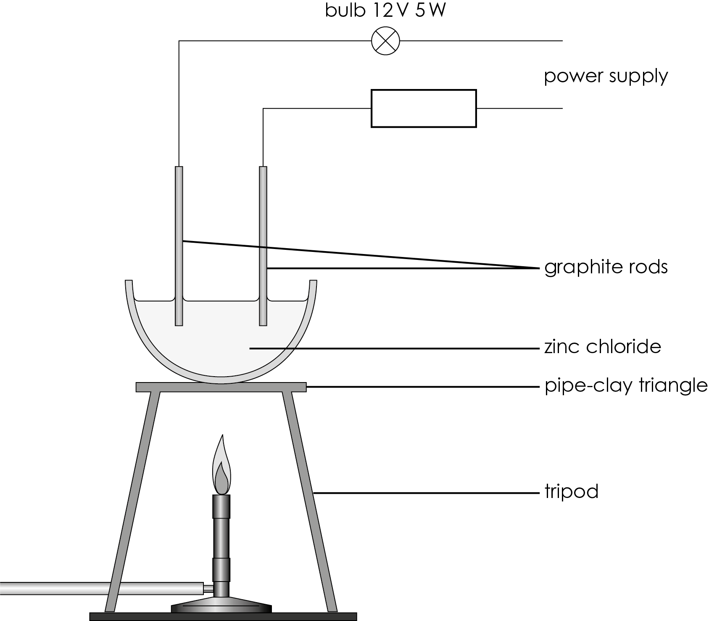

Explain why the bulb lit up when the zinc chloride melted.   
Hint: Look at your answer to **question 4(a)** to help you write your explanation.

(2 marks)

[Total: 27 marks]

Which question(s) did you get wrong? Why?

What will you do next time you’re asked a similar question?