Bonding: teacher guidance

This resource forms part of the Review my learning series from the Royal Society of Chemistry. Additional support for addressing misconceptions identified using these worksheets can be found at rsc.li/3mm0IeW.

These worksheets assess content from the 14–16 specifications. They can be used to identify learners’ knowledge gaps and misconceptions following the completion of that part of the curriculum.

The Bonding worksheets cover the following topics:
- identifying ionic, covalent and metallic bonds from diagrams
- the presence of ions in ionic bonds
- electrostatic forces in ionic bonds
- sharing electrons in covalent bonds
- the presence of positive metal ions and negative electrons in metallic bonds
- types of elements involved in ionic, covalent and metallic bonds
- explaining why metals conduct electricity
- explaining the conditions needed for ionic compounds to conduct electricity
- explaining why covalent substances do not conduct electricity.

If learners successfully answer questions on these topics, they can attempt the extension questions. These consist of drawing diagrams to represent ionic and covalent bonds.

Level 1 () is a scaffolded worksheet in which learners select words from a word list to complete sentences. Level 2 () is partially scaffolded worksheet in which learners complete sentences. Level 3 () is an unscaffolded worksheet in which most of the tasks involve answering questions with a minimum of prompts.

The worksheets can be used in a variety of ways:
- as an assessment of learners’ knowledge at the beginning or end of a period of teaching – the level of the worksheet used can be matched to the ability of the learners
- as an assessment of knowledge during a period of teaching and after learners have completed the relevant section of the specification
- as a revision tool prior to the relevant examination
- as a refresher exercise for teachers or non-subject specialists.

There is also scope to increase the level of the worksheets used as learners progress through their curriculum.

If learners struggle with a particular type of bonding, you could consider using the separate worksheet for that bonding type first, then encourage learners to attempt the partially scaffolded Bonding worksheet to reinforce their understanding.

The ‘What do I understand?’ page is common to all levels of worksheet and can be used both to identify areas needing whole class attention and as an indicator for learners to help guide their revision.

The Teacher guidance provides model answers for each level and guidance on learners’ misconceptions. Learners can use the model answers to self- or peer assess.

Answers

Bonding: knowledge check
- scaffolded/partially scaffolded/unscaffolded
  - The type of bonding in figure A is ionic bonding.
  - The type of bonding in figure B is covalent bonding.
  - The type of bonding in figure C is metallic bonding.
Guidance: Most learners will have no problems recognising the types of bonding in the figures, but there may be many misconceptions in understanding them. Learners need a good understanding of electronic configurations and charges within an atom to understand the diagrams.
The use of dots and crosses can lead some learners to think they are used to show different types of electron, not simply where the electrons originate from. The charges on the ions and use of square brackets may be confusing for some learners. Simple rules, eg that metal atoms produce positive ions, can help learners apply the correct charges. Diagrams representing covalent molecules lead to many errors. Adding extra electrons to the outer shells is common, as is only showing one electron being shared.
- scaffolded/partially scaffolded

Ionic bonding – this bond is formed when electrons are transferred from a metal atom to a non-metal atom, forming positively charged ions and negatively charged ions. Strong electrostatic forces attract the oppositely charged ions to each other.

unscaffolded
  - metals and non-metals
  - One or more electrons is transferred from a metal atom to a non-metal atom.
  - ions
  - electrostatic forces
Guidance: Learners commonly confuse and misuse the terms atom and ion. Although not directly relevant for this question, many learners will use the term molecule to describe ionic compounds. Only covalent substances form molecules.
- scaffolded/partially scaffolded

Covalent bonding – this bonding occurs between non-metal atoms. In a single covalent bond, a pair of electrons is shared between two atoms. These shared electrons are found in the outer shells of the atoms. Each atom contributes one electron to the shared pair of electrons.

unscaffolded
  - non-metals

A pair of electrons is shared between two atoms, each atom contributing one electron.
Guidance: Note that in a dative (or coordinate) covalent bond, one of the atoms donates both shared electrons.
- scaffolded/partially scaffolded

Metallic bonding – the electrons leave the outer shells of metal atoms, forming positive metal ions and a 'sea' of delocalised electrons that are free to move. This bond is the result of the strong electrostatic forces of attraction between the positive metal ions and the negative delocalised electrons.

unscaffolded
  - positive metal ions and negative electrons
  - Metal atoms lose negatively charged electrons to form metal ions. There are now more positively charged protons in the atom than negatively charged electrons and the metal ion has an overall positive charge.
  - electrostatic forces
Guidance: Learners may find delocalised electrons referred to as free electrons on some websites. A common misunderstanding is to refer to metal atoms instead of metal ions in metallic bonds.

Bonding: test myself
- scaffolded/partially scaffolded/unscaffolded
  - metals and non-metals
  - non-metals only
  - metals only
Guidance: A common misunderstanding is that ionic and covalent bonds can form between any elements. Understanding electronic configurations and the Periodic table may help learners realise the types of bonds formed by which type of elements.
- scaffolded/partially scaffolded/unscaffolded

Electrons are shared in covalent bonding.
Guidance: It may help to remind learners of the use of ‘co’ in everyday words such as cooperation, where it refers to sharing.
- scaffolded/partially scaffolded/unscaffolded

The arrow represents an electron being transferred from one atom to another.
Guidance: When learners are drawing their own diagrams, the head and tail of the arrow must start and end exactly. Encourage learners to use the term ‘transferred’ rather than ‘move’, ‘go’, etc.
- scaffolded/partially scaffolded/unscaffolded

Electrostatic forces of attraction hold the particles together in an ionic bond.
Guidance: The term ‘electrostatic’ is probably a new word for most learners and is easily confused with similar words such as electrolysis, electronic, etc.
- scaffolded/partially scaffolded/unscaffolded

Delocalised means that the electrons are free to move around.
Guidance: Most learners will be familiar with the word local and its meaning. They can be encouraged to suggest how the term delocalised might apply to metallic bonding.

- scaffolded/partially scaffolded/unscaffolded

The charged particles in an ionic compound are called ions.
Guidance: A common misunderstanding is to refer to molecules of ionic compounds.
- scaffolded/partially scaffolded/unscaffolded

The bonds in a compound can be either ionic or covalent.
Guidance: Learners can refer to the diagrams in question 1.1 to help answer this.
- scaffolded/partially scaffolded/unscaffolded

Metals are good conductors of electricity because they contain delocalised electrons that are free to move and carry the charge.
Guidance: See guidance for question 2.5.
- scaffolded/partially scaffolded/unscaffolded

Ionic compounds cannot conduct electricity when they are in the solid state because the ions are not free to move. They can conduct electricity when they are in a solution or when they are liquid because the ions can move and carry the charge.
Guidance: Some learners will confuse the liquid state with being in solution. Simple models or diagrams showing the structure of an ionic compound in the different states, and in a solution, can help learners understand this question.
- scaffolded/partially scaffolded/unscaffolded

Most covalent compounds do not conduct electricity because they do not have charged particles (ions/electrons or ions/electrons) that can move and carry the charge.
Guidance: A misunderstanding is that, because an atom is sharing an extra electron in a covalent substance, it has an extra negative charge and charged particles may conduct electricity. In a covalent molecule, learners need to consider the number of positive and negative charges of the whole molecule.

Bonding: feeling confident?
- scaffolded
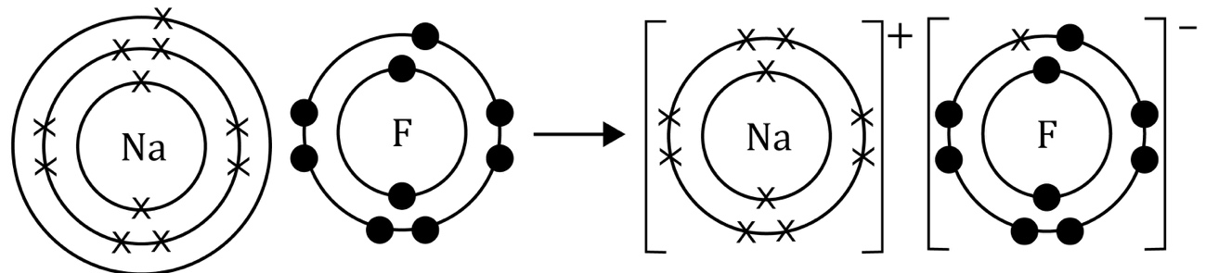

partially scaffolded/unscaffolded

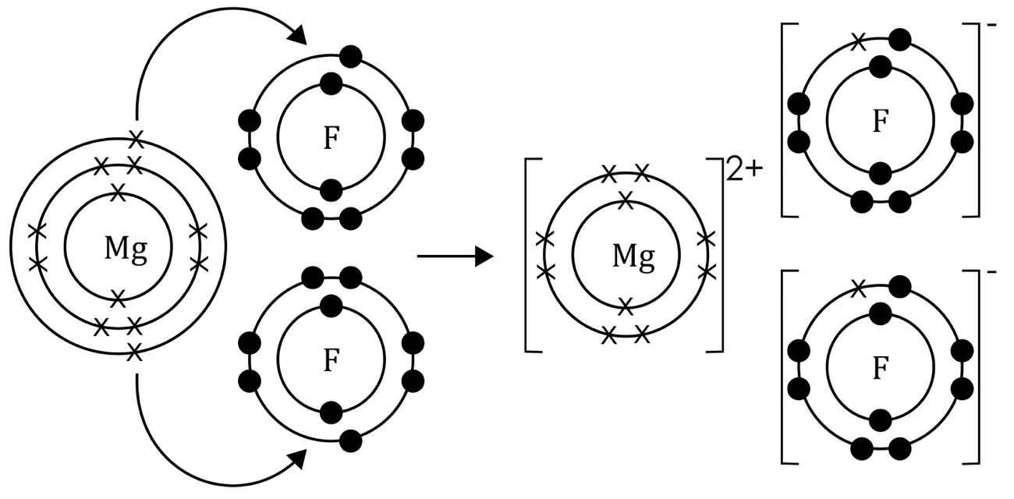

Guidance: For the partially scaffolded and unscaffolded worksheets, learners need to be able to use the Periodic table to draw the correct electronic configurations for the atoms involved. Drawing the wrong number of electrons in each shell is a common error.
Common errors on diagrams showing how electrons are rearranged in an ionic bond include omitting the squared brackets (many websites have similar diagrams with the squared brackets omitted), showing the wrong number of electrons transferred, adding extra electrons and errors in calculating the correct number of charges on the ions. Encourage learners to do a final total count of the total number of electrons to check that electrons have not been lost or gained.

- scaffolded/partially scaffolded/unscaffolded
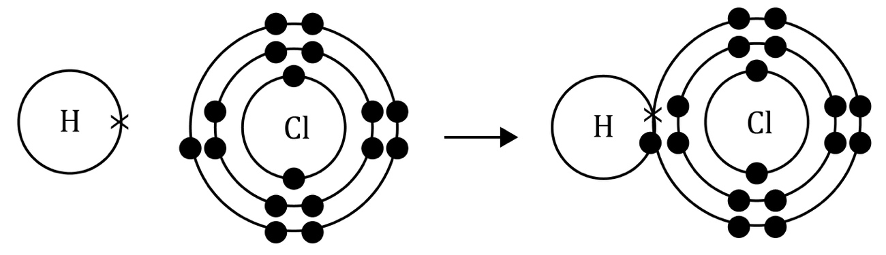
Guidance: Common misconceptions learners have when drawing diagrams to represent covalent bonds are only showing one electron being shared and adding extra electrons for sharing. Encourage them to count the number of electrons in the outer shells to check they do not exceed the permitted number for that shell, ensuring that the shared electrons are counted for both atoms.
- scaffolded/partially scaffolded/unscaffolded

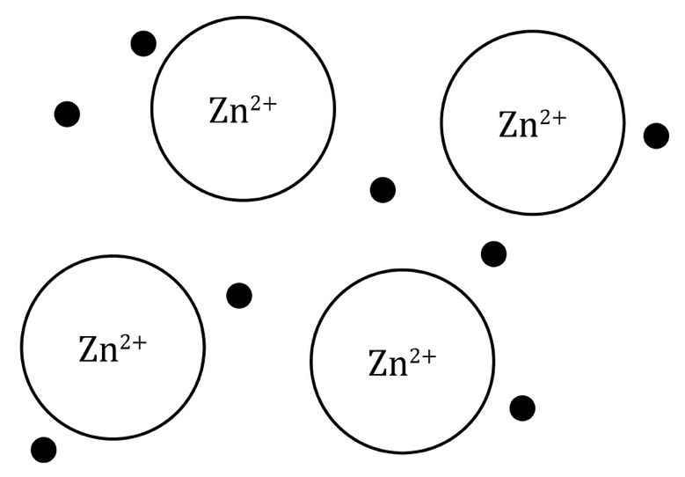
Guidance: Electrons in a metal become delocalised because metal atoms are packed closely together. The metal ions should be drawn in regular rows to show the lattice structure of the metal. Since zinc ions have a 2+ charge, there should be two delocalised electrons for every metal ion. A common misconception is that metallic bonding involves the transfer of electrons from one atom to another. Learners need to understand that the electrostatic forces of attraction are between the positive metal ion and the sea of electrons, not between specific ions and electrons.

Bonding: what do I understand?
Mini-topic | Assessed via:
I can identify ionic, covalent and metallic bonds from diagrams. | Q1.1  Q3.1, Q3.2
I know that there are ions in ionic bonds. | Q1.1, Q1.2, Q2.6
I know about electrostatic forces in ionic bonds. | Q1.2, Q2.4
I know that electrons are shared in covalent bonds. | Q1.1, Q1.3, Q2.2, Q2.3
I know that there are positive metal ions and negative delocalised electrons in metallic bonds. | Q1.1, Q1.4, Q2.5
I know the types of elements involved in:  - ionic bonds  - covalent bond  - metallic bonds. | Q1.2, Q1.3, Q1.4,  Q2.1
I can explain why metals conduct electricity. | Q2.8
I can explain the conditions required for ionic compounds to conduct electricity. | Q2.9
I can explain why covalent substances do not conduct electricity. | Q2.10
Feeling confident? topics | Assessed via:
I can draw diagrams to represent ionic and covalent bonds. | Q3.1, Q3.2

