Carbon allotropes: Johnstone’s triangle

This resource is from the **Johnstone’s triangle series** which can be viewed at: [rsc.li/3WUOFVK](https://rsc.li/3WUOFVK). Use this resource alongside our **Developing understanding** worksheets which can be downloaded from: [rsc.li/3X08N96](https://rsc.li/3X08N96)

Learning objectives

1. Describe two different carbon allotropes based on observations.
2. Use symbolic models to represent carbon allotropes.
3. Explain how the different bonding in carbon allotropes relates to their properties.

How to use Johnstone’s triangle

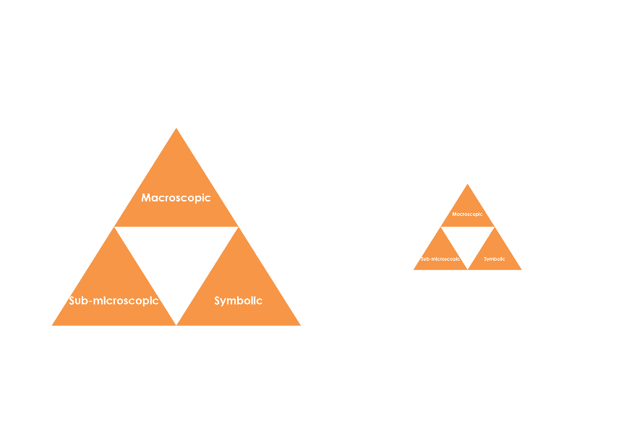Use Johnstone’s triangle to develop learners’ thinking about scientific concepts at three different conceptual levels:

* Macroscopic – what we can see
* Symbolic – what we use to represent what we’ve seen
* Sub-microscopic – smaller than we can see

For learners to gain a deeper awareness of a topic, they need to understand it at all three levels.

Read more about how to use Johnstone’s triangle in your teaching with these *Education in Chemistry* articles:

* Develop deeper understanding with models: [rsc.li/3T5zt5Z](https://rsc.li/3T5zt5Z)
* Improve students’ understanding with Johnstone’s triangle: [rsc.li/3AhucBD](https://rsc.li/3AhucBD)

Scaffolding

It is important to share the structure of the triangle with learners prior to use. Tell them why you want them to use the triangle and how it will help them to develop their understanding. Ask learners to complete the Johnstone’s triangle worksheet independently, in small groups or as a whole class activity.

Use an ‘I try, we try, you try’ approach when you are introducing Johnstone’s triangle for the first time, as detailed in the article *Develop deeper understanding with models*, link above.

Next steps

Get your students to use the completed Johnstone’s triangle as a support document to refer back to when they move on to complete the associated **Developing understanding** worksheet ([rsc.li/3X08N96](https://rsc.li/3X08N96)).

These worksheets contain icons in the margin referring to the conceptual level of thinking needed to answer the question.

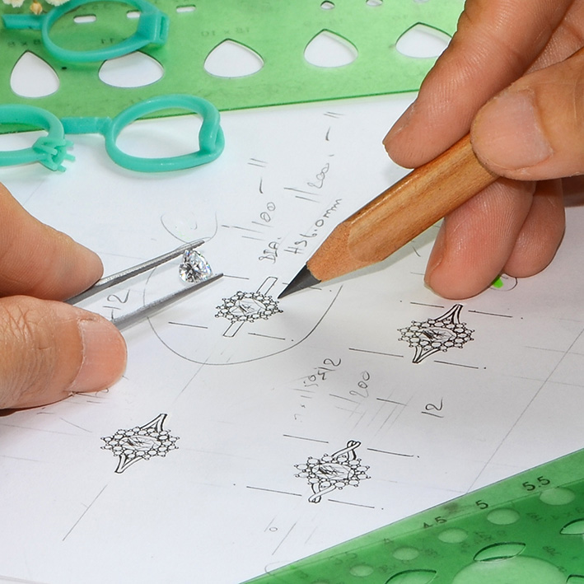

Macroscopic

What do we observe?

Describe the following allotropes, their properties and uses:

* Diamond **Transparent crystal, highly reflective, very hard,   
  electrical insulator. Used for decoration and industrial cutting.**
* Graphite **Black/grey solid with a metallic lustre. Soft, conducts   
  electricity. Used for pencils, lubricants and electrodes.**

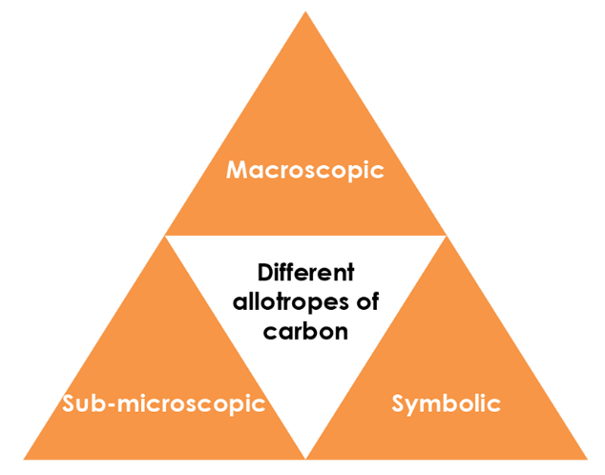

Symbolic

How do we represent what is happening?

Find carbon on the periodic table. Copy its symbol and data below:

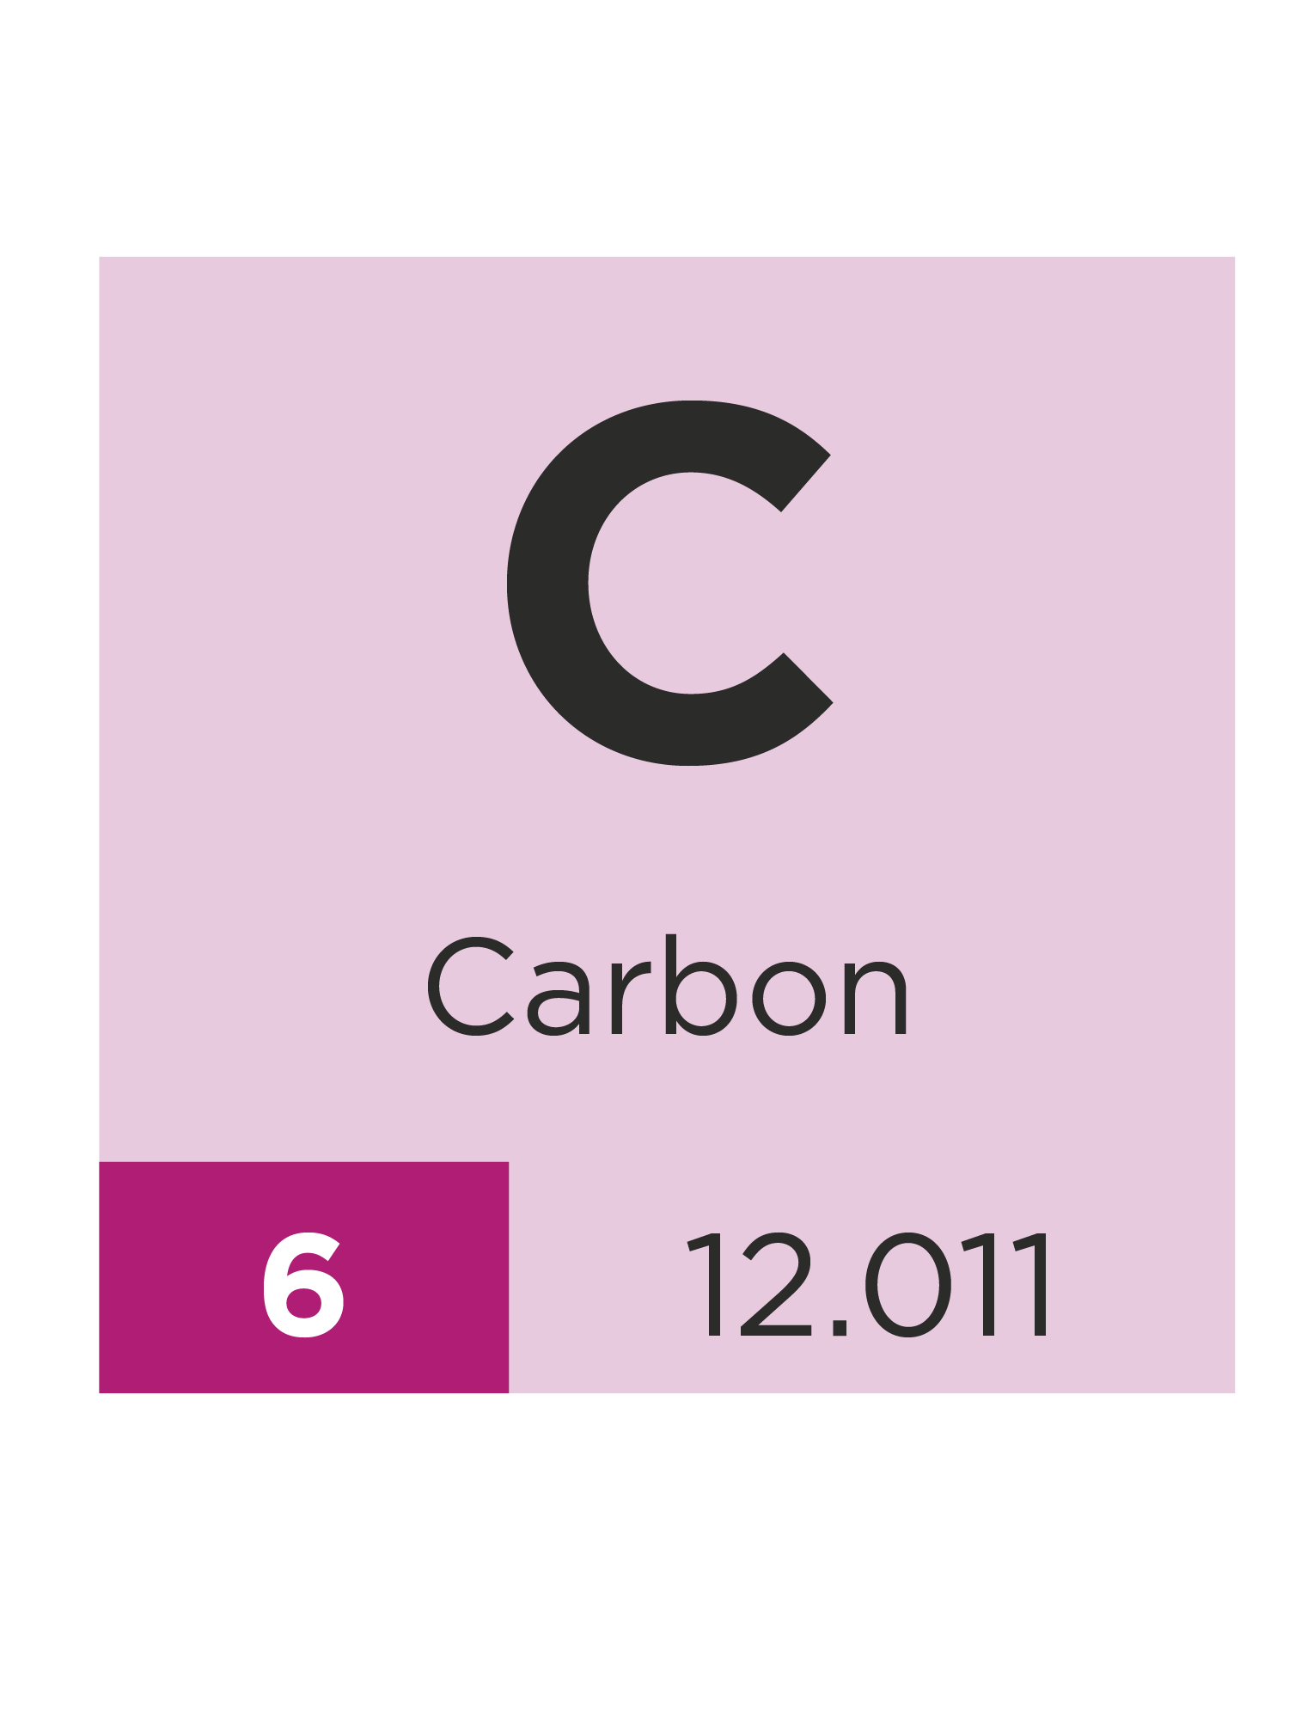

Which allotrope of carbon is represented by the symbol ?

**Buckminsterfullerene (buckyball)**

Sub-microscopic

What is happening that we can’t see?

Write the name of each carbon allotrope beneath its ball-and-stick diagram.

|  |  |
| --- | --- |
| A ball-and-stick diagram showing a spherical macromolecule made up of atoms bonded together in a pattern of alternating pentagons and hexagons. | A ball-and-stick diagram showing a single flat sheet of atoms bonded together in a pattern of hexagons with hanging bonds at the outer edges. |
| **Buckminster-fullerene** | **Graphene** |
| A ball-and-stick diagram showing three flat sheets of atoms bonded together in a pattern of hexagons with hanging bonds at the outer edges. Between the sheets, which are arranged horizontally, there are vertical dotted lines. | A ball-and-stick diagram showing a 3D arrangement of atoms bonded together in a tetrahedrical pattern where each atom forms a bond with four other atoms. |
| **Graphite** | **Diamond** |