F4 Modelling radioactive decay

Scale

|  |  |  |  |
| --- | --- | --- | --- |
| **Subatomic** | **Atom** | **Molecule** | **Giant structure** |
|  |  |  |  |

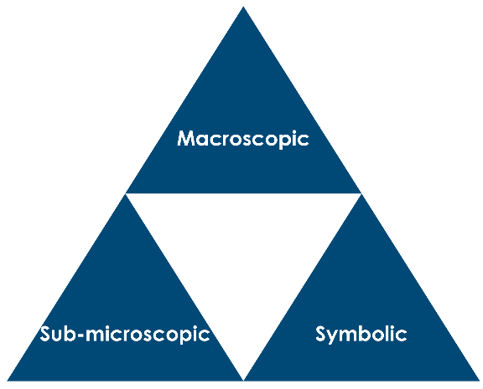

Radioactive decay is a random process – each nucleus in a sample of a radioactive isotope decays in a random manner, regardless of what other nuclei are doing. We can’t predict when a particular nucleus will decay but we can predict that half the radioactive nuclei in the sample will decay in a fixed time – the radioactive half-life.

In this simulation of radioactive decay, you will drop a cardboard tray containing pieces of pasta onto a table. This causes some of the pasta to change from lying on their sides to standing on one of their flat ends – this is a random process, similar to the way that radioactive decay is a random process. We will take the pieces of pasta lying on their sides to represent radioactive nuclei, and the pieces which stand on a flat end to represent a radioactive nucleus which has decayed.

Method

1. Pour your pasta pieces into the cardboard tray.
2. Swirl the tray to get the pasta into a single layer – make sure that all the pieces of pasta are lying on their sides and count them. Record the starting number of pieces of pasta in the table on the next page.
3. Drop the tray onto a table from a height of 5 to 10 cm.
4. Count and remove the pieces of pasta which are now standing on their flat end and enter this number in the table.
5. Repeat this process a further nine times.
6. Plot a graph of unchanged pasta (represents the number of undecayed radioactive nuclei) in the sample against the ‘drop number’ (represents time).
7. Share your results with other groups of students to find a class average for the number of ‘undecayed nuclei’ at each stage – draw another graph using the average figures.

Results

|  |  |  |
| --- | --- | --- |
| **Drop number** | **Unchanged pasta** | **Pasta removed** |
| 0 |  | 0 |
| 1 |  |  |
| 2 |  |  |
| 3 |  |  |
| 4 |  |  |
| 5 |  |  |
| 6 |  |  |
| 7 |  |  |
| 8 |  |  |
| 9 |  |  |
| 10 |  |  |



Questions on the data

1. Use your graph to work out three **consecutive** values of ‘radioactive half-life’ based on the graph drawn using your own data. Make sure you show your working on the graph.

|  |  |
| --- | --- |
| **Half-life** | **Duration (drops)** |
| 1 |  |
| 2 |  |
| 3 |  |

1. What do you notice when you compare the half-life values?
2. Give the nuclear symbol for an alpha particle.
3. Each of these nuclear reactions produces an alpha particle (. Work out and write the nuclear symbol for the other product in each case.
4. Give the nuclear symbol for a beta particle.
5. Each of these nuclear reactions produces a beta particle. Work out and write the nuclear symbol for the other product in each case.

1. emits a total of six alpha particles and four beta particles in its natural decay series. What is the nuclear symbol for the final product?

**The following questions use the data in the table below:**

|  |  |
| --- | --- |
| **Isotope** | **Half-life** |
| uranium-238 | 4.5 x 109 years |
| carbon-14 | 5.7 x 103 years |
| strontium-90 | 28 years |
| iodine-90 | 8.1 days |
| bismuth-214 | 19.7 minutes |
| polonium-214 | 1.5 x 10-4 seconds |

1. Assume that you start with 32 g of each isotope.
2. How much uranium-238 would be left after 4.5 x 109 years?
3. How much would be left after 78.8 minutes?
4. How long would it take for you to be left with 4.0 g of ?
5. How much would be left after 4.56 x 104 years?
6. Carbon from a piece of wood taken from an ancient tomb gave a reading of 9 counts per minute per gram. A sample of new wood taken in 2022 gave a reading of 36 counts per minute per gram.
7. Estimate the year in which the tomb was built, given that the half-life of carbon-14 is 5730 years.
8. Comment on the accuracy of your answer.