Oxygen and methylene blue – teacher notes

Topic
Organic chemistry, redox reactions, dyes and colour chemistry.

Timing
15 minutes

Description
In this experiment students generate oxygen gas by the reaction between hydrogen peroxide and potassium manganate(VII), and then test for the gas by bubbling it into a solution of the reduced form of methylene blue dye, turning the solution blue.

Apparatus
- Eye protection
- Student worksheet
- Beaker, 10 cm³
- Plastic pipette (standard form)
- Piece of rubber tubing, ca 10 cm long
- Scissors

Chemicals
Solutions should be contained in plastic pipettes. See the accompanying guidance on apparatus and techniques for microscale chemistry, which includes instructions for preparing a variety of solutions here https://rsc.li/3UUjNSf

- Hydrogen peroxide 5% solution
- Potassium manganate(VII), 0.1 mol dm^{–3}
- Methylene blue solution (colourless, leuco form of dye)
- Glucose

Observations
This experiment is a little tricky to perform and students will need to practice it first! The hydrogen peroxide and potassium manganate(VII) react together vigorously to produce oxygen gas.

The colourless solution of methylene blue should turn blue quickly when the oxygen gas is directed into it. Students are given the structures of the oxidised and reduced forms of methylene blue and are asked to say which is which.

The oxidised (blue) form contains conjugated double and single bonds throughout the whole molecule, whereas in the colourless form the delocalised electron systems are isolated from each other. The structures are given below.
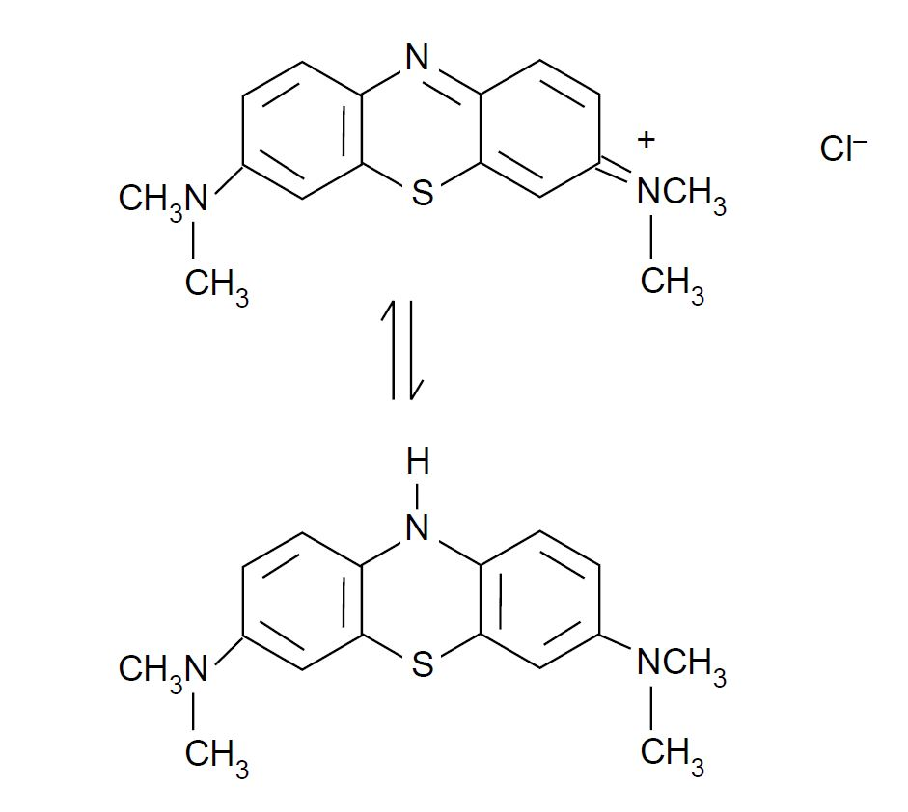

Notes
Dissolve 4 g of potassium hydroxide pellets in 150 cm³ of deionised water in a plastic bottle or stoppered 250 cm³ conical flask. Allow to cool and add 5 g of glucose powder. Add 3–4 drops of methylene blue solution (0.25 g in 1000 cm³ of deionised water or Aldrich cat. no. 31,911-2). The blue solution should become colourless on standing a few minutes, but will turn blue when shaken.

Health, safety and technical notes

- Wear eye protection throughout (splash-resistant goggles to BS EN166 3).
- Glucose / methylene blue / sodium hydroxide solution is corrosive, goggles (to BS EN166 3) should be worn. Reducing the concentration to below 0.5 mol dm⁻³ will mean it is merely an irritant and will still work (see CLEAPSS Hazcard HC040c, HC032).
- Sodium hydroxide itself is highly corrosive, if students are making up their own solutions (see CLEAPSS Hazcard HC091a).
- Hydrogen peroxide, 5% solution H₂O₂(aq) and potassium manganate(VII), KMnO₄(aq), 0.1 mol dm^{–3} are of low hazard (see CLEAPSS Hazcard HC050, HC081).
- Using less (2.4g) of potassium hydroxide will mean the solution is irritant rather than corrosive, and pupils can just use safety glasses (see CLEAPSS Hazcard HC091b).

