Particle diagrams: teacher guidance

**These Knowledge check worksheets**provide a series of questions to assess learners’ knowledge and understanding of this topic at the end of a period of teaching or as revision. They are available at Foundation and Higher level and as fully editable versions so you can adapt them to suit learners’ needs. Use for individual student work in class or at home. Find the full set of answers below.

Also available to assess this topic:

* **Review my learning** **worksheets**: available with three levels of scaffolded support to help build confidence in every learner. Use before, during or after teaching the relevant topic, to understand progress and identify misconceptions, **rsc.li/44igB7V**.
* **In context worksheets** ask learners to apply their knowledge to interesting contexts from everyday life, helping them develop their skills and prepare for examination, including calculation questions to practise mathematical skills within a genuine chemical context, **rsc.li/4b0gz6j**.

Answers

Foundation

1. (a) **A** atoms

**C** ions

**D** molecules

[3 marks]

(b)

|  |  |  |  |
| --- | --- | --- | --- |
| **The particles are in:** | **Solid** | **Liquid** | **Gas** |
| a fixed position | 🗸 |  |  |
| free to move |  | **🗸** | **🗸** |
| regular pattern | **🗸** |  |  |
| arranged irregularly |  | **🗸** | **🗸** |

[4 marks]  
One mark for each of one to three correct. Four marks for four or five correct.

1. (a)

|  |  |  |
| --- | --- | --- |
| **Starting phase** | **Final phase** | **Name of change** |
| solid | liquid | **melting** |
| liquid | gas | **boiling** |
| gas | liquid | **condensing** |
| liquid | solid | **freezing** |

[4 marks]

(b) i. The energy of the particles increases when a solid changes to a liquid.

[1 mark]

ii. The energy of the particles increases when a liquid changes to a gas.

[1 mark]

(c) i. The particles move away from their fixed positions when a solid changes to a liquid. [1 mark]

ii. The particles move away from the surface of the liquid   
and move freely in all directions. [1 mark]

(d) **D** No new substances are made. [1 mark]

(e) **B** the chemical formulae of the particles [1 mark]

1. (a) copper [1 mark]

(b) Copper has the highest melting point, suggesting it has the   
strongest force between the particles. [1 mark]

(c) [1 mark]

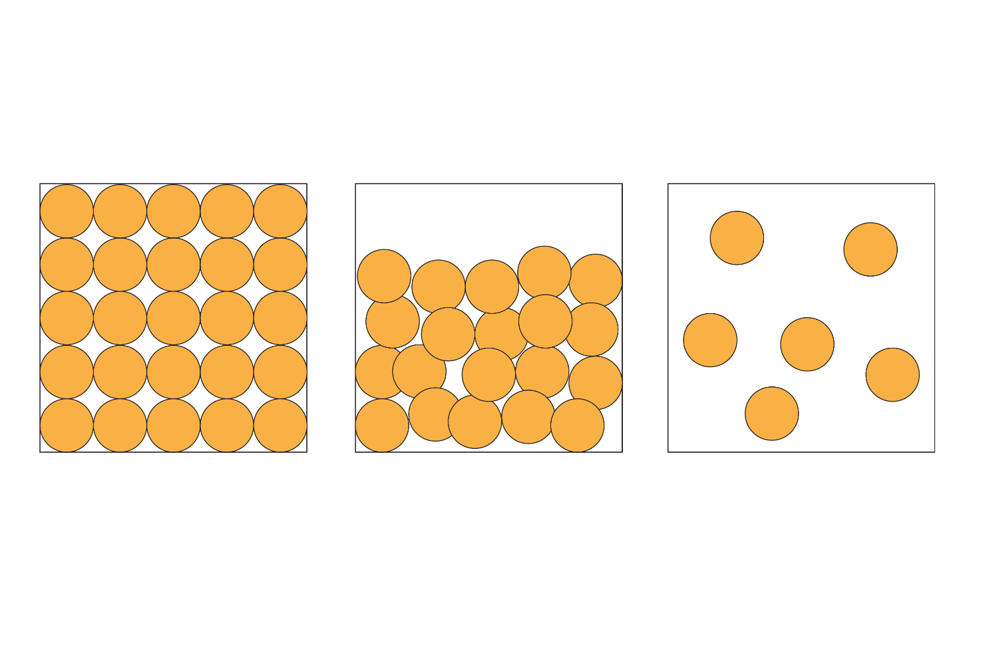

(d) In solids, the forces of attraction are the strongest [1]. In liquids, they are stronger than in gases but weaker than in solids [1]. In gases, the forces of attraction between the particles are the weakest [1]. [3 marks]

[Total: 23 marks]

Higher

1. (a) Any two from: atoms, molecules or ions. [2 marks]

(b) i. Not all particles are spherical, for example, carbon dioxide   
is a linear/oblong shape. [1 mark]

ii. Atoms are mostly empty space. [1 mark]

iii. Different atoms, molecules and ions are different sizes. [1 mark]

1. (a) i. the liquid and gas diagrams [1 mark]

ii. the solid diagram [1 mark]

iii. the gas diagram [1 mark]

iv. the gas diagram [1 mark]

(b) the diagram of solid particles [1 mark]

1. (a) ratio of helium atom diameter to distance between   
   the atoms 0.064:3.0 [1]

1:46.7 [1] [2 marks]

(b) The particles and the distances between them are not to scale. [1 mark]

1. (a) Changes of state are physical changes because no new substances   
   are made, whereas in chemical changes new substances are made.  
    [1 mark]

(b)

|  |  |
| --- | --- |
| **Change of state** | **Term describing change of state** |
| solid to liquid | **melting** |
| **liquid to gas** | boiling |
| gas to liquid | **condensing** |
| **liquid to solid** | freezing |
| solid to gas | **subliming** |

[5 marks]

(c) i. The energy of the particles increases. [1 mark]

ii. The particles move away from their fixed position when a solid changes to a liquid. [1] The particles move away from the surface of the liquid when it changes to a gas and move freely. [1] [2 marks]

1. (a) i. metallic bonds [1 mark]

ii. intermolecular forces [1 mark]

iii. intermolecular forces [1 mark]

(b) i. The stronger the forces between particles, the higher the melting and boiling points. [1 mark]

ii. The stronger the forces between particles, the less the particles   
vibrate or move. [1 mark]

[Total: 27 marks]